**Update (2017-04-DEC)**

Also you forget to change the UAE Flag to Kuwait flag inside the web site like admin panel and seller when they enter the text.

**Infoware (2017-04-DEC): Done.**

Also in the add new address make the map a little bit smaller and doesn't affect the below text

**Infoware (2017-04-DEC): Done.**

Option to change the password for delivery staff

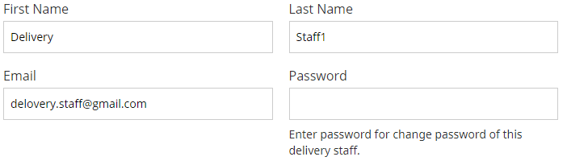

**Infoware (2017-04-DEC): Admin can change the delivery staff from edit delivery staff page.**

Remove Shipping Charges from seller account

**Infoware (2017-04-DEC): Done.**

My orders and Finance tab doesn’t work in seller profile

**Infoware (2017-04-DEC): My Order and Finance tab are not implemented in development site. So those tabs are under work in progress.**

Cancel option doesn’t work when I add the new branch

**Infoware (2017-04-DEC): Done.**