**Update (2017-22-NOV)**

Site URL: <http://www.infowarescripts.com/mscommerce/>

Admin URL: <http://www.infowarescripts.com/mscommerce/admin>

Admin Username: info@msecommerce.com

Admin Password: admin

**Milestone Two:**

**Front End/Web Site:**

**Seller Sign Up:**

**Infoware (2017-22-NOV): Click on “Seller Signup” button from header menu.**

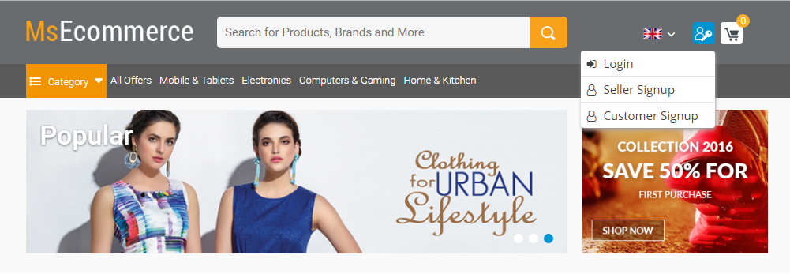

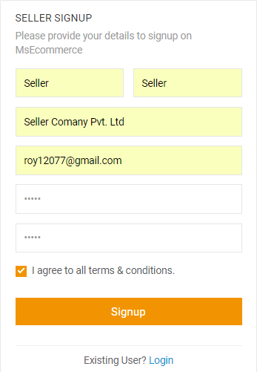

**Infoware (2017-22-NOV): After provide all above information click on “Signup” button then a verification mail will be send to user register email address from where user can verify his email address. After mail verification user can login in this site by his register email address and password otherwise user can not login in this site.**

**Buyer Sign Up:**

**Infoware (2017-22-NOV): Click on “Customer Signup” button from header menu.**



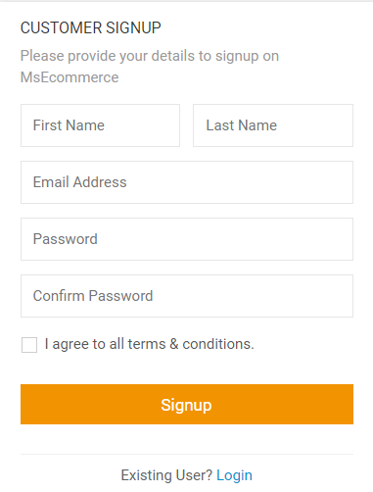

**Infoware (2017-22-NOV): After provide all above information click on “Signup” button then a verification mail will be send to user register email address from where user can verify his email address. After mail verification user can login in by his register email address and password otherwise user can not login in this site.**

**Login**

**Infoware (2017-22-NOV): Click on “Login” button header menu.**



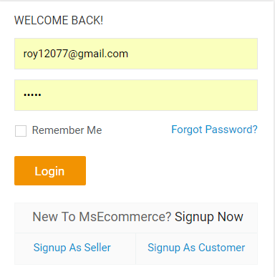

**Infoware (2017-22-NOV): Only verified or active user can login in this site. User can login by his register email address and password.**

**Click on “Forget Password” for reset password.**

**Forgot Password:**

**Infoware (2017-22-NOV): In email address field enter user email address and click on submit button then reset password link will be send to user entire email address. Click on reset password link then a reset password page will be opend.**

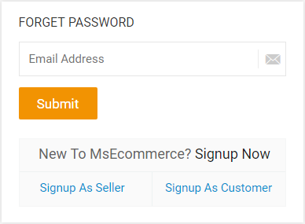

**Reset Password:**

**Infoware (2017-22-NOV): Here you give your new password and confirm password and then click on save button then your new password will be saved.**

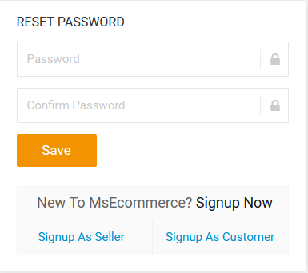

**Buyer Edit profile:**

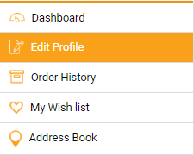

**Infoware(2017-22-NOV): Click on left menu “Edit Profile” for update buyer information.**

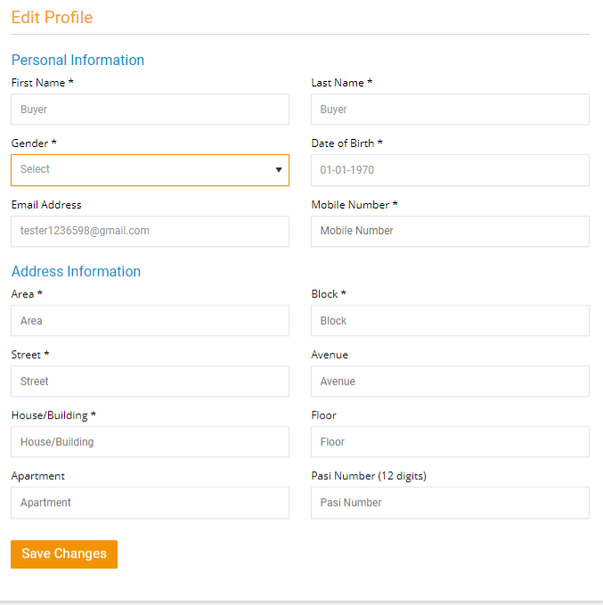

**Infoware(2017-22-NOV): (*) mark field are mandatory and without (*) mark fields are optional in buyer edit profile page.**

**Seller Edit profile:**

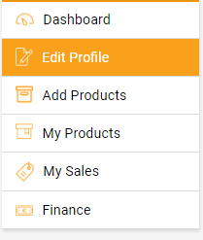

**Infoware(2017-22-NOV): Click on left menu “Edit Profile” for update seller information.**

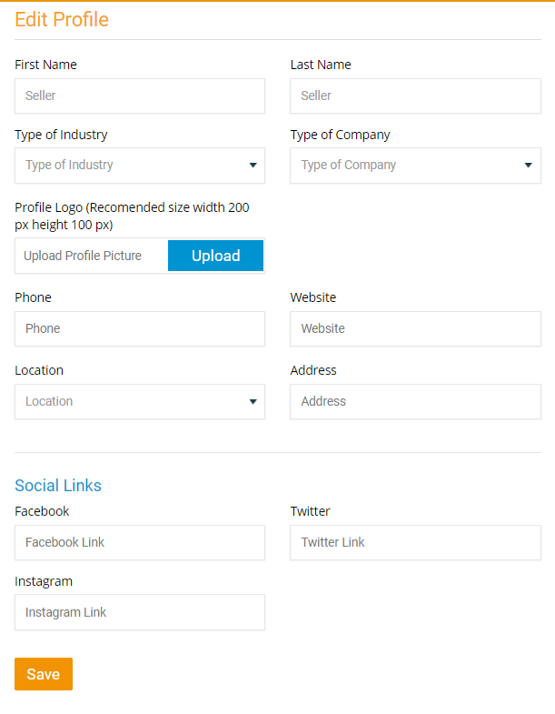

**Change Password:**

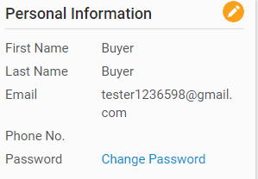

**Infoware(2017-22-NOV): After buyer login click on “Change Password” from buyer dashboard page for change password.**

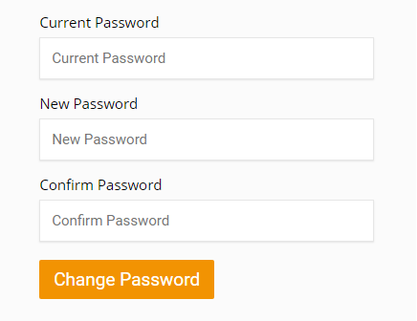

**Infoware(2017-22-NOV): Give Current Password in Current Password field and then give New Password and then give Confirm Password and click on Change Password button for change password.**

**Add Product:**

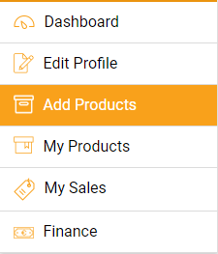

**Infoware(2017-22-NOV): Click on “Add Product” from the left menu.**

**Seller can add product under a category and subcategory and provide other information such as product price, quantity and other. Seller cannot upload more than five images for any one product.**

**In Offer price area seller can add offer for any product.**

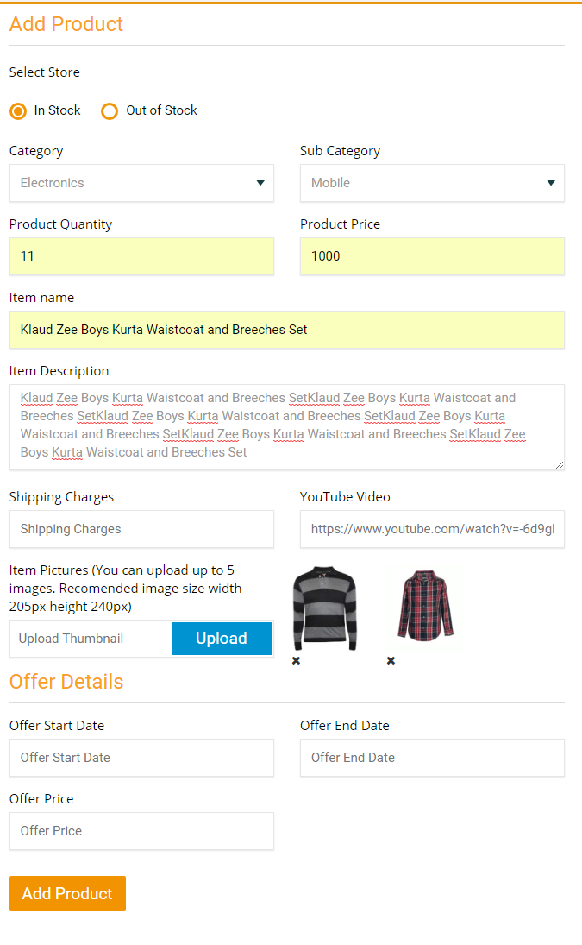

**Supplier My Product:**

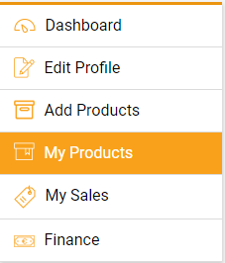

**Infoware (2017-22-NOV): Click on “My Product” to view the list of seller all products.**

**When seller adds any product then the product status will be shown “Awaiting Approval”. After admin approve his product then this product will be published in this site.**

**Click on “Edit” icon for edit any product.**

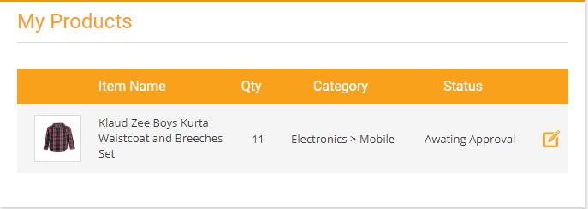

**Infoware(2017-22-NOV): In edit product page seller can edit his product information.**

**Click on “Cross” icon on product image for delete product image.**

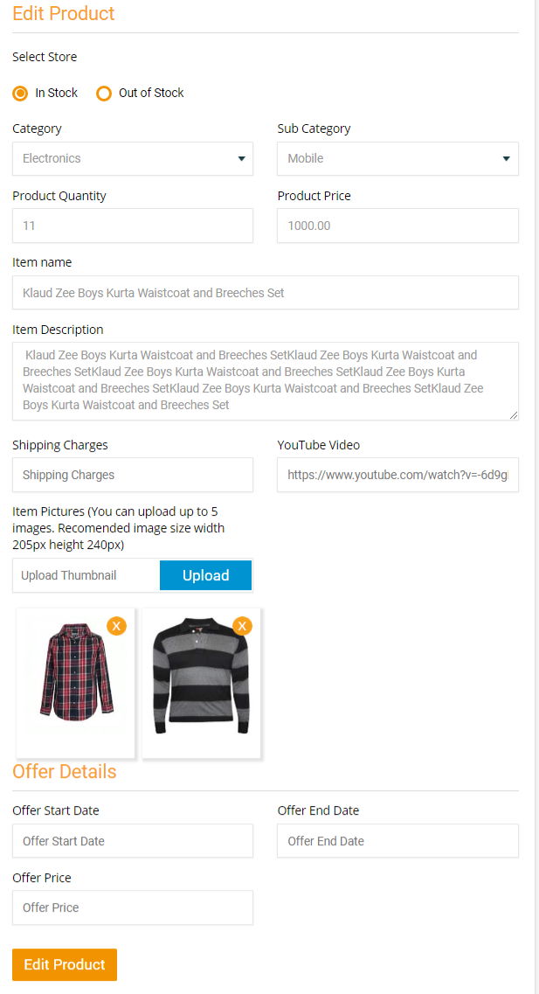

**Admin Panel:**

**Category Management:**

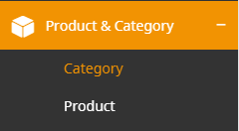

**Infoware(2017-22-NOV): Click on menu “Category” under the “Product & Category”.**

**In category listing admin can search category by category and status and keyword such as category name and subcategory name.**

**Click on “Add Category” for add category.**

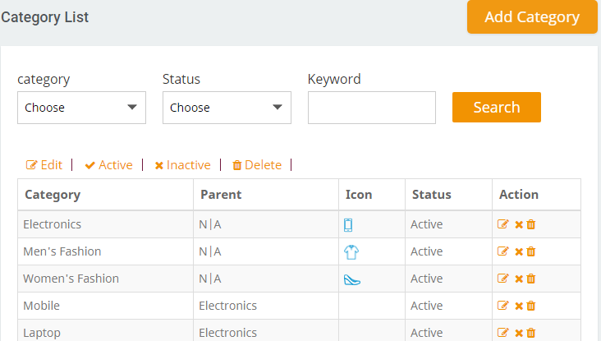

**Infoware(2017-22-NOV): Click on “Active/Inactive” button for active and inactive and category and subcategory.**

**Click on “Delete” icon for delete category .If any category and subcategory is used in product then this category and subcategory cannot delete.**

**Click on “Edit” icon for edit any category.**

**Infoware(2017-22-NOV): In add category page admin can add category by two language such as English and Arabic.**

**If admin want to create any subcategory then leave the select category field.**

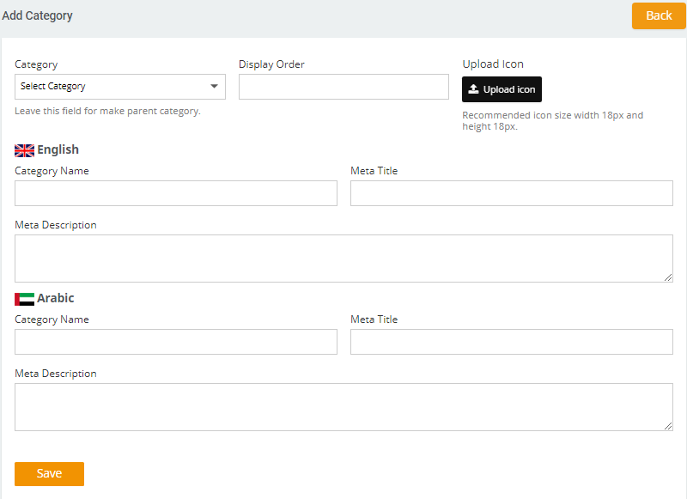

**Category Management:**

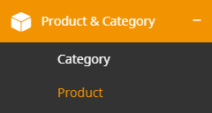

**Infoware(2017-22-NOV): Click on menu “Product” under the “Product & Category”.**

**In product listing page admin can search product by category and subcategory and status and keyword such as product name product price.**

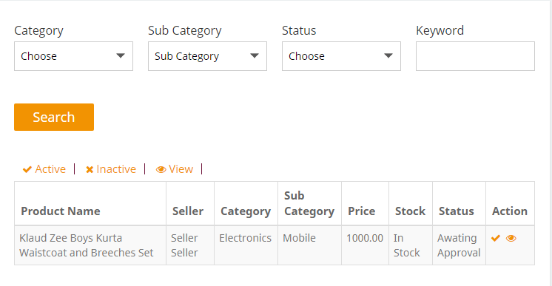

**Infoware(2017-22-NOV): Click on “Active/Inactive” icon for active and inactive any product.**

**Click on “View” icon for view the details of any product.**

**Seller/Buyer Management:**

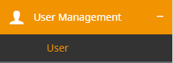

**Infoware (2017-22-NOV): Click on menu “User” under the “User Management”.**

**In user listing page admin can search by user type and user status and keyword such as user first name, last name and email.**

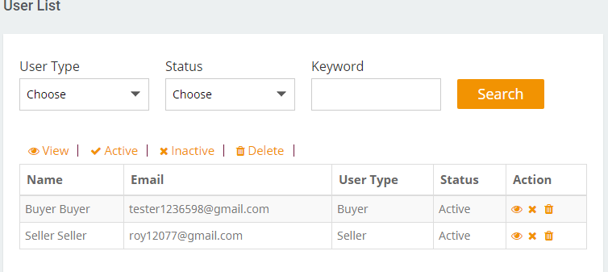

**Infoware(2017-22-NOV): Click on “Active/Inactive” icon for active and inactive any user.**

**Click on “View” icon for view the details of any user.**

**Click on “Delete” icon for delete any user.**

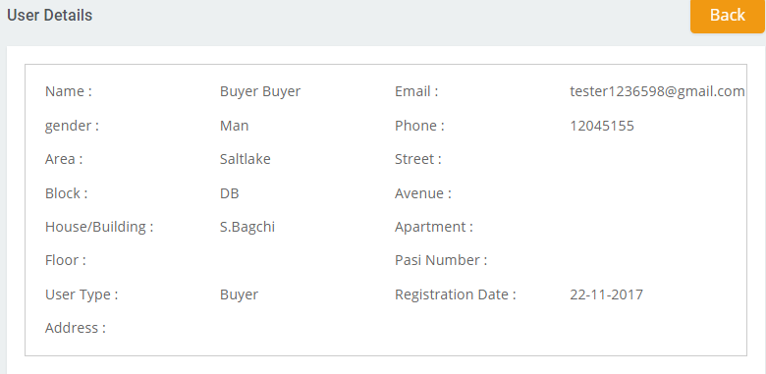

**Manage Deliver Staff:**

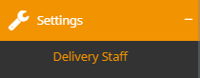

**Infoware(2017-22-NOV): Click on menu “Delivery Staff” under the “Settings”.**

**Click on “Add Delivery User” for add delivery user.**

**Here admin can search delivery staff by status and keyword such as name and email.**

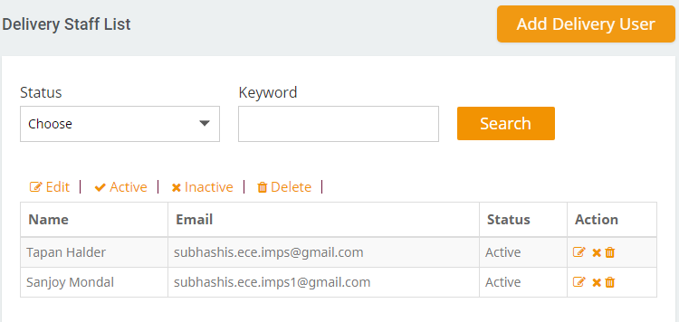

**Infoware (2017-22-NOV): Click on “Active/Inactive” icon for active and inactive any user.**

**Click on “Edit” icon for view the details of any user.**

**Click on “Delete” icon for delete any user.**

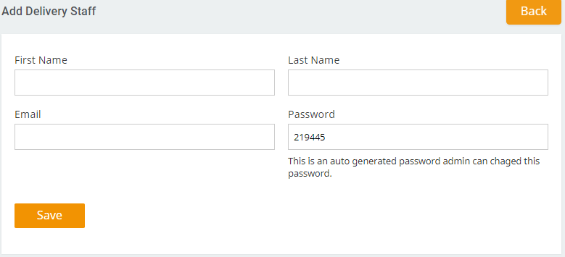

**Infoware(2017-22-NOV): In add delivery admin add delivery staff by the information of delivery staff first name, last name, email and password. Here the password field it is auto generated password admin can change this password. After provide all information clicks on save button then a mail will be send to register email address with username (email) and password.**