Introduction:

1. Creating a project in JIRA:

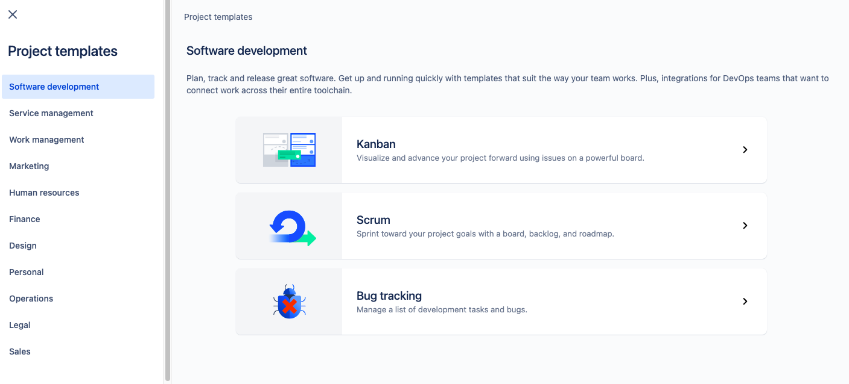

<https://www.atlassian.com/agile/kanban/kanban-vs-scrum>

*Kanban methodologies are continuous and more fluid, whereas scrum is based on short, structured work sprints.*

[*Agile*](https://www.atlassian.com/agile) *is a structured and iterative approach to project management and product development. It recognizes the volatility of product development, and provides a methodology for self-organizing teams to respond to change without going off the rails. Today, agile is hardly a competitive advantage. No one has the luxury to develop a product for years or even months in a black box. This means it’s more important than ever to get it right.*

[*Kanban*](https://www.atlassian.com/agile/kanban) *is all about visualizing your work, limiting* [*work in progress*](https://www.atlassian.com/agile/kanban/wip-limits)*, and maximizing efficiency (or flow). Kanban teams focus on reducing the time a project takes (or* [*user story*](https://www.atlassian.com/agile/project-management/user-stories)*) from start to finish. They do this by using a* [*kanban board*](https://www.atlassian.com/agile/kanban/boards) *and continuously improving their flow of work.*

[*Scrum*](https://www.atlassian.com/agile/scrum) *teams commit to shipping working software through set intervals called sprints. Their goal is to create learning loops to quickly gather and integrate customer feedback. Scrum teams adopt specific roles, create special artifacts, and hold regular ceremonies to keep things moving forward. Scrum is best defined in* [*The Scrum Guide*](https://www.scrumguides.org/scrum-guide.html)*.*

[*Agile*](https://www.atlassian.com/agile) *is a structured and iterative approach to project management and product development. It recognizes the volatility of product development, and provides a methodology for self-organizing teams to respond to change without going off the rails. Today, agile is hardly a competitive advantage. No one has the luxury to develop a product for years or even months in a black box. This means it’s more important than ever to get it right.*

[*Kanban*](https://www.atlassian.com/agile/kanban) *is all about visualizing your work, limiting* [*work in progress*](https://www.atlassian.com/agile/kanban/wip-limits)*, and maximizing efficiency (or flow). Kanban teams focus on reducing the time a project takes (or* [*user story*](https://www.atlassian.com/agile/project-management/user-stories)*) from start to finish. They do this by using a* [*kanban board*](https://www.atlassian.com/agile/kanban/boards) *and continuously improving their flow of work.*

[*Scrum*](https://www.atlassian.com/agile/scrum) *teams commit to shipping working software through set intervals called sprints. Their goal is to create learning loops to quickly gather and integrate customer feedback. Scrum teams adopt specific roles, create special artifacts, and hold regular ceremonies to keep things moving forward. Scrum is best defined in* [*The Scrum Guide*](https://www.scrumguides.org/scrum-guide.html)*.*

*https://www.javatpoint.com/jira-kanban-vs-scrum*

* *Jira epic is a large user story which is broken into smaller tasks (user stories) based on the customer or end-user needs.*

*Creating a ROADMAP:*

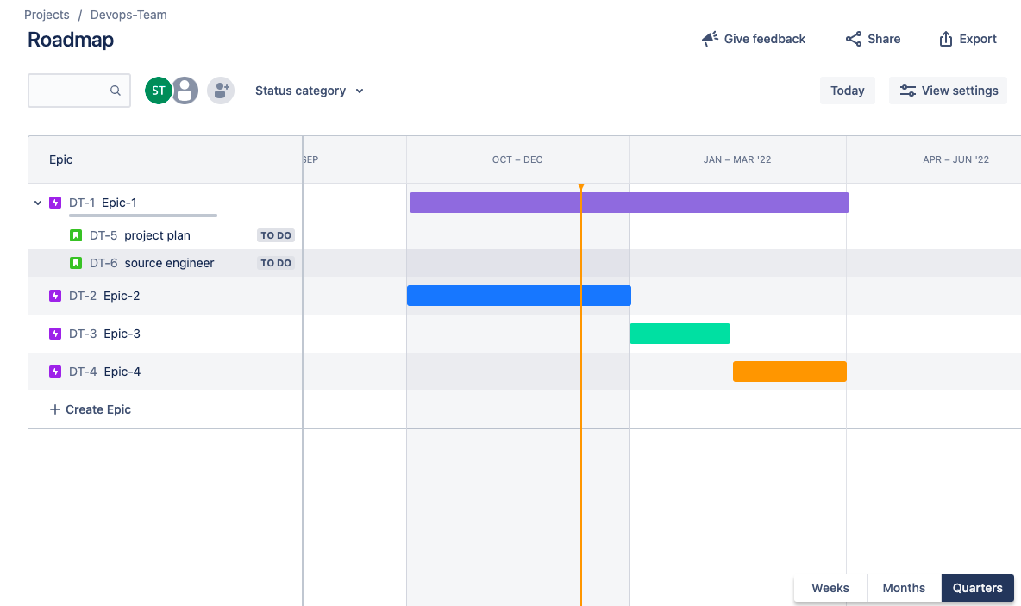

*ADDING WATCHERS:*

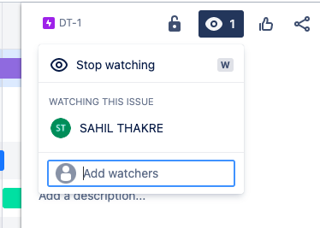

*SHARING THE PROJECT:*

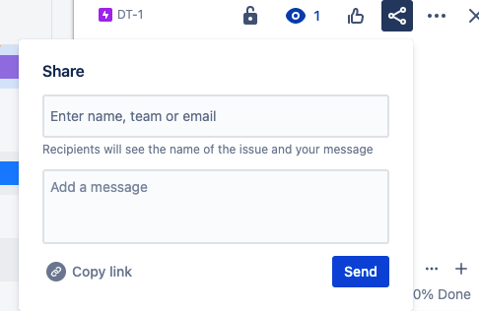

*CONFIGURING EPIC:*

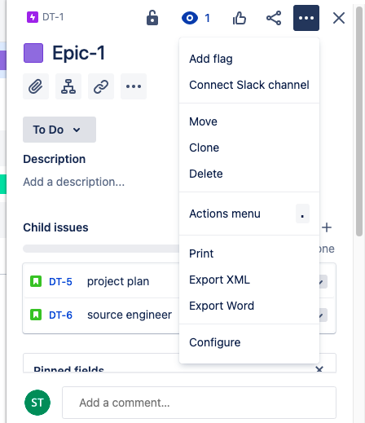

*ADDING FIELDS:*

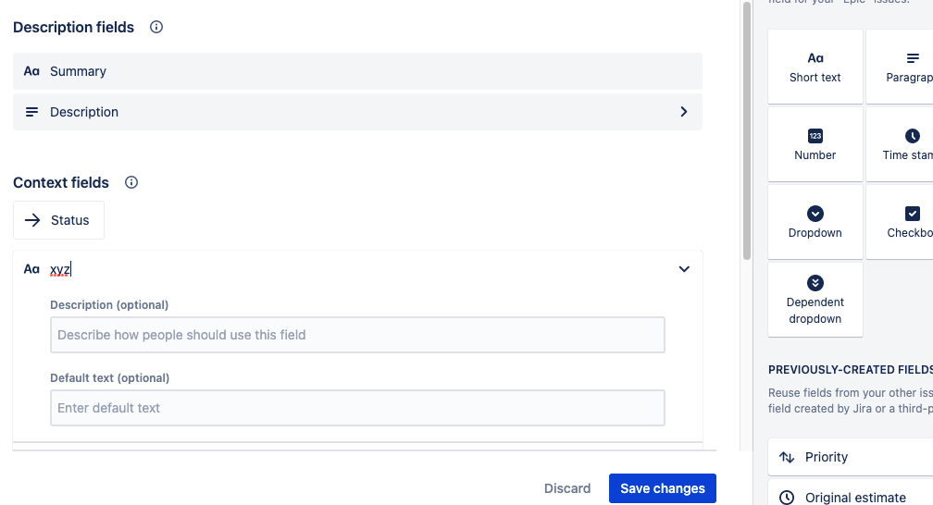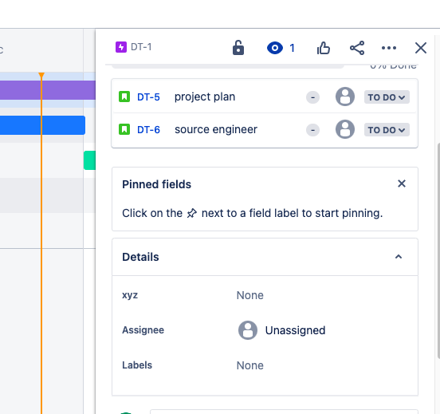

*ASSIGNING IT TO USERS/TEAM-MEMBERS:*

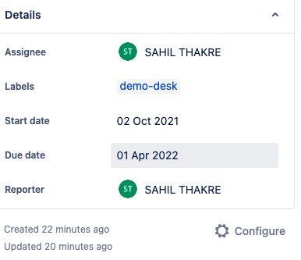

*LINKING THE ISSUE:*

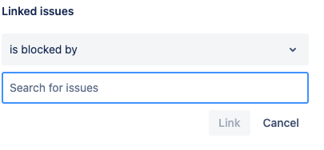

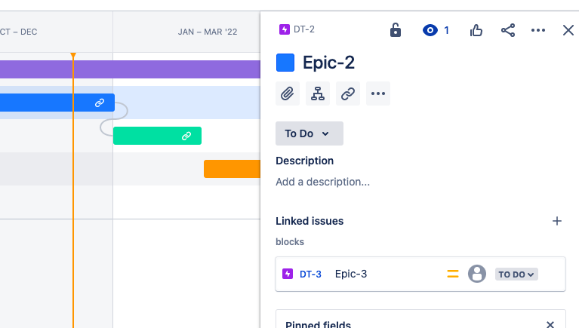

*Backlogs Pane:*

*Backlogs display all the issues that are not assigned to sprint currently.*

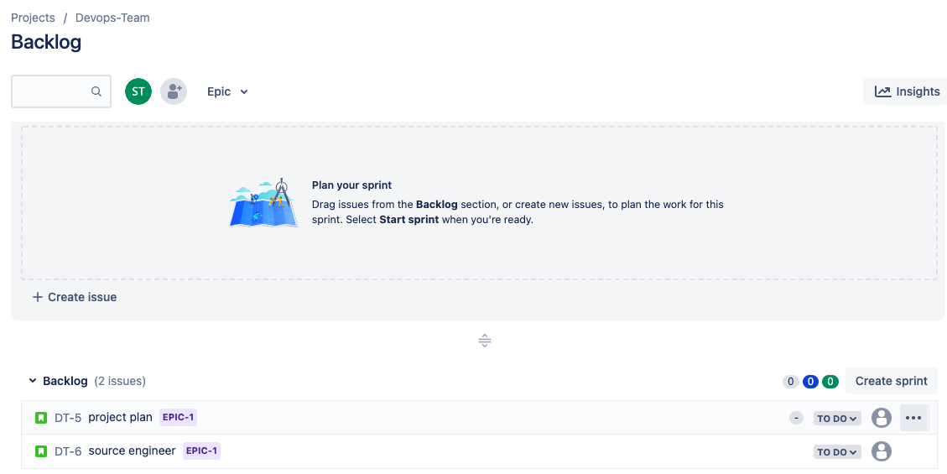

*And Boards will show us all the epics we have to do in the next sprint interval typically two weeks.*

*Adding issues directly inside backlog and assigning the parent:*

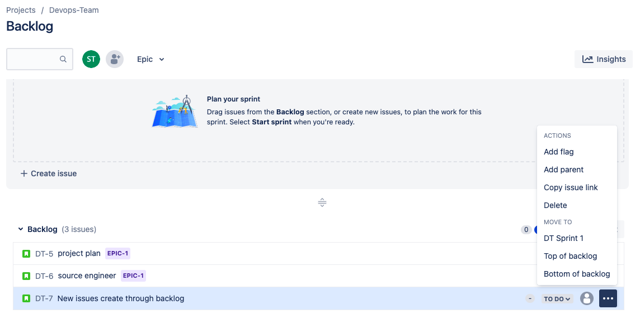

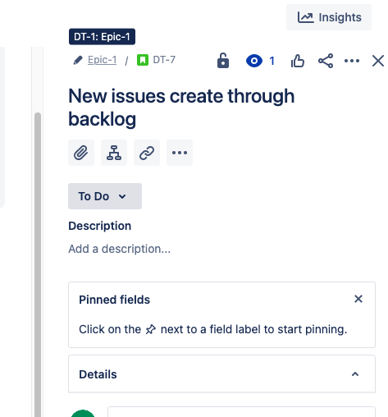

*Creating a sprint in backlog:*

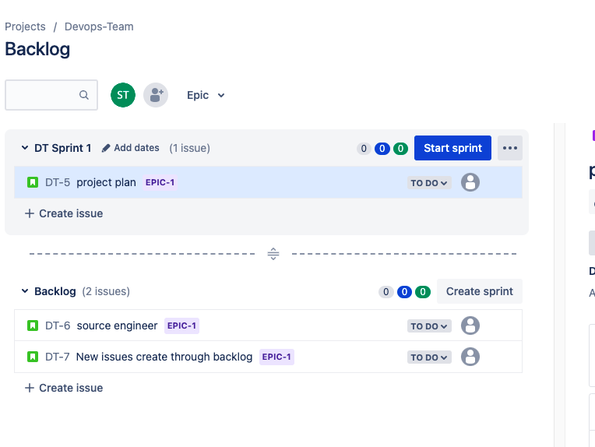

*Click on start sprint:*

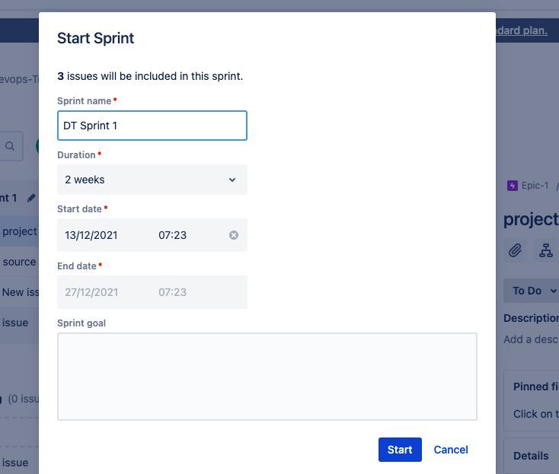

*Boards:*

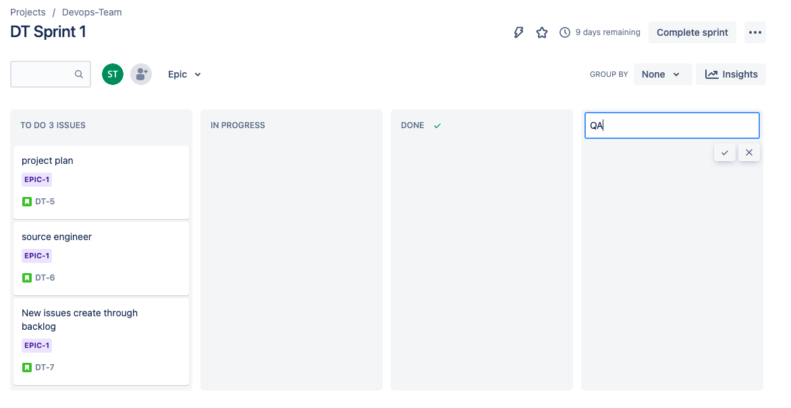

*CHANGING THE PROGRESS STATUS:*

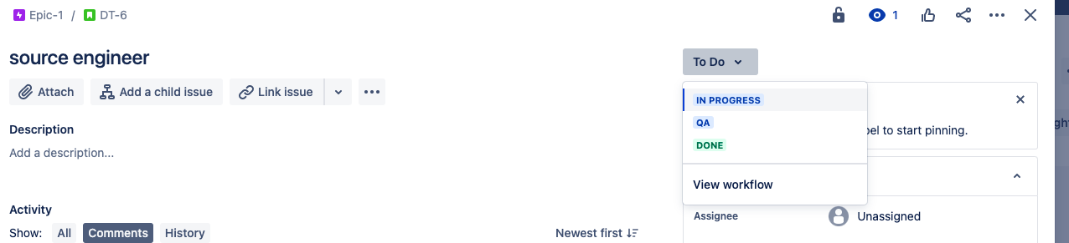

*GROUP BY :*

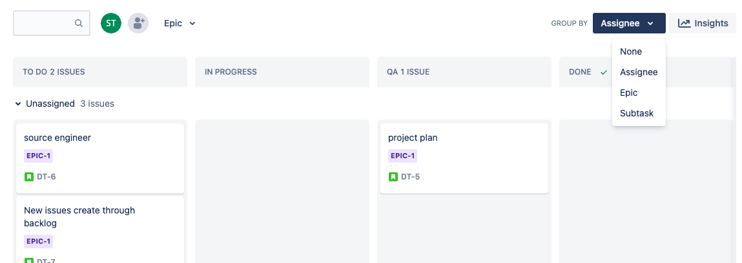

*ADDING BOARD TO THE LANDING PAGE/ DEFAULTS: (STAR)*

**

*CLICK ON THREE DOTS( EXTRA OPTION ON RIGHT) TO EDIT THE WORKFLOW:*

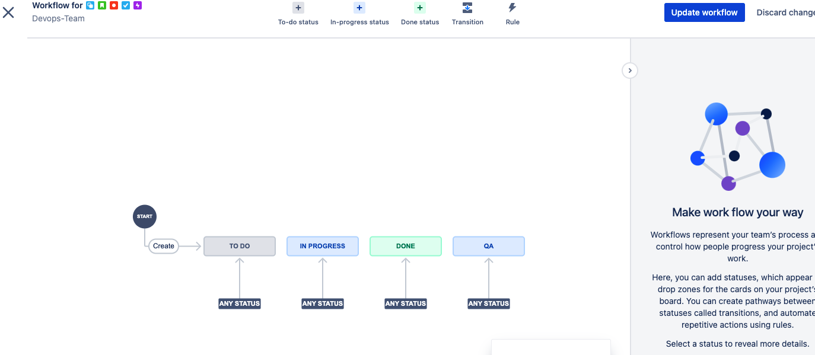

*EDITING WORKFLOW;*

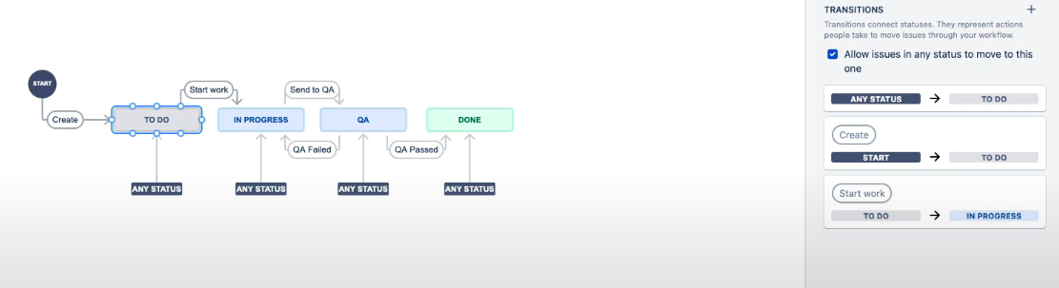

*Uncheck the box in right and try to move epics to different stages, it won't be possible now.*

*Assigning the issue In workflow:*

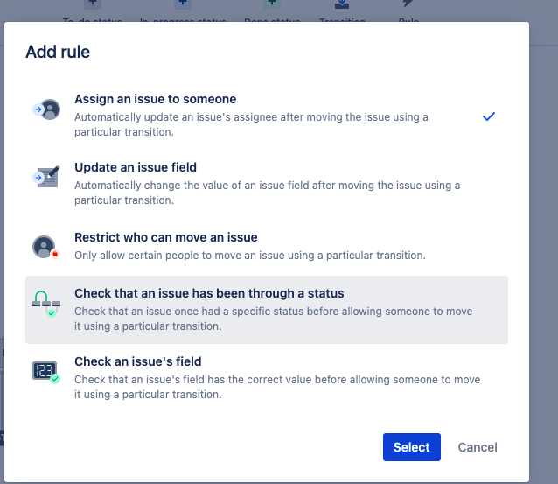

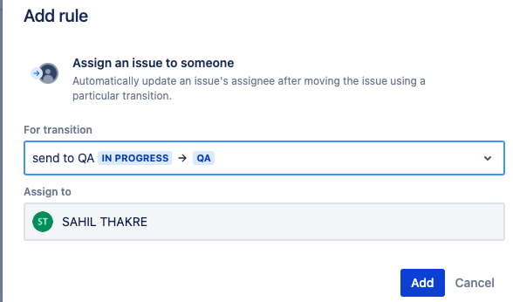

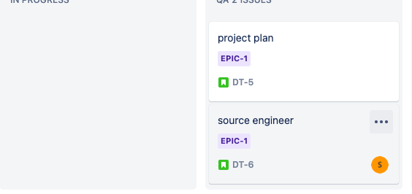

*Modifying the epics with issue type:*

*Project Settings ⇒ Issue type ⇒*

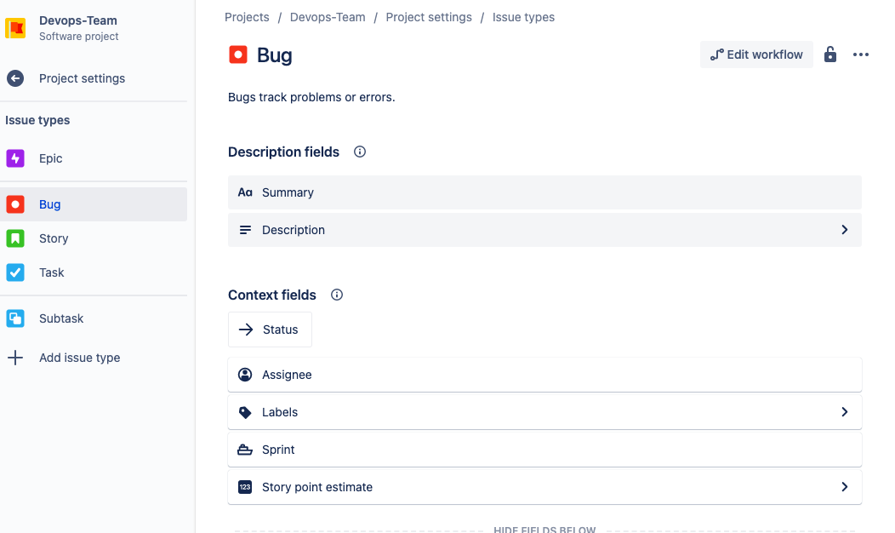

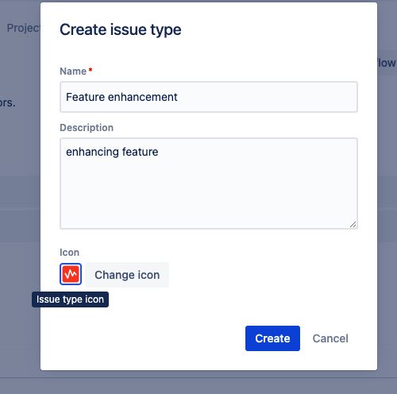

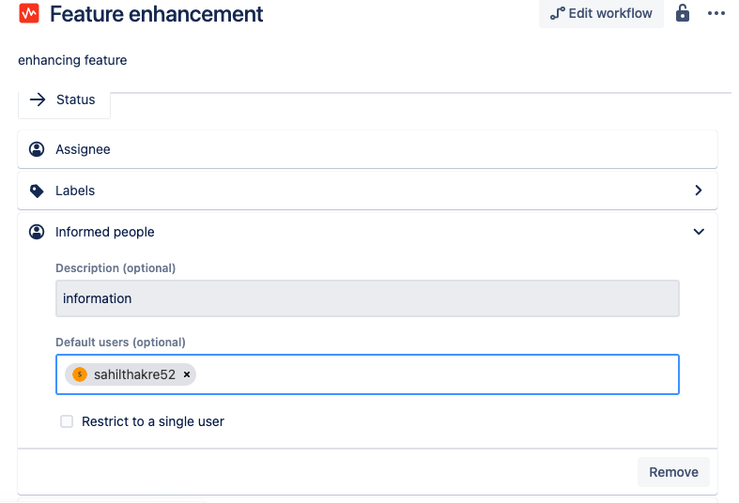

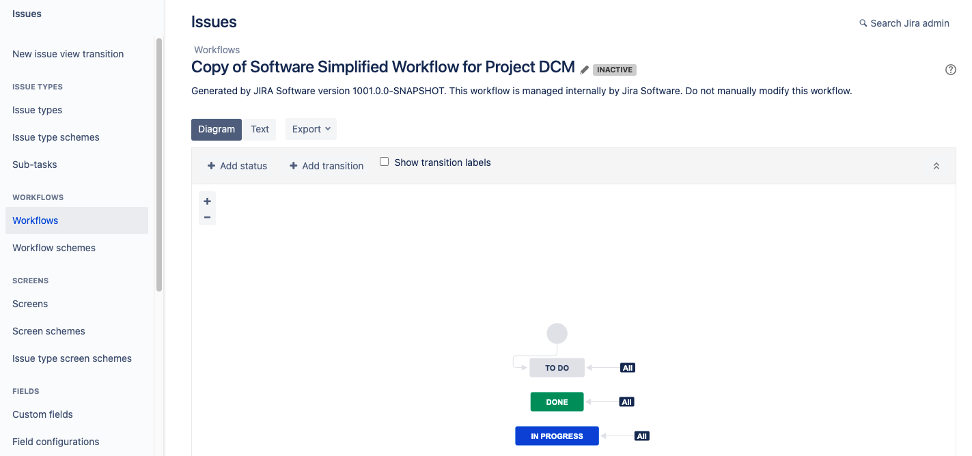

**

*In company Managed:*

1. *Goto Project Settings to make changes to the workflow. ⇒ Click on setting on top right section ⇒ choose issues ⇒ switch to workflow.*
2. *Select and search for workflow templates.*
3. *Select the workflow “name matching to project”*
4. *Edit the workflow as done previously.*
5. *Go to workflow schemes ⇒ edit ⇒ add workflow.*
6. *Choose your workflow.*
7. *Publish it.*
8. *Go to project again.*
9. *Active sprints ⇒ board settings*
10. *Add a new column as QA and map the status.*
11. *Create the sprint.*