**IELTS Task 2 Scoring Review**

**How the IELTS Writing Test is Scored**

Several people have asked me to explain how the examiner determines the Writing Test score. This page should answer that question. However, the grading for the Writing Test has changed a little since I was an examiner so some things on this page are just my estimation of how the examiners grade the writing today. The two official "Writing Band Descriptors" shown below are from 2005 and I believe these haven't changed since then, but the "Score Sheet" is my guess at what happens now.

--------------------------------------------------------------------------------------------------------------------------------------------------------------------

* First, the examiners gives a separate grade for each of Task 1 and Task 2, using the "Band Descriptors" that are shown below.
* They calculate the score for each Task by getting the average score of the following four items:

1) Task Achievement (for Task 1) or Task Response (for Task 2)

2) Coherence & Cohesion

3) Lexical Resource (= vocabulary) and,

4) Grammatical Range and Accuracy.

I am guessing that if the average score is a ".25" or a ".75" number, the examiner then goes ***down*** to the nearest ".0" or ".5" number.

For example:

|  |  |
| --- | --- |
| Task Achievement | 7 |
| Coherence & Cohesion | 6 |
| Vocabulary | 6 |
| Grammar | 6 |

Average = 6.25 => 6.0

|  |  |
| --- | --- |
| Task Achievement | 6 |
| Coherence & Cohesion | 7 |
| Vocabulary | 7 |
| Grammar | 7 |

Average = 6.75 => 6.5

* Then the examiners use a "Score Sheet" that blends the score for the Task 1 with the score for the Task 2 to give a final Writing Test score. On this score sheet, the Task 2 score is given more weighting than the Task 1 score.

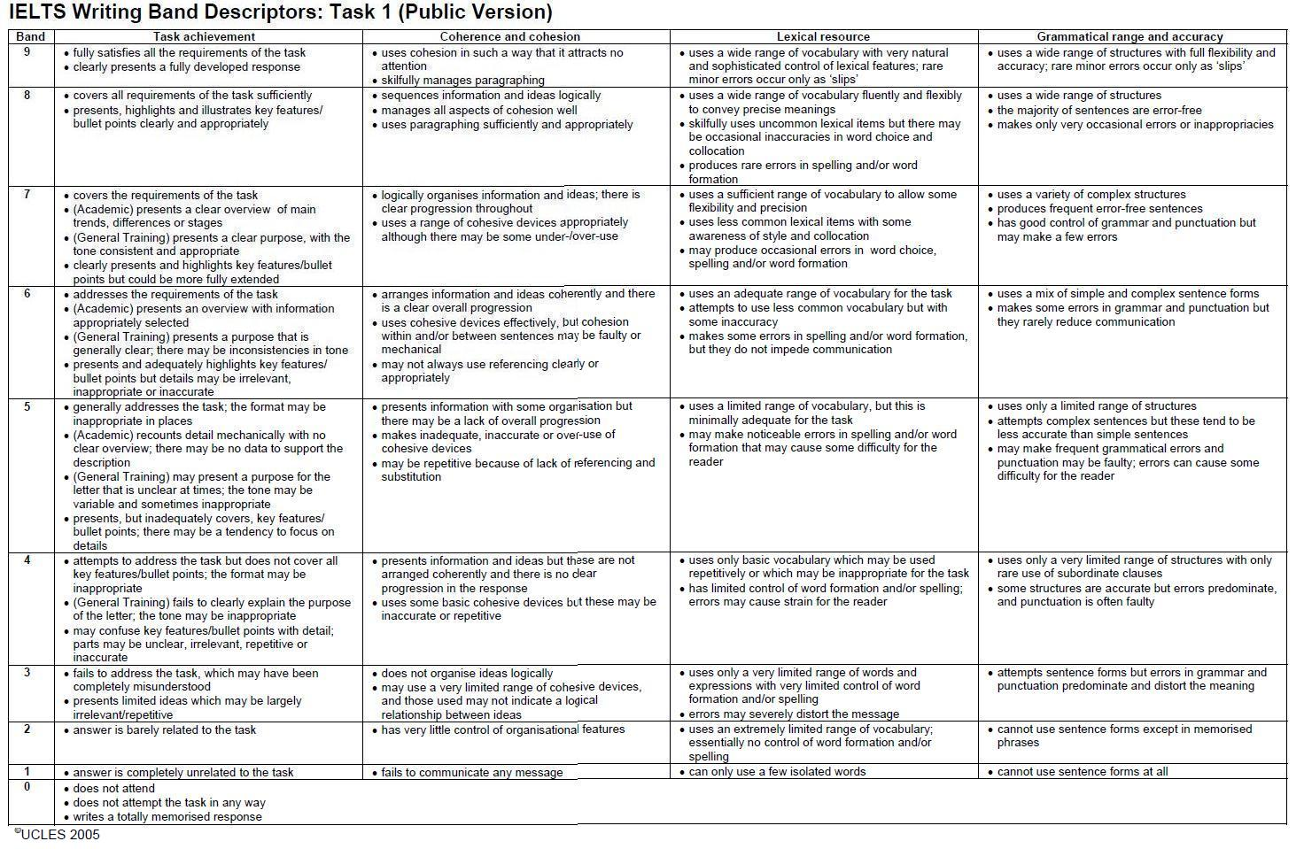

(A copy of the Task 1 Band Descriptors can be downloaded here:  [ielts-yasi.englishlab.net/TASK_1_WRITING_GRADING_CRITERIA.JPG](http://ielts-yasi.englishlab.net/TASK_1_WRITING_GRADING_CRITERIA.JPG))

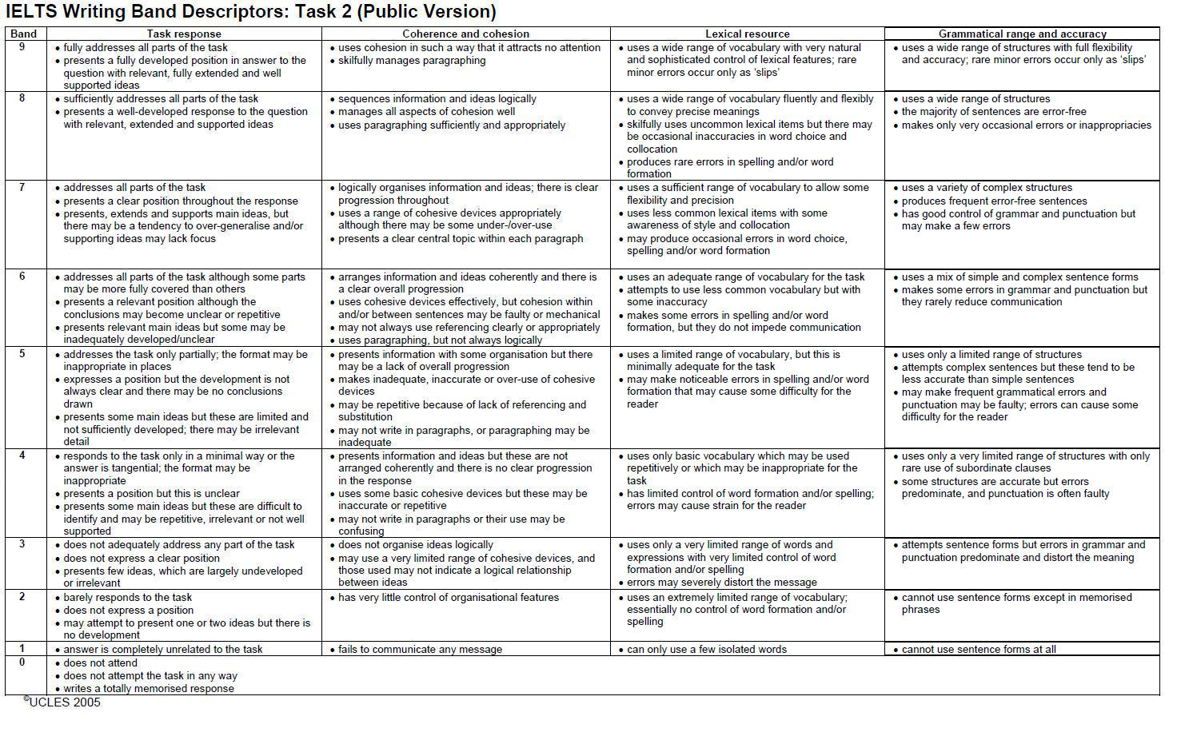(A copy of the Task 2 Band Descriptors can be downloaded here:  [ielts-yasi.englishlab.net/TASK_2_WRITING_GRADING_CRITERIA.JPG](http://ielts-yasi.englishlab.net/TASK_2_WRITING_GRADING_CRITERIA.JPG))

**The Writing Test Score Sheet**

(Note that this is just ***my estimation*** of what the current score sheet looks like. I might be wrong in some places but I think this score sheet should be close to the real thing.)

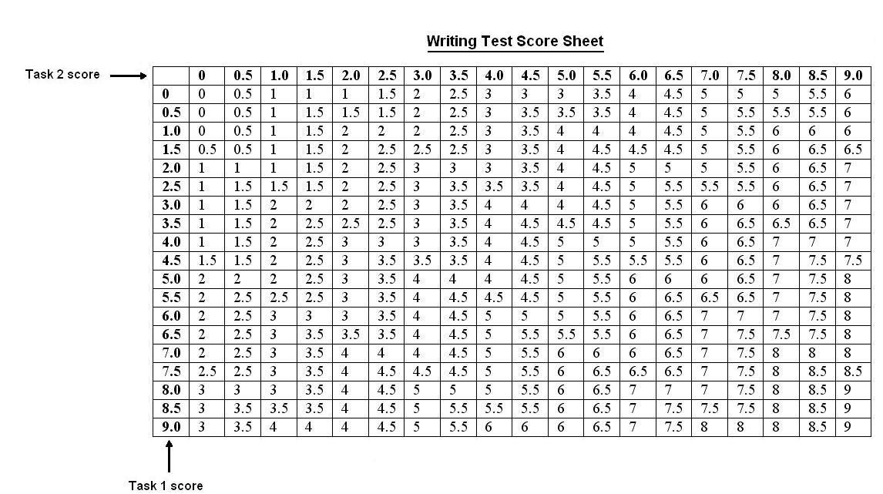

Example: A Task 1 score of **6.5** combined with a Task 2 score of **5.0** gives a final score for the Writing Test of **5.5**

**What do "Coherence" and "Cohesion" Mean?**

The two words, "coherence" and "cohesion" mean different things but the two ideas are connected and, in fact, overlap. "Coherence" in an essay (or when you are speaking about interconnected idea in the Speaking test) means the overall "understandability" of what you write or say. When writing an essay, coherence involves such features as: summarizing the overall argument of an essay in the introductory paragraph; presenting ideas in a logical sequence; putting separate, major points into separate paragraphs; and beginning each paragraph with a 'topic sentence', following by supporting sentences. Coherence is based more on the logic of the ideas and how they are presented rather than on the language that is used to express these ideas.

"Cohesion" refers to the degree to which sentences (or even different parts of one sentence) are connected so that the flow of ideas is easy to follow. To achieve good cohesion, you need to know how to use "cohesive devices", which are certain words or phrases that serve the purpose of connecting two statements, usually by referring back to what you have previously written or said. For example, if you write "Statement A" and then follow with the words, "On the other hand, Statement B", then these two sentences "cohere" or "stick together" and it is easy to follow the flow of ideas. Good cohesion leads to good coherence, which is the ultimate aim.

Here's an example of how coherence and cohesion overlap. If you have a major new point to add to your essay then you should put that in a paragraph by itself and begin the paragraph with a topic sentence that more or less summarizes the point you want to make. This topic sentence, following by supporting sentences, make your paragraph more coherent. However, your essay will be less coherent if you suddenly start a paragraph without some form of connection to what you have previously written, either in the previous paragraph or some other previous part of your essay. This problem can be overcome by beginning that topic sentence with words such as, "On the other hand", which connect to the last statement made in the previous paragraph. This shows good cohesion.

For both Task 1 and Task 2 of the Writing test, "Coherence and Cohesion" is one of the four items that is given a sub-score. The other three items are: ‘Task Response’ (or, ‘Task Achievement’ for Task 1), ‘Lexical Resource’ ( = vocabulary) and ‘Grammatical Range and Accuracy’.