Task 1 with Examiners Comments

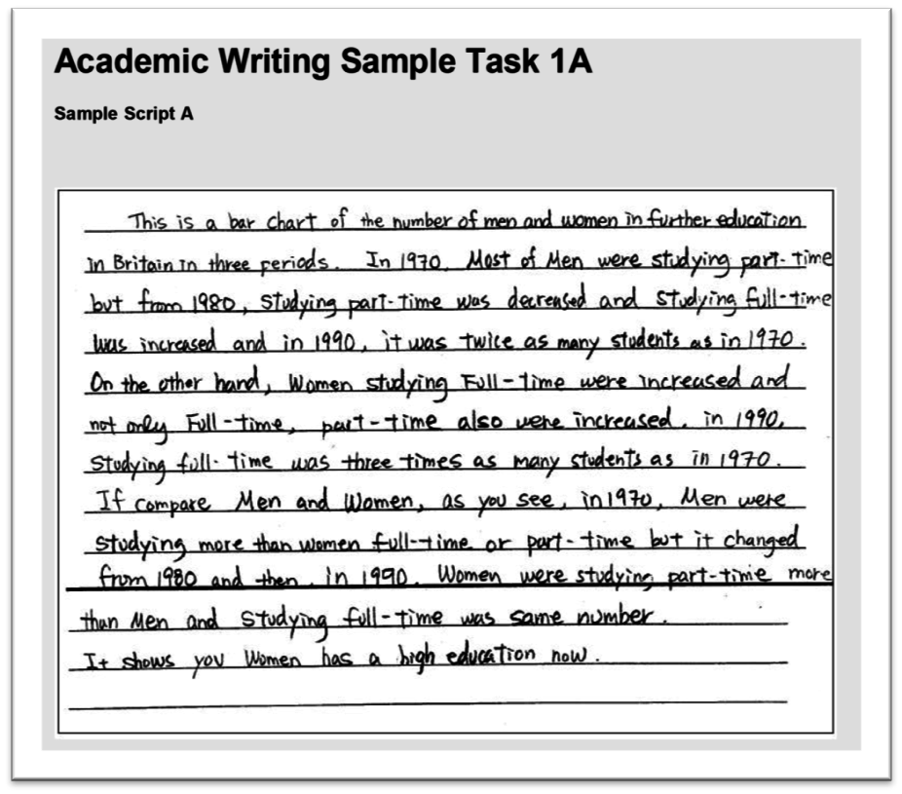

**Examiner comments**

The writer has made a good effort to answer the question and describe the main points in the charts. The statements are generally accurate but not full enough to give all the key points. There is a brief introductory sentence which could be further expanded. The writer does not use the figures from the charts to support the statements. This means that some important details are missing.

The candidate’s response to the question is not long enough. For Task 1 candidates must write at least 150 words but this answer is below that number. The writing is presented in a satisfactory format. Full sentences are used. The points made in the answer are relevant to the question but could be developed. The candidate does not complete the requirements of the task because there is no clear overview. The final sentence only refers to female students and therefore does not provide a full summary of the information.

The writing is quite difficult for the reader to follow. The writer attempts to describe the main differences between male and female students in education. However, the information is not always presented in a clear way. For example, in the second sentence the writer moves from male students studying part-time in 1970; part-time and full-time in 1980; and studying full-time in 1990 and 1970. The sentence is not easy to read as the points are arranged in a confusing way. The writer uses the linking phrase ’on the other hand’ correctly. However, more linking words and phrases could be used in the answer.

The writer uses a limited range of vocabulary to present the information. Many words and phrases which the writer uses have already been given in the task and these are repeated in the answer. There is some use of words to describe trends such as ‘increase’ and ‘decrease’. In addition, the writer uses the language of comparison, for example ‘compare’ and ‘twice as many’. However, the writer’s use of such words and phrases is limited.

The writer shows some awareness of sentence structure. However, there are frequent grammatical errors throughout the answer. These include problems of word order: ‘men were studying more than women full-time or part-time’; and problems with subject verb agreement: ‘women has’ instead of ‘women have’. The word ‘it’ is often misused and can lead to difficulties in understanding the message. Although the writer uses long sentences, the ideas are linked by words such as ‘but’ and ‘and’ rather than by relative pronouns such as ‘who’ and ‘which’. Present, and past tenses are generally used accurately. The writer has some knowledge of the passive voice but this is used incorrectly with the verbs ‘increase’ and ‘decrease’. In addition there are some punctuation mistakes.

In conclusion, this answer does not fully address the task. Some key points are missing, and the overall conclusion is not clear.

**Overall band score: 5**