**Weak and Strong Topic Sentences**

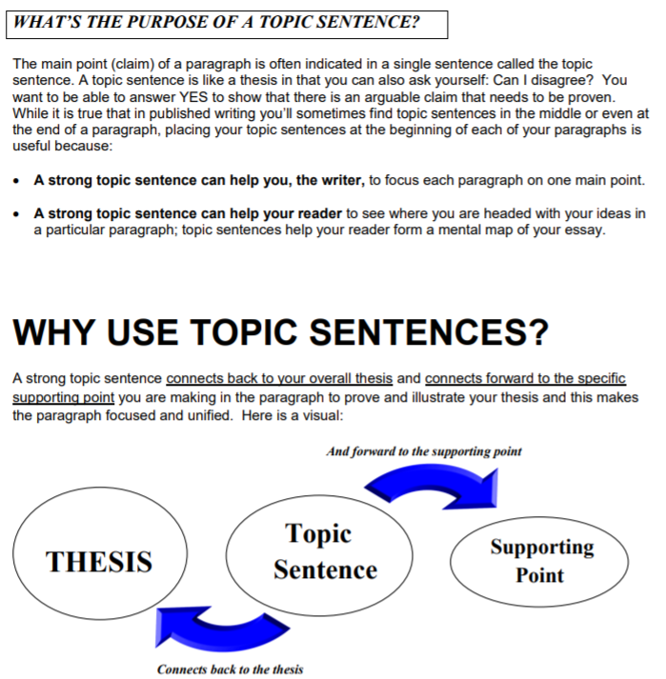

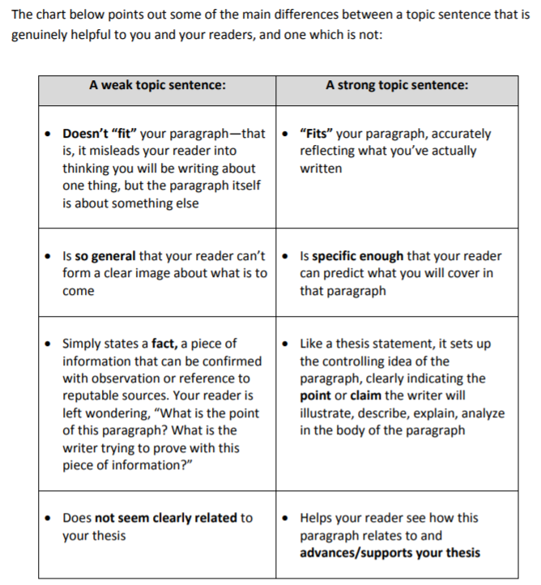

SOME GUIDELINES FOR WRITING STRONG TOPIC SENTENCES:

1. A topic sentence must predict or promise what follows, so it cannot be a question. To orient the reader, you may use a question as the first sentence, with the topic sentence as the answer to that question.

Weak: Should schools provide free computers for their students?

Strong: Schools must provide free computers for their students to prepare them for their future careers.

1. Phrases such as “I think” or “in my opinion” may muddle or weaken topic sentences. Your writing is always your opinion, so you don’t need these phrases unless they are central to the idea that you are trying to convey.

Weak: I think that it is important for every woman to carry pepper spray.

Strong: As violent criminals take over the city streets, women must carry pepper spray to protect themselves.

1. The topic sentence should provide clear relationships among all of its elements so that it can provide a framework for understanding the rest of the paragraph.

Weak: Historians record only dry statistics; we should read novels.

Strong: Accurate historical novels give us a deeper understanding of the past than do the dry collections of facts and statistics that pass for history texts.

1. A topic sentence needs to be clear and specific, so that it can predict and summarize the rest of the paragraph for the reader.

Weak: Public transit is terrible.

Strong: Incapable of providing reliable service, the San Francisco Municipal Transit System is failing its ridership.

1. **A topic sentence must be coherent so that the reader can use it as a key to the rest of the paragraph.**

*Weak:*   The differences of their socioeconomic classes, indeed, were not more potent than the already inherent differences among the population.

*Better:*   Bosnia is split apart not by any economic class differences, but by racial and ethnic conflicts.

1. **A topic sentence provides an accurate indication of what will follow in the rest of the paragraph.**

*Weak example:* First, we need a better way to educate students.

*Explanation:* The claim is vague because it does not provide enough information about what will follow, and it is too broad to be covered effectively in one paragraph or short unit of support.

*Stronger example:* Creating a national set of standards for math and English education will improve student learning in many states.

*Explanation:* The sentence replaces the vague phrase “a better way” and leads readers to expect supporting facts and examples as to why standardizing education in these subjects might improve student learning in many states.

1. **A good topic sentence is the most general sentence in the paragraph and thus does not include supporting details.**

*Weak example:* Salaries should be capped in baseball for many reasons, most importantly so we don’t allow the same team to win year after year.

Explanation: This topic sentence includes a supporting detail that should be included later in the paragraph to back up the main point.

*Stronger example:* Introducing a salary cap would improve the game of baseball for many reasons.

*Explanation:* This topic sentence omits the additional supporting detail so that it can be expanded upon later in the paragraph, yet the sentence still makes a claim about salary caps – improvement of the game.

1. **A good topic sentence is clear and easy to follow.**

*Weak example:* In general, writing an essay, thesis, or other academic or nonacademic document is considerably easier and of much higher quality if you first construct an outline, of which there are many different types.

*Explanation:* The confusing sentence structure and unnecessary vocabulary bury the main idea, making it difficult for the reader to follow the topic sentence.

*Stronger example:* Most forms of writing can be improved by first creating an outline.

*Explanation:* This topic sentence cuts out unnecessary verbiage and simplifies the previous statement, making it easier for the reader to follow. The writer can include examples of what kinds of writing can benefit from outlining in the supporting sentences.