**SmartTrack: Real-Time Railway Fault Detection & Localization**

**Introduction**

Railway safety is a critical concern globally, with track defects often leading to catastrophic accidents. The **SmartTrack** system leverages **Artificial Intelligence (AI)** and **image processing** to detect and localize railway track faults in real time. By employing **machine learning (ML) and deep learning (DL) techniques**, SmartTrack enhances railway safety, reduces maintenance costs, and provides timely alerts to railway authorities.

**Features**

* **Automated Railway Track Inspection**
* **High-Resolution Image Processing for Fault Detection**
* **Real-Time Alerts to Railway Authorities**
* **Scalable & Cost-Effective Solution for Global Railway Networks**

**Dataset**

The dataset comprises railway track images collected from:

* **Public & Private Datasets**: Labeled conditions of railway tracks.
* **Drone & CCTV Footage**: Captured real-time images.
* **Manual Uploads**: Allows operators to input track images for analysis.

The dataset includes both **normal and faulty tracks** with conditions such as cracks, debris, and misalignment. Data augmentation techniques (rotation, flipping, zooming, and contrast enhancement) improve the dataset diversity.

**Methodology**

**1. Image Acquisition & Preprocessing**

* Images are resized to **224x224 pixels** for CNN-based models.
* **Grayscale Conversion** reduces unnecessary color details.
* **Noise Reduction** (Gaussian Blur, Median Filtering) for clarity.
* **Canny Edge Detection** highlights track defects.
* **Contrast Enhancement** improves defect visibility.
* **Image Normalization** scales pixel values between **0 and 1**.

**2. Feature Extraction**

* **Texture-based Features** (GLCM, LBP) for identifying surface properties.
* **Shape-based Features** for detecting cracks, edges, and contours.
* **Deep Feature Extraction** using **CNN architectures** (ResNet, MobileNet).

**3. Model Training & Classification**

**Machine Learning Approaches**

* **Support Vector Machines (SVM)** for feature-based classification.
* **Random Forest** for ensemble-based decision making.
* **Artificial Neural Networks (ANNs)** for lightweight prediction models.

**Deep Learning Approaches**

* **CNNs (ResNet, MobileNet, VGG)** for automated feature extraction.
* **YOLO (You Only Look Once)** for real-time fault detection.
* **Transfer Learning** (ResNet50, VGG16) for improved accuracy.

**4. Real-Time Fault Detection & Alerts**

* The trained model analyzes track images and classifies them as **faulty or non-faulty**.
* If a fault is detected, an **alert is generated** with **fault location, images, and details**.
* Alerts are sent to railway authorities for **immediate remedial actions**.

**Execution Steps**

1. **Install Dependencies**:
2. pip install tensorflow opencv-python torch torchvision numpy
3. **Train the Model**:
4. python train_model.py
5. **Deploy the Application**:
6. docker-compose up
7. **Upload Railway Track Images** for fault detection.
8. **View Results on Web Interface** with fault classifications and confidence scores.

**Results**

* The **EfficientNet-B0 model** achieved **98.11% validation accuracy**.
* Low false positive and negative rates ensure **high reliability**.
* Training time reduced using **Automatic Mixed Precision (AMP)**.
* Model performance tracked using **accuracy curves, confusion matrix, and classification reports**.

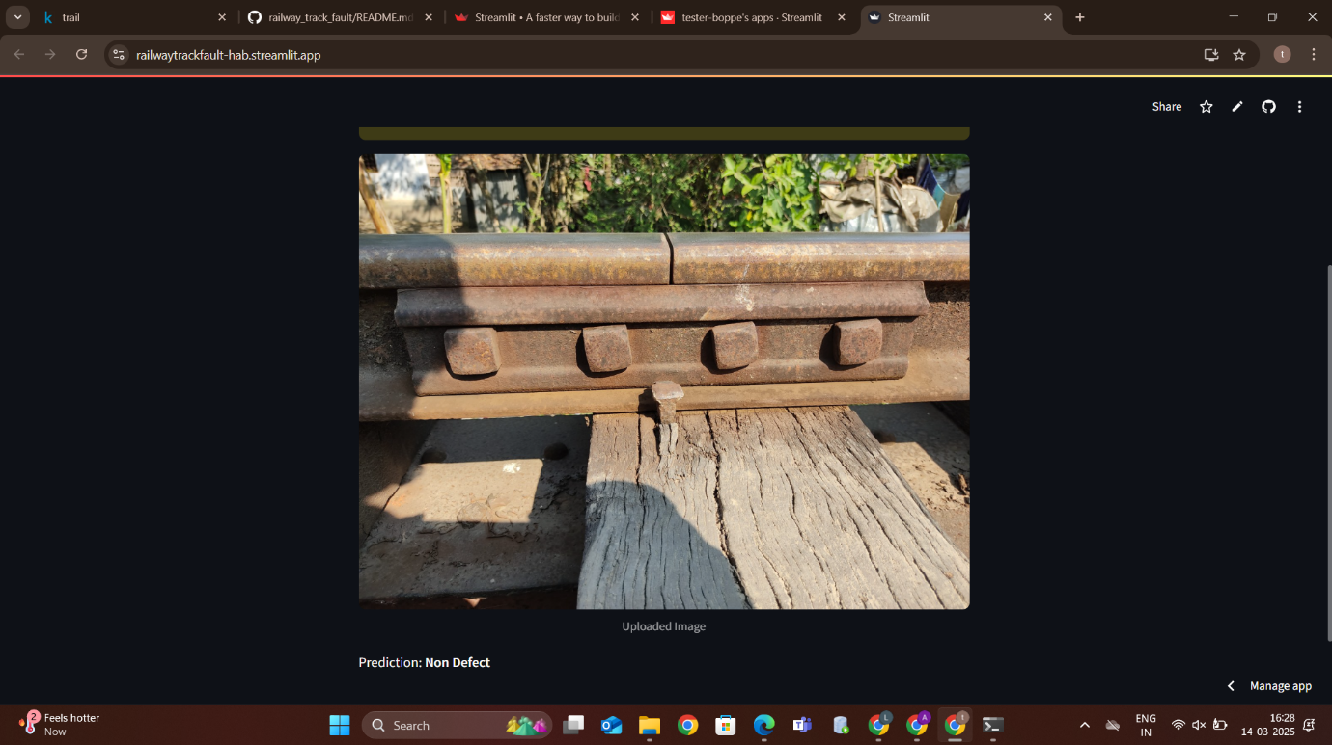

**Conclusion**

SmartTrack presents a **fast, efficient, and scalable** railway fault detection system, leveraging deep learning for accurate and real-time defect identification. By integrating **AI-driven automation**, the project aims to enhance railway safety, minimize track maintenance costs, and prevent railway disasters.

**Contributors**

* **Garapati Durga Prasad** - Shri Vishnu Engineering College for Women
* **Gidla Praneetha Neha** - Shri Vishnu Engineering College for Women
* **Boppe Lakshmi Venkata Lasya Priya** - Shri Vishnu Engineering College for Women
* **Pathipati Lavanya** - Shri Vishnu Engineering College for Women
* **Samyuktha Boddapu** - Shri Vishnu Engineering College for Women

**License**

This project is licensed under the **MIT License**.

**Contact**

For queries, reach out to [**bdurgaprasad_garapati@svecw.ed.in**](mailto:bdurgaprasad_garapati@svecw.ed.in).