# Online shop emulation

User can visit our console shop, view the list of products with prices, view product details, buy a product if it is available.

### Main page

User sees welcome screen and main menu. Menu consists of four points:

* Product list
* Manufacturer list
* Account details
* Exit

User enters a number and proceed to selected page. If number is incorrect, then user is returned to the menu.

### Manufacturer list

User sees a list of manufacturers.

Each row contains manufacturer name, origin country and products count.

List is numbered, so user can choose some manufacturer and view details or press zero to get back to the main menu.

### Product list

User sees a list of products.

Each row contains product name, manufacturer and price.

List is numbered, so user can choose some product and view details or press zero to get back to the main menu.

### Product details

User sees information about some particular product: name, manufacturer, price and description. User sees product details menu:

* Buy product
* View manufacturer details
* Return to the list of products
* Return to the main menu

### Manufacturer details

User sees information about some particular manufacturer: name, origin country, description, and products count. User sees manufacturer details menu:

* Return to the list of manufacturers
* Return to the main menu

### Buy menu

User sees confirmation message ‘Are you sure you want to buy <product name>?’. User can confirm or get back to the product details.

If user confirms, then validation should be performed. If it is ok, product count is decreased and money balance is changed. Product name is added to purchased products list.

### Account details

User sees current balance and list of bought product names.

User can return to main menu.

## Diagrams

### Package structure

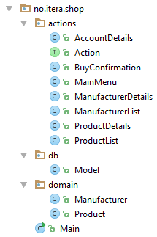

### Actions

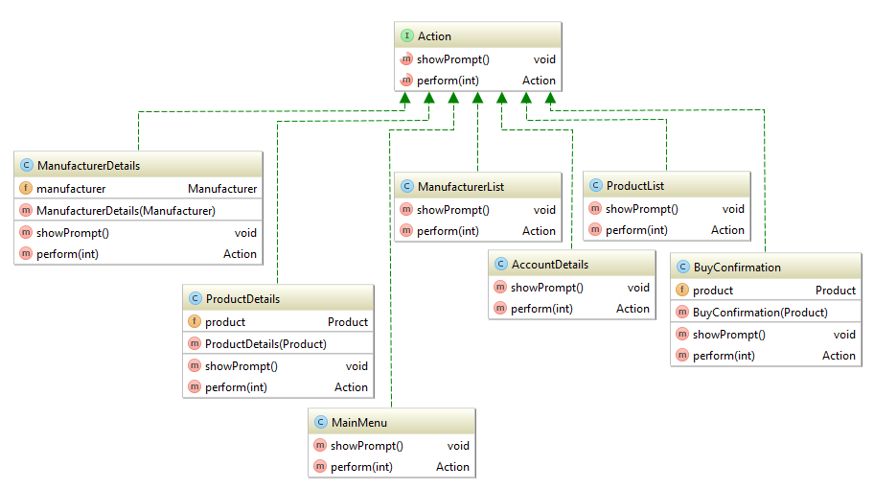

### Domain

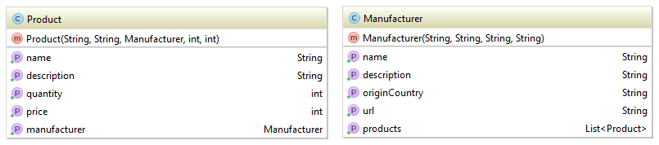

### Model

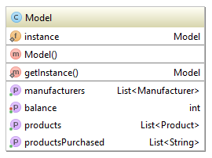

## Code snippets

### Read input from console

Scanner scanner = **new** Scanner(System.***in***);

Integer choice = scanner.nextInt();

### Singleton implementation

**private** Model() {}

**private static** Model *instance* = **new** Model();

**public static** Model getInstance() {

**return** *instance*;

}

## Additional requirements

* Get start balance as a console argument.
* Add page with products for particular manufacturer.
* Create wizard for adding new products.

## Model data

**manufacturers** = **new** ArrayList<>();

Manufacturer apple = **new** Manufacturer(**"Apple"**, **"Apple Inc. is an American multinational technology company headquartered in Cupertino, California, that designs, develops, and sells consumer electronics, computer software, and online services. Its hardware products include the iPhone smartphone, the iPad tablet computer, the Mac personal computer, the iPod portable media player, the Apple Watch smartwatch, and the Apple TV digital media player. Apple's consumer software includes the macOS and iOS operating systems, the iTunes media player, the Safari web browser, and the iLife and iWork creativity and productivity suites. Its online services include the iTunes Store, the iOS App Store and Mac App Store, and iCloud."**, **"USA"**, **"http://apple.com"**);

**manufacturers**.add(apple);

Manufacturer microsoft = **new** Manufacturer(**"Microsoft"**, **"Microsoft Corporation is an American multinational technology company headquartered in Redmond, Washington, that develops, manufactures, licenses, supports and sells computer software, consumer electronics and personal computers and services. Its best known software products are the Microsoft Windows line of operating systems, Microsoft Office office suite, and Internet Explorer and Edge web browsers. Its flagship hardware products are the Xbox video game consoles and the Microsoft Surface tablet lineup. As of 2011, it was the world's largest software maker by revenue, and one of the world's most valuable companies."**, **"USA"**, **"https://princeton.edu"**);

**manufacturers**.add(microsoft);

Manufacturer lenovo = **new** Manufacturer(**"Lenovo"**, **"Lenovo Group Ltd. is a Chinese multinational technology company with headquarters in Beijing, China, and Morrisville, North Carolina, United States. It designs, develops, manufactures and sells personal computers, tablet computers, smartphones, workstations, servers, electronic storage devices, IT management software, and smart televisions. In 2015, Lenovo was the world's largest personal computer vendor by unit sales. It markets the ThinkPad line of notebook computers, IdeaPad line of notebook laptops, IdeaCentre line of desktops, Yoga line of notebook laptops, and the ThinkCentre line of desktops."**, **"China"**, **"http://www.lenovo.com/"**);

**manufacturers**.add(lenovo);

Manufacturer samsung = **new** Manufacturer(**"Samsung"**, **"Samsung is a South Korean multinational conglomerate company headquartered in Samsung Town, Seoul. It comprises numerous subsidiaries and affiliated businesses, most of them united under the Samsung brand, and is the largest South Korean chaebol (business conglomerate)."**, **"South Korea"**, **"http://samsung.com"**);

**manufacturers**.add(samsung);

Manufacturer sony = **new** Manufacturer(**"Sony"**, **"Sony Corporation is a Japanese multinational conglomerate corporation headquartered in Kōnan, Minato, Tokyo, Japan. Its diversified business includes consumer and professional electronics, gaming, entertainment and financial services. The company is one of the leading manufacturers of electronic products for the consumer and professional markets. Sony is ranked 116th on the 2015 list of Fortune Global 500."**, **"Japan"**, **"http://sony.net"**);

**manufacturers**.add(sony);

**products** = **new** ArrayList<>();

Product iphone = **new** Product(**"iPhone"**, **"iPhone is a line of smartphones designed and marketed by Apple Inc. They run Apple's iOS mobile operating system.[14] The first generation iPhone was released on June 29, 2007; the most recent iPhone model is the iPhone 7, which was unveiled at a special event on September 7, 2016."**, apple, 1000, 25);

Product ipad = **new** Product(**"iPad"**, **"iPad is an iOS-based line of tablet computers designed and marketed by Apple Inc. The first iPad was released on April 3, 2010; the most recent iPad models are the 9.7-inch iPad Pro released on March 31, 2016 and the iPad Mini 4, released on September 9, 2015. The user interface is built around the device's multi-touch screen, including a virtual keyboard. The iPad includes built-in Wi-Fi and cellular connectivity on select models. As of January 2015, there have been over 250 million iPads sold.[7] IPad tablets are second most popular, by sales, against Android-based ones, since 2013, when Android tablet sales increased by 127%.[18]"**, apple, 2500, 5);

apple.getProducts().add(ipad);

apple.getProducts().add(iphone);

Product surface = **new** Product(**"Microsoft Surface"**, **"Microsoft Surface is a series of Windows-based personal computing devices designed and manufactured by Microsoft under its hardware division, a part of the Windows and Devices group. It comprises hybrid tablets, 2-in-1 detachables, and interactive whiteboards."**, microsoft, 2200, 45);

Product xbox = **new** Product(**"Xbox"**, **"Xbox is a video gaming brand created and owned by Microsoft. It represents a series of video game consoles developed by Microsoft, with three consoles released in the sixth, seventh, and eighth generations respectively. The brand also represents applications (games), streaming services, and an online service by the name of Xbox Live. The brand was first introduced on November 15, 2001 in the United States, with the launch of the original Xbox console."**, microsoft, 800, 125);

Product lumia = **new** Product(**"Microsoft Lumia"**, **"Microsoft Lumia (previously the Nokia Lumia Series) is a range of mobile devices designed and marketed by Microsoft Mobile and previously by Nokia. Introduced in November 2011, the line was the result of a long-term partnership between Nokia and Microsoft—as such, all Lumia smartphones run the Windows Phone operating system. The Lumia name is derived from the partitive plural form of the Finnish word lumi, meaning \"snow\".[1][2]"**, microsoft, 600, 56);

microsoft.getProducts().add(surface);

microsoft.getProducts().add(xbox);

microsoft.getProducts().add(lumia);

Product yoga = **new** Product(**"Lenovo Yoga"**, **"Lenovo Yoga is a range of laptop and tablet computer products from Lenovo, named for their ability to assume multiple form factors due to a hinged screen."**, lenovo, 450, 220);

lenovo.getProducts().add(yoga);

Product galaxy = **new** Product(**"Samsung Galaxy"**, **"Samsung Galaxy (stylized as SAMSUNG Galaxy, previously Samsung GALAXY) is a series of mobile computing devices designed, manufactured and marketed by Samsung Electronics. The product line includes the Galaxy S series of high-end smartphones, the Galaxy Tab series of tablets, the Galaxy Note series of tablets and phablets with the added functionality of a stylus, and the first version of the Galaxy Gear smartwatch, with later versions dropping the Galaxy branding."**, samsung, 300, 15);

samsung.getProducts().add(galaxy);

Product cyberShot = **new** Product(**"Cyber-shot"**, **"Cyber-shot is Sony's line of point-and-shoot digital cameras introduced in 1996. Cyber-shot model names use a DSC prefix, which is an initialism for \"Digital Still Camera\". Many Cyber-shot models feature Carl Zeiss trademarked lenses, while others use Sony, or Sony G lenses."**, sony, 200, 32);

Product playstation = **new** Product(**"PlayStation"**, **"PlayStation is a series of video game consoles created and owned by Sony Interactive Entertainment. The brand was first introduced on December 3, 1994 in Japan with the launch of the original PlayStation console.[1] It now consists of four home consoles, as well as a media center, an online service, a line of controllers, two handhelds and a phone, as well as multiple magazines."**, sony, 950, 251);

Product xperia = **new** Product(**"Xperia"**, **"Xperia is the brand name of smartphones and tablets from Sony Mobile. The name Xperia is derived from the word \"experience\"[citation needed], and was first used in the Xperia X1 tagline, \"I Xperia the best\"."**, sony, 550, 29);

sony.getProducts().add(cyberShot);

sony.getProducts().add(playstation);

sony.getProducts().add(xperia);

**products**.add(iphone);

**products**.add(ipad);

**products**.add(surface);

**products**.add(xbox);

**products**.add(lumia);

**products**.add(yoga);

**products**.add(galaxy);

**products**.add(cyberShot);

**products**.add(playstation);

**products**.add(xperia);