Road Accident Test Full Report

1. Introduction

This report presented a detailed analysis for VIC road accident based on historical data. And provided some possible solutions to reduce the accident rate in VIC.

1. Road Accident Analysis

The ACCIDENT.csv mainly provided the road accident records from 2014 to 2017. While there is a small part of data from 2006, but the data seems to be crashed because the ACCIDENT_NO do not match the year of ACCIDENTDATE of the record. And there is also a record for the year of 2036. Therefore, all the data record not in the range from 2014 to 2017 are discarded from this analysis.

* 1. General Statics

There is total 54248 accidents occurred during the 4-year period from 2014 to 2017. 129405 people are involved in the accidents and more than half people injured including 1031 lives lost in the accidents.

|  |  |  |  |  |
| --- | --- | --- | --- | --- |
| Year | Accidents | Persons | Injured | Killed |
| 2014 | 14249 | 34060 | 17700 | 248 |
| 2015 | 14417 | 34381 | 17795 | 252 |
| 2016 | 14294 | 33798 | 17744 | 290 |
| 2017 | 11288 | 27166 | 14201 | 241 |
| Total | 54248 | 129405 | 67440 | 1031 |

* 1. Analysis over Time

During 4-year period, most of the accidents were happened on 8-9 am in the morning and 3-6 pm during afternoon, which are all the peak hour during the day.

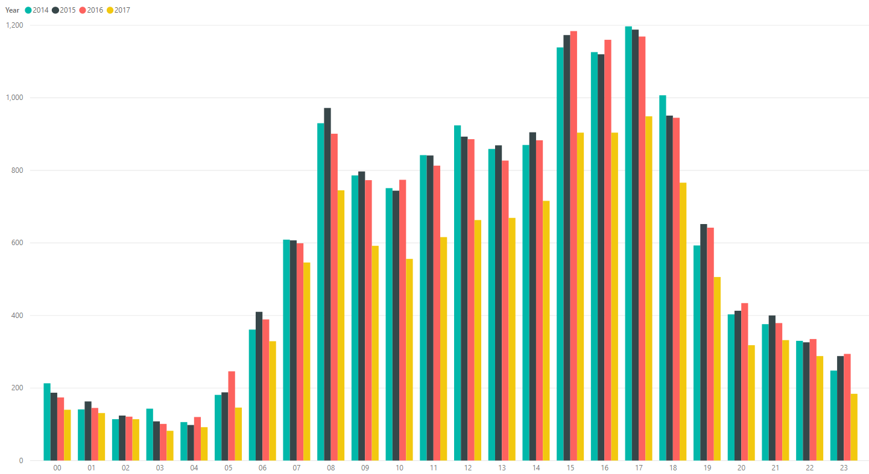

Also, if investigate a week, this pattern applies to weekdays, which is accident mostly happen on 8-9 am in the morning and 3-6 pm during afternoon. On weekends, the pattern is a little bit different. Most accidents happened from 11 am to 5 pm.

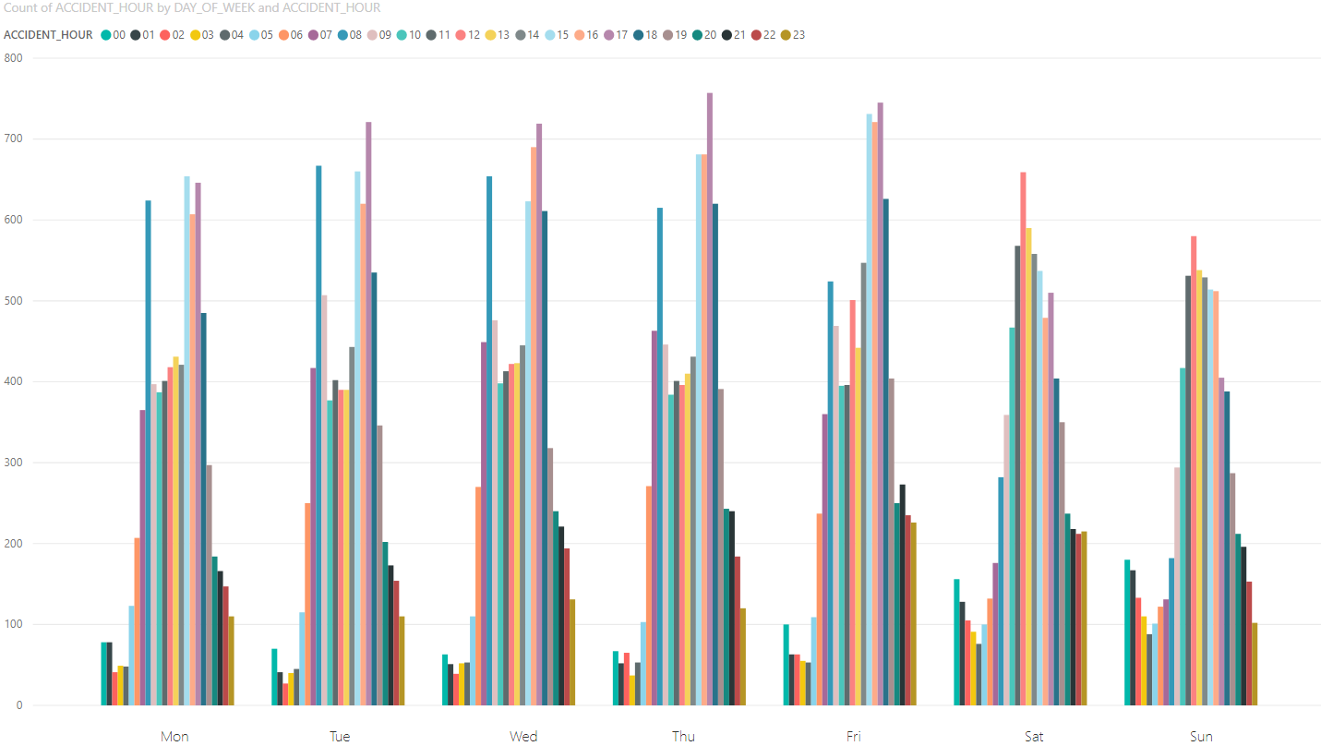

* 1. Analysis over Location

In combine with locations, it shows 8 of top 10 most accident happened place is in the Melbourne CBD area. All the locations are happened to the traffic interaction. And 6 of the 8 most common accident happening places are in the Free Tram Zone, and just on the city cycle.

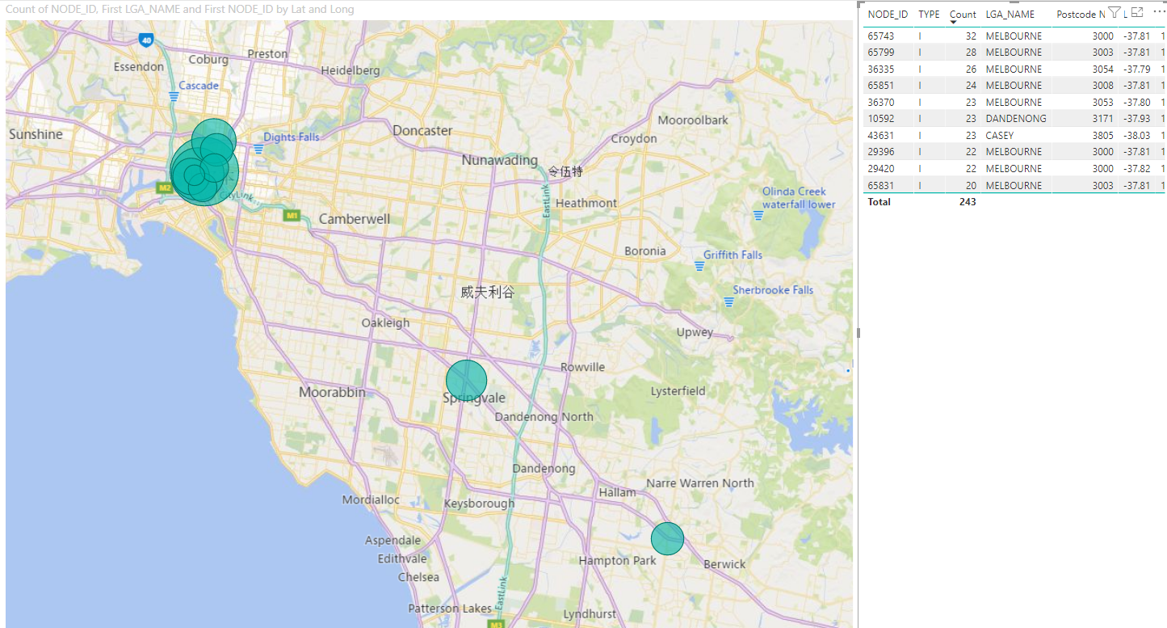

* 1. Analysis over Light condition

It seems the light condition does not infect that much as over 3 quarters of accidents are happened with good light condition.

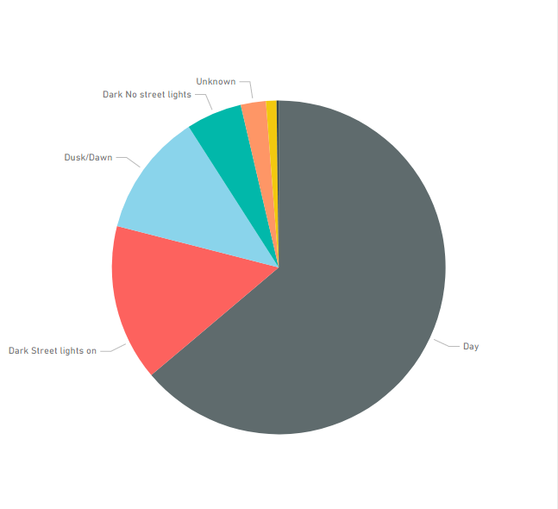

* 1. Analysis over collision type

The results show that most accidents are happened between cars, that is also why the peak hours has most accidents happened.

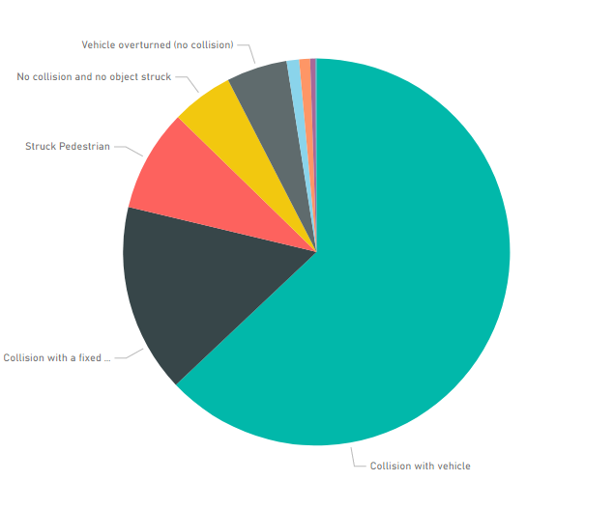

1. Conclusion and Suggestion

Based on the analysis of the data set. It is found that most accidents happened at the peak hour at the crowded places.

Therefore, the following suggestions are provided to be considered to reduce the accidents.

1. Suggesting companies provides flexible working hours that people can go to work at different time range or offering more remote work, which can reduce the load of traffic.
2. Improving the traffic rules, setting up more roadside signs, and proving more strict training to drivers which helps them to drive safely with trams. Especially for interstate drivers who are not familiar with the rules such as hook turns that only applies in Melbourne.