Setup of git:

Google->git

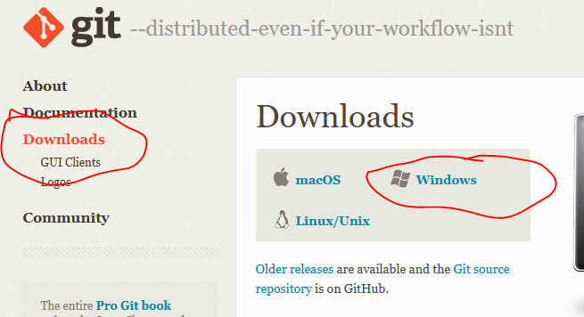

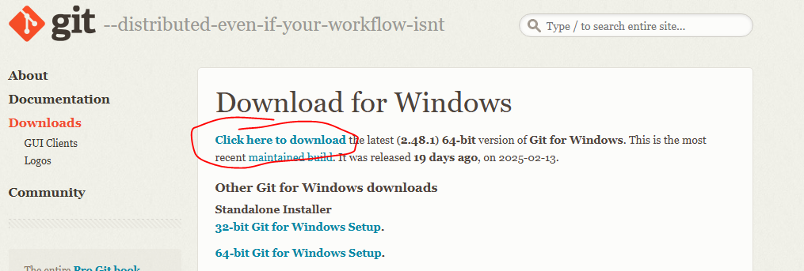

Click on downloaded file and install git

Click on next-next, ensure cmd window is selected in below screen, for remaining screens click on next and finish the installation.

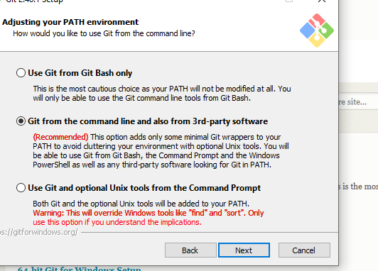

Then, we have to install and create account for github, which is the place where we can save and share the codes and it can be accessed using git commands.

Suppose, 2-3 people are working on a piece of code, then Github has the intelligence to merge them properly. In case of conflict, it will reject the code to be merged and it will ask to resolve the conflict between submitted codes and once it is fine, it will accept the code in the repository.

First we will create a git repository, goto github. Create an account

te01011988st@gmail.com

pwd-Testgit@1234

username-testgit01011988

once you login, create repository

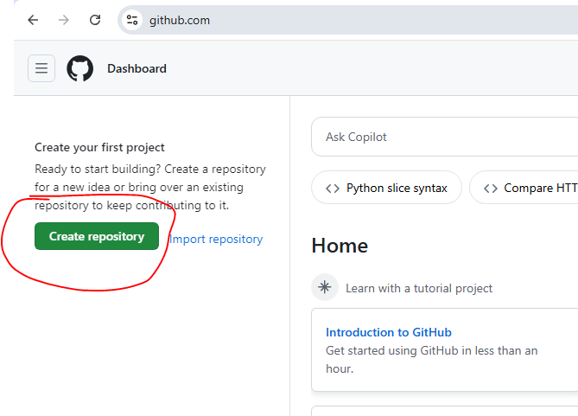

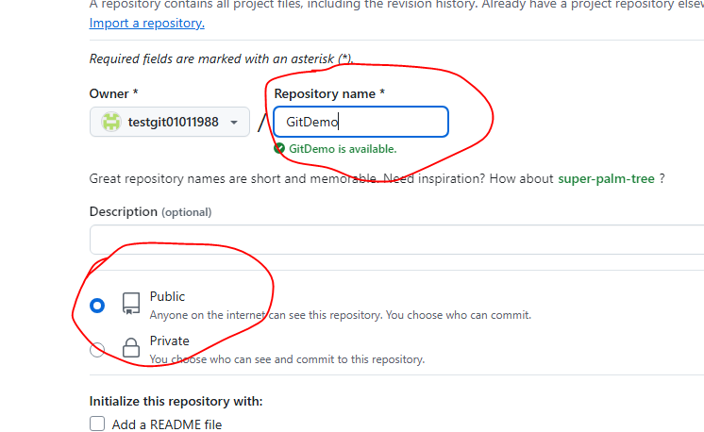

Here, we are able to select public, but in real projects, we might not be able to directl make it public, admin team might be allowing the accesses.

Click on create repository

Now, GitDemo repository is created, we have to push the code from local system to GitDemo.

First, we need to tell GIT who we are, which user is communicating to github and his email id. And we will be communicating to the github using git commands

There are tools to talk to github like Tortoise git(which has ui to communicate and we need not remember the commands), eclipse also has also plugins, tools like Intellij.

But If we know git commands in cmd, it will be more helpful. As, in some places, they must be using intellij or Tortoise, so we know git commands, we can use it everywhere as cmd is present everywhere. And it if we know the basic commands, we can learn the tools.

**Working with GIT**

**For Git basic commands use the below link for reference:**

[**https://confluence.atlassian.com/bitbucketserver/basic-git-commands-776639767.html**](https://confluence.atlassian.com/bitbucketserver/basic-git-commands-776639767.html)

**Goto cmd and start using git commands. Git command always start with “git”**

**First tell git who you are:**

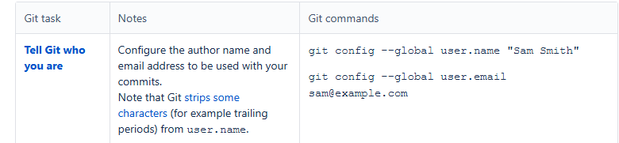

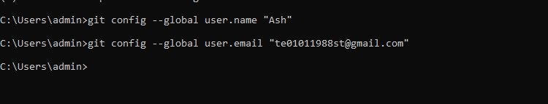

**First create a folder with all files to work on github. (suppose we places few files in C:\Users\admin\Desktop\automation\RestAssured\Git in local system)**

**Then we have to initialize the github using init command. Github takes the code which is committed.**

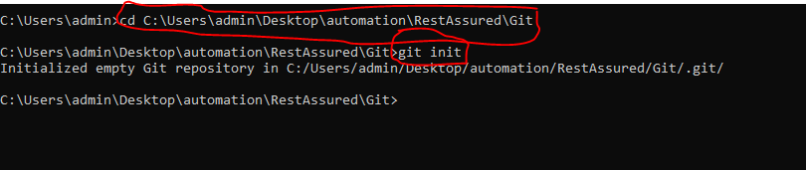

**Now there are 2 concepts of stash and commit. Written code is in Stash(say first level of commit) and we can commit the code which is stashed. Github works on the code which is committed.**

**Add code to stash-> commit the code from stash and place in commit-> push to github**