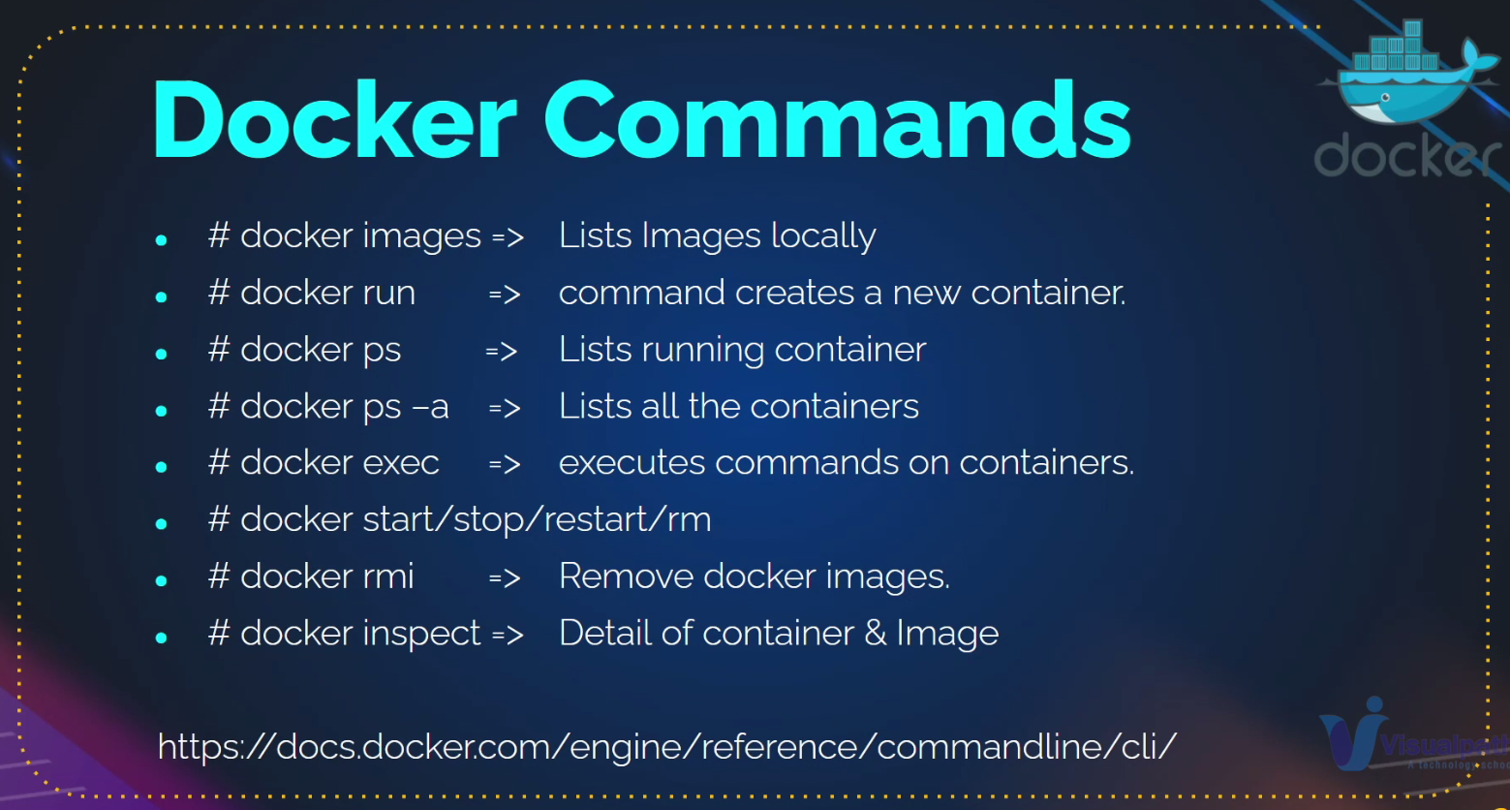

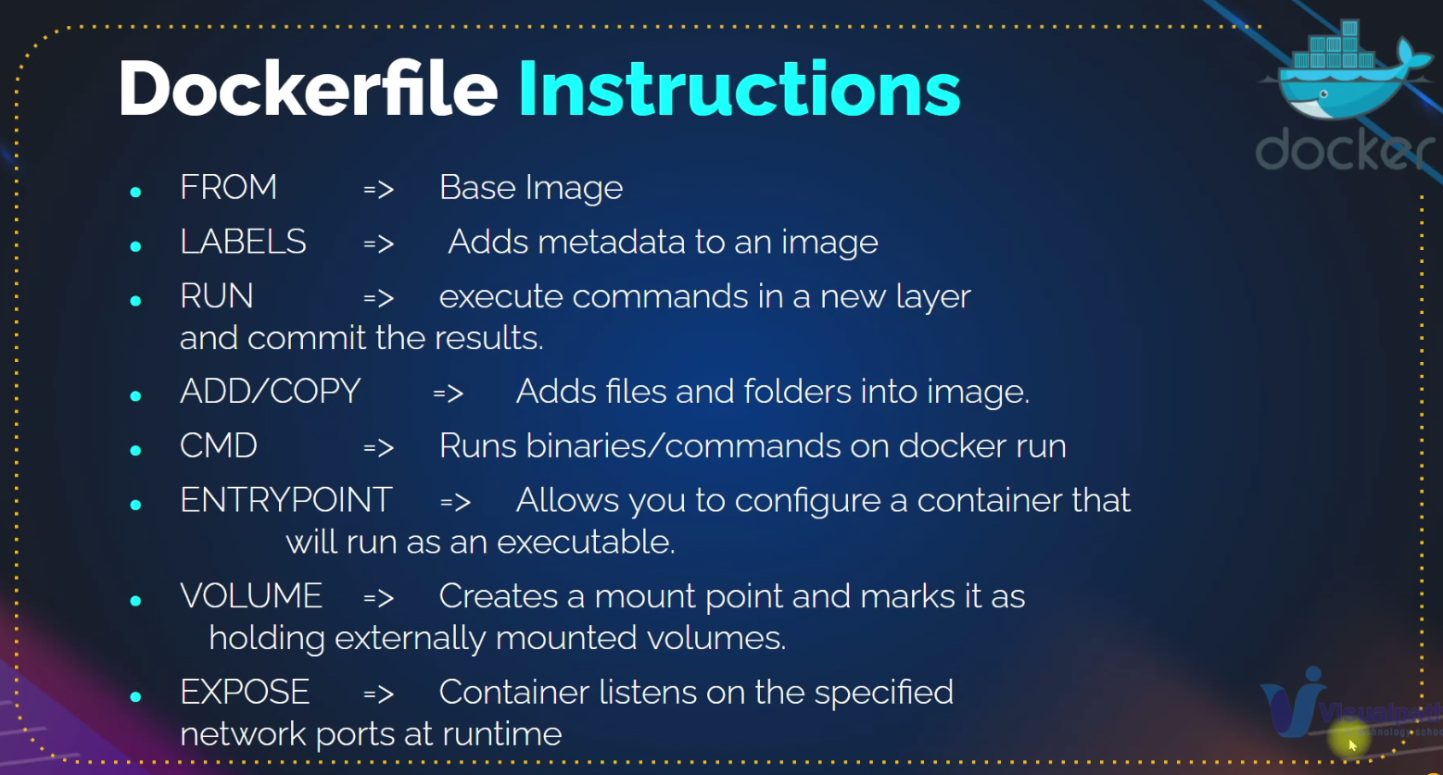

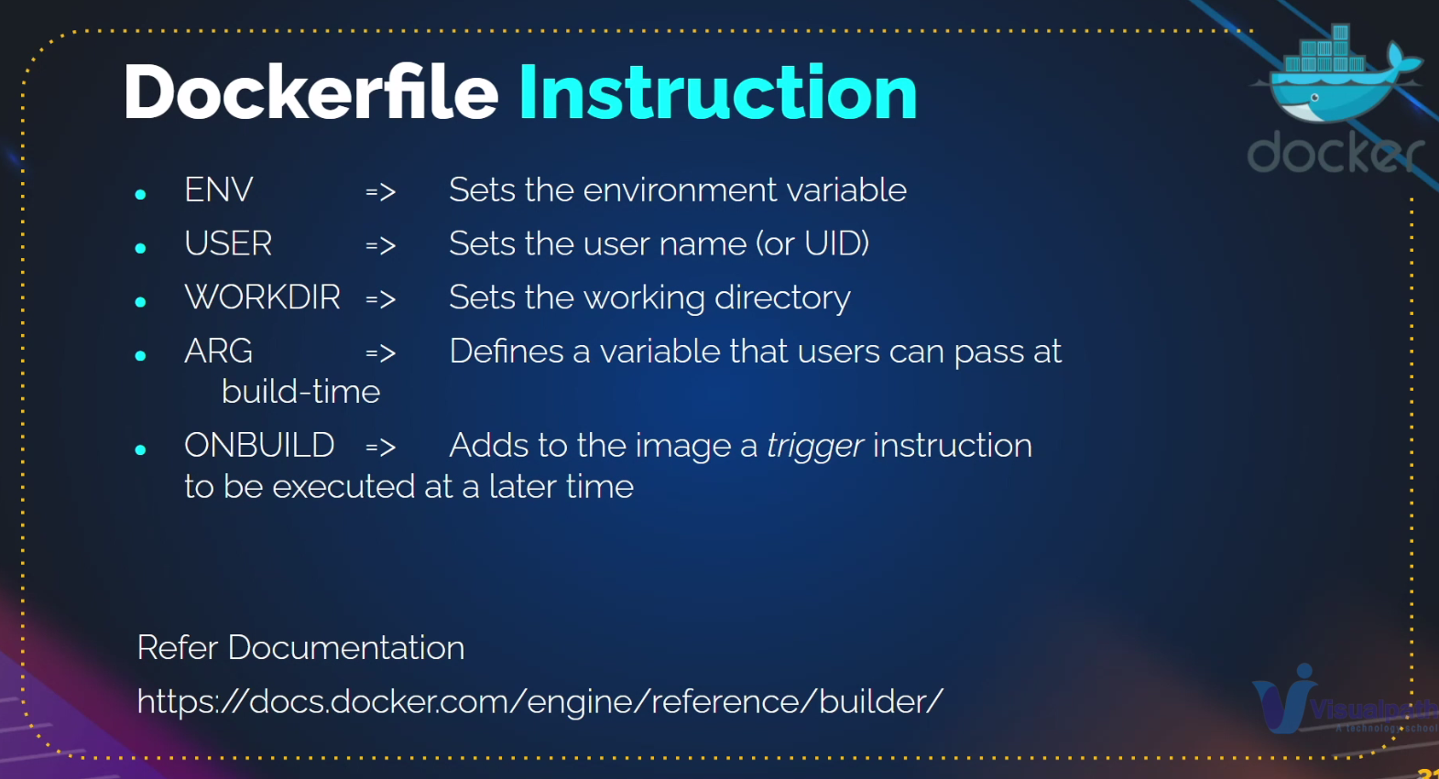

Bind mode – inject data from host to container.

Docker volumes – for preserving purpose of the data

Push images to docker hub

<https://hub.docker.com/repository/docker/mrdockernnm/admin/general>

understand cmd and entry point

do docker steps form official docker docs form Imran

Docker compose – it is a tool that enables to run all the containers together, instead of running them one by one manually.

Docker compose is used to run all your project container together inside of a one network

Containering/dockerising means that you need write docker file and docker compose file.

CMD/Entrypoint:

Entry point has higher priority then comes cmd