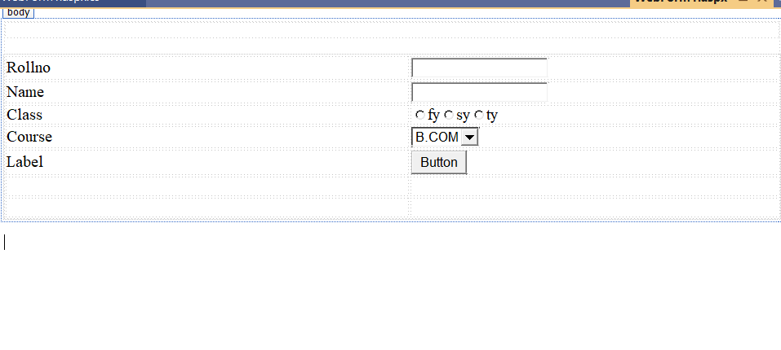

using System;

using System.Collections.Generic;

using System.Linq;

using System.Web;

using System.Web.UI;

using System.Web.UI.WebControls;

namespace Pract3a

{

public partial class WebForm1 : System.Web.UI.Page

{

protected void Page_Load(object sender, EventArgs e)

{

}

protected void Button1_Click(object sender, EventArgs e)

{

string s;

if (RadioButton1.Checked == true)

{

s = RadioButton1.Text;

}

if(RadioButton2.Checked == true)

{

s = RadioButton2.Text;

}

else

{

s = RadioButton3.Text;

}

Label5.Text += "in" + s;

}

protected void DropDownList1_SelectedIndexChanged(object sender, EventArgs e)

{

Label5.Text = "You have been enrolled in " + DropDownList1.SelectedItem;

}

}

}