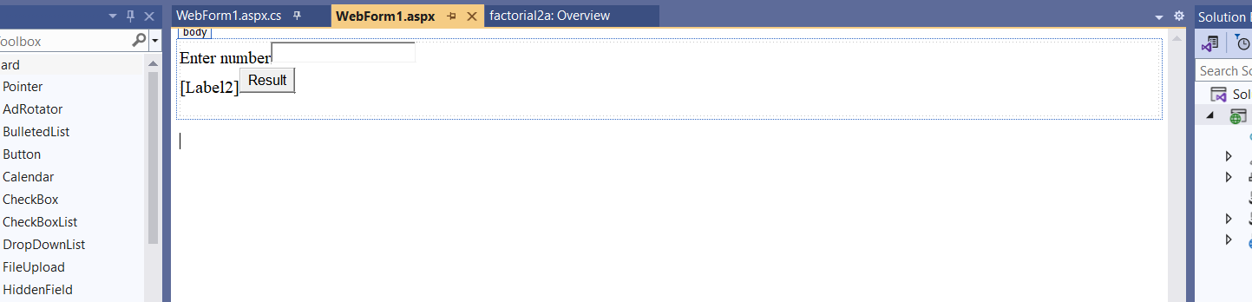

2 Label

1 TextBox

1 Button(Double Click and program)

**FACTORIAL:-**

using System;

using System.Collections.Generic;

using System.Linq;

using System.Web;

using System.Web.UI;

using System.Web.UI.WebControls;

class fact

{

public int n, f;

public fact()

{

f = 1;

}

public void cal()

{

int i;

for(i = 1; i <= n; i++)

{

f = f * i;

}

}

}

namespace factorial2a

{

public partial class WebForm1 : System.Web.UI.Page

{

protected void Page_Load(object sender, EventArgs e)

{

}

protected void Button1_Click(object sender, EventArgs e)

{

fact f1=new fact();

f1.n = int.Parse(TextBox1.Text);

f1.cal();

Label2.Text = f1.f.ToString();

}

}

}