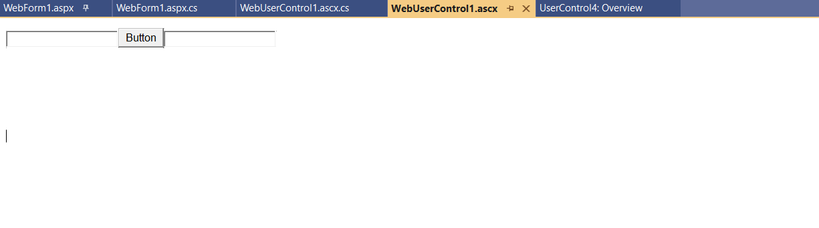

Take 2 textbox 1 button

webUserControl1.ascx.cs

using System;

using System.Collections.Generic;

using System.Linq;

using System.Web;

using System.Web.UI;

using System.Web.UI.WebControls;

namespace UserControl4

{

public partial class WebUserControl1 : System.Web.UI.UserControl

{

protected void Page_Load(object sender, EventArgs e)

{

}

protected void Button1_Click(object sender, EventArgs e)

{

TextBox2.Text = "Welcome" + TextBox1.Text;

}

}

}

WebForm1.aspx.cs

using System.Web;

using System.Web.UI;

using System.Web.UI.WebControls;

namespace UserControl4

{

public partial class WebForm1 : System.Web.UI.Page

{

protected void Page_Load(object sender, EventArgs e)

{

}

protected void Button1_Click(object sender, EventArgs e)

{

TextBox2.Text = "Hello Guest" + TextBox1.Text;

}

}

}