# What is IOC and DI?

IOC (Inversion of Control) and DI (Dependency Injection) is a design pattern to provide loose coupling.

# The role of IOC container in spring?

IOC container is responsible to:

* create the instance
* configure the instance, and
* assemble the dependencies

# BeanFactory and ApplicationContext

BeanFactory is the basic container whereas ApplicationContext is the advanced container. ApplicationContext extends the BeanFactory interface. ApplicationContext provides more facilities than BeanFactory such as integration with spring AOP, message resource handling for i18n etc.

# The difference between constructor injection and setter injection

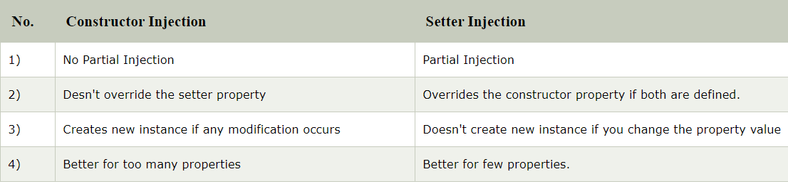

# What is autowiring in spring? What are the autowiring modes?

Autowiring enables the programmer to inject the bean automatically. We don't need to write explicit injection logic.

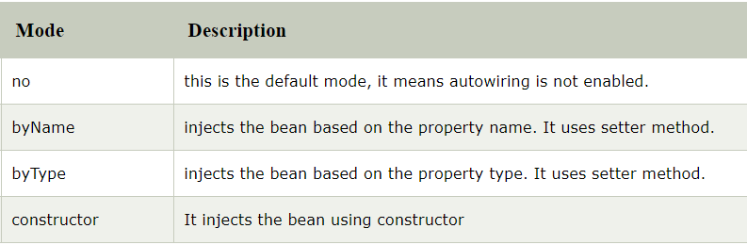

# The different bean scopes in spring

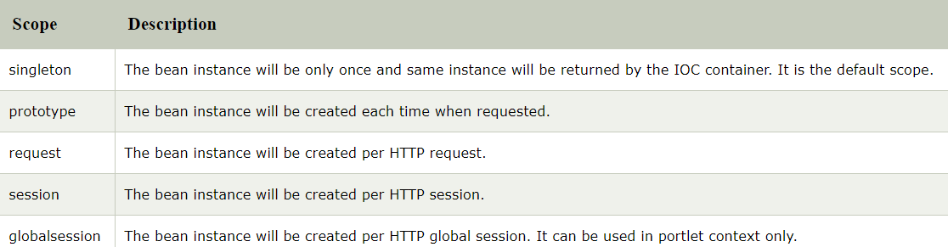

# Hibernate vs JPA

