Integrated Student Mentoring App for University Campuses

Problem Statement

"Design an integrated student mentoring app for university campuses that efficiently manages and maintains comprehensive student data, while providing a user-friendly platform for students to seek guidance and solutions for academic, personal, and administrative challenges. The app should facilitate effective communication between students and mentors, track student progress, offer personalized recommendations, and promote a supportive university community through easy access to resources and peer interactions. It will eradicate the problem of using traditional pen and paper method which conserves lot of energy, time and resources."

Software Requirements Specification (SRS) Document

1. Introduction

The Integrated Student Mentoring App (ISMA) is a comprehensive platform designed to streamline student mentoring and support services within university campuses. This app aims to efficiently manage and maintain student data while providing a user-friendly interface for students to seek guidance and solutions for a wide range of challenges, including academic, personal, and administrative issues. ISMA aims to foster a supportive university community by promoting seamless communication between students and mentors and offering access to relevant resources.

2. Scope

The ISMA will cover the following features:

- User Registration: Students, mentors, and administrators can create and manage their accounts.

- Student Profile Management: Students can update and maintain their personal, academic, and extracurricular information.

- Mentor Matching: Intelligent algorithm for pairing students with suitable mentors based on preferences and areas of expertise.

- Communication: Real-time chat and video conferencing capabilities for students to seek guidance from mentors.

- Problem Submission: Students can submit various types of challenges they are facing, categorized into academic, personal, and administrative.

- Resource Center: A repository of resources, articles, and guides to help students address common challenges.

- Progress Tracking: Students can track their academic progress, set goals, and monitor their improvement over time.

- Notifications: Students receive alerts and notifications for upcoming events, deadlines, and personalized recommendations.

- Reporting: Administrators can generate reports on student engagement, mentorship effectiveness, and issue resolution.

3. Functional Requirements

3.1 User Management

   - FR1: Users (students, mentors, administrators) must register with valid university credentials.

   - FR2: Users can log in to their accounts using secure authentication methods.

3.2 Student Profile Management

   - FR3: Students can create and update their profiles with personal, academic, and extracurricular details.

3.3 Mentor Matching

   - FR4: An intelligent algorithm matches students with suitable mentors based on preferences and areas of expertise.

3.4 Communication

   - FR5: Students can initiate real-time text and video chats with their assigned mentors.

   - FR6: Mentors can schedule and conduct virtual mentoring sessions.

3.5 Problem Submission

- FR7: Students can submit academic, personal, or administrative challenges they are facing.

- FR8: Challenges are categorized and assigned to the appropriate mentor or support staff.

3.6 Resource Center

- FR9: Students can access a comprehensive resource repository containing articles, guides, and multimedia materials.

3.7 Progress Tracking

- FR10: Students can set academic goals, track progress, and receive recommendations for improvement.

- FR11: Students can view their historical performance and growth over time.

3.8 Notifications

- FR12: Students receive notifications for upcoming events, deadlines, and personalized recommendations.

3.9 Reporting

- FR13: Administrators can generate reports on student engagement, mentorship effectiveness, and challenge resolution.

4. Non-Functional Requirements

* NFR1: Security: The app must implement robust encryption and authentication mechanisms to ensure data privacy and prevent unauthorized access.
* NFR2: Performance: The app must provide a seamless user experience, with minimal latency during communication and data retrieval.
* NFR3: Usability: The user interface should be intuitive and accessible, catering to users of varying technical backgrounds.
* NFR4: Scalability: The app should be designed to handle a growing number of users and data without compromising performance.
* NFR5: Reliability: The app should have high availability and minimal downtime.
* NFR6: Compatibility: The app must be compatible with various devices, including smartphones, tablets, and computers, and across multiple platforms (iOS, Android, web).

5. UML Diagrams

5.1 Working Flow Diagram

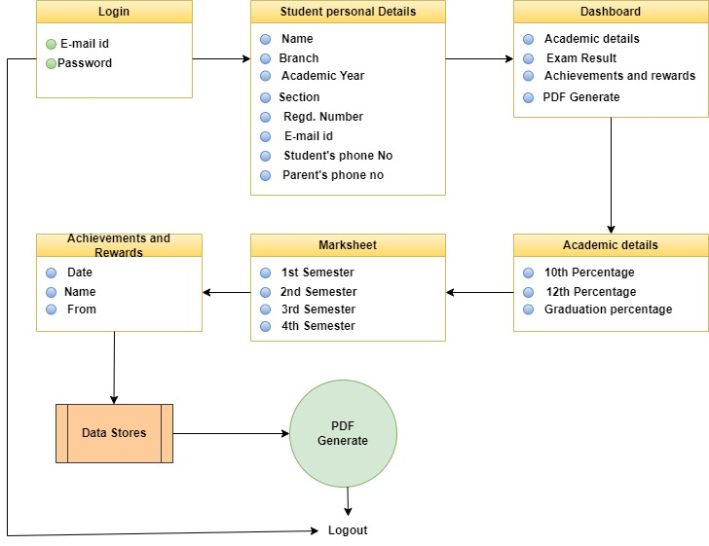

5.2 Use case Diagram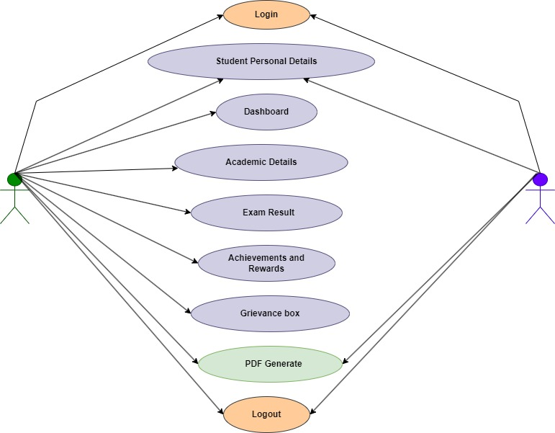

6. **References**

* **Black Book, Android Application Development – Pradeep Kothari**
* **Geeksforgeeks**
* **Androiddevolpers**
* **Medium**
* **Google for Developers**
* **Chat Gpt**

7. Conclusion

The Integrated Student Mentoring App (ISMA) is envisioned to revolutionize student mentoring and support services within university campuses. By offering an efficient platform for managing student data and facilitating communication between students and mentors, ISMA aims to enhance the overall student experience and contribute to a more supportive and successful university community.