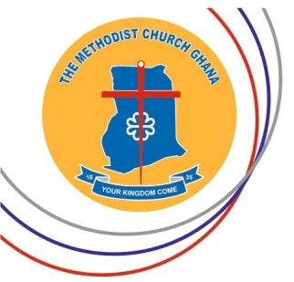**THE METHODIST CHURCH – GHANA**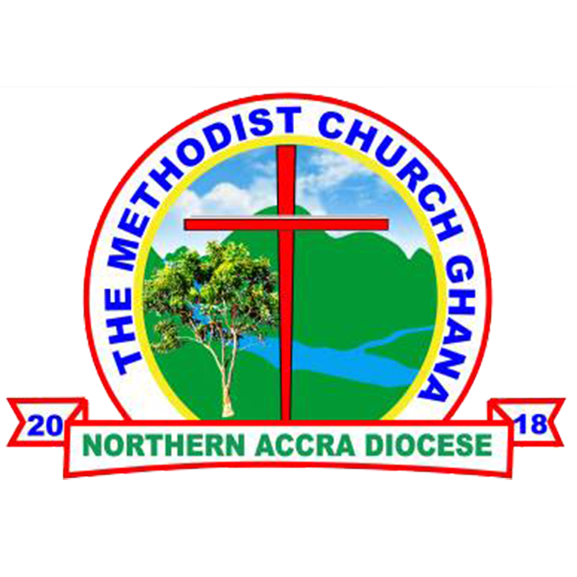

THERE WILL BE A COMMISSIONING SERVICE FOR NEWLY TRAINED METHODIST MINISTERS

**DATE**: SUNDAY, 27TH JUNE, 2021

**VENUE**: MOST REV. KWESI DICKSON MEMORIAL METHODIST CHURCH, ADJIRINGANOR

**PRESIDING BISHOP ADMINISTRATIVE BISHOP**

MOST REV. DR. PAUL K. BOAFO RT. REV. MICHAEL A. BOSSMAN

**HOST BISHOP**

RT. REV. PROF. JOSEPH M. Y. EDUSA-EYISON