2nd May, 2021

Mr. Enoch Osafo

Beloved in Christ,

**INVITATION AS GUEST OF HONOUR DURING THE OFFICAL OPENING OF NORTHERN ACCRA MYF CONFERENCE**

Greetings to you in the name of our Lord and Saviour Jesus Christ.

The Northern Accra MYF Secretariat writes on behalf of the Executive Committee and the entire membership of the Methodist Youth Fellowship in the Diocese, to officially invite you as **THE GUEST OF HONOUR** during the **Official Opening** of her **2nd Biennial Delegates’ Conference**.

The official opening is scheduled with the following details

**Date**: 5th June, 2021

**Time**: 8am to 12pm

**Venue**: Emmaus Methodist Church, Awoshie Circuit

**Theme**: Discipleship: Teaching Everyone to Live like Jesus Christ (Colossians 1:28-29).

**Key Personalities**: The Bishop, the Synod Secretary and Lay Chairman of Northern Accra Diocese of the Methodist Church Ghana.

We hope our letter would be duly considered.

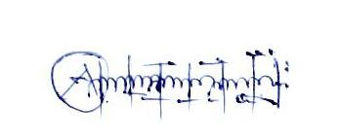Yours In His Service

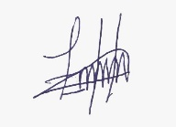

Bro. Emil K. Agyapong-Manu Rev. Enoch Antwi-Boasiako

(Diocesan Vice Chairman) (Diocesan Youth Organizer)

Tel: 0246458850