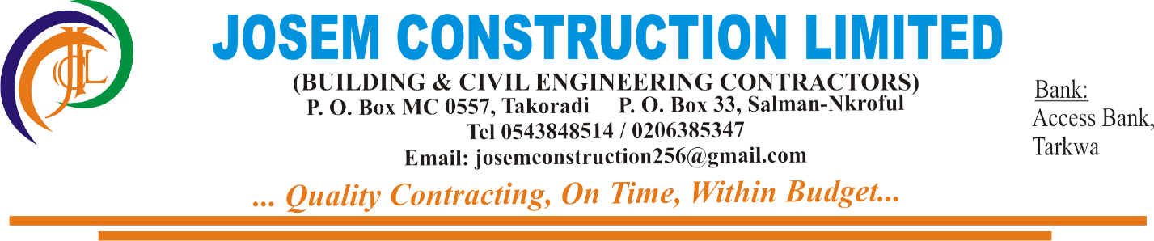

11th November,2020

THE SITE MANAGER

MAXAM GHANA LIMITED

ADAMUS RESOURCES SITE

Dear Sir,

**BANKING DETAILS**

Please find herewith the Bank details for Josem Construction Limited as requested:

**ACCOUNT NAME:** JOSEM CONSTRUCTION LIMITED

**ACCOUNT NUMBER:** 0150107174351

**BANK NAME:** ACCESS BANK

**BRANCH:** TARKWA

Kind Regards

………Signed……….

Joseph Osei Emprah

(MD)