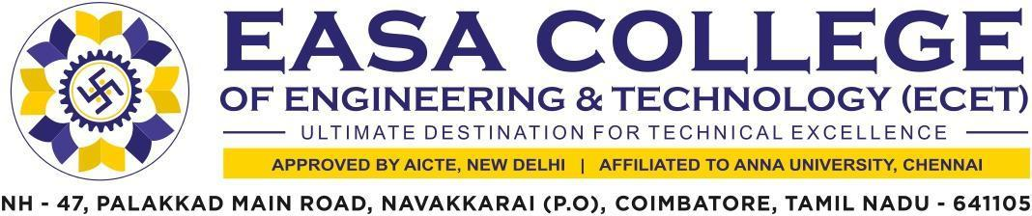

1.3.1 Institution integrates crosscutting issues relevant to
Professional Ethics, Gender, Human Values, Environment and Sustainability into the Curriculum.

The supporting documents for this metric exceed the upload limit of 5Mb. Hence the documents are made available in HEI website and links for the metric is given below.

Metric | Parameter | Link to Relevant Document
1.3.1 | Institution integrates crosscutting issues relevant to  Professional Ethics, Gender, Human Values, Environment and Sustainability into the Curriculum. | VIEW

