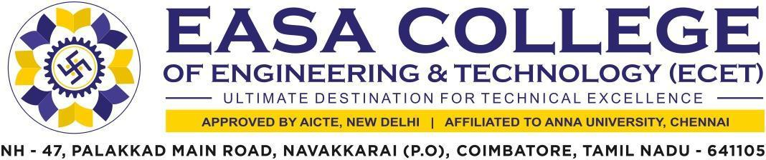

2.3.1 Student centric methods, such as experiential learning, participative learning and problem solving methodologies are used for enhancing learning experiences using ICT tools.

The supporting documents for this metric exceed the up load limit of 5Mb. Hence the documents are made available in HEI website and links forthemetricisgivenbelow.

Metric | Parameter | Linkto  Relevant  Document
2.3.1.a) | Student centric methods, such as experiential learning, participative learning and problem solving methodologies are used for enhancing learning experiences using ICT tools (Description) | VIEW FILE
b) | Additional Information | VIEW FILE

