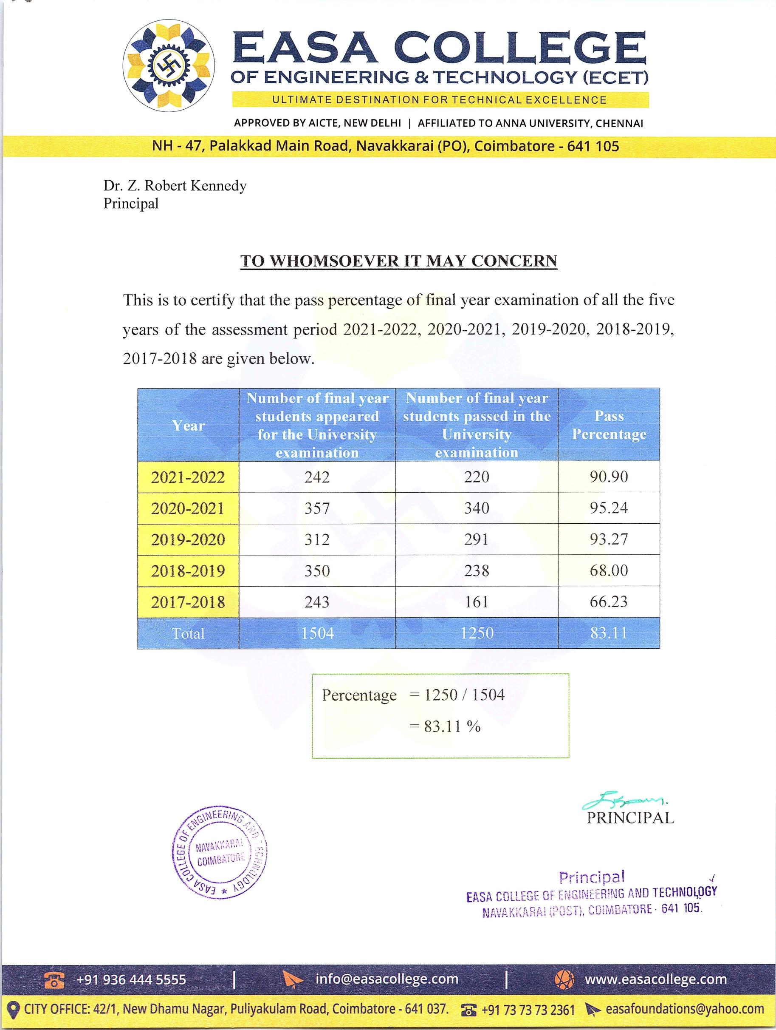

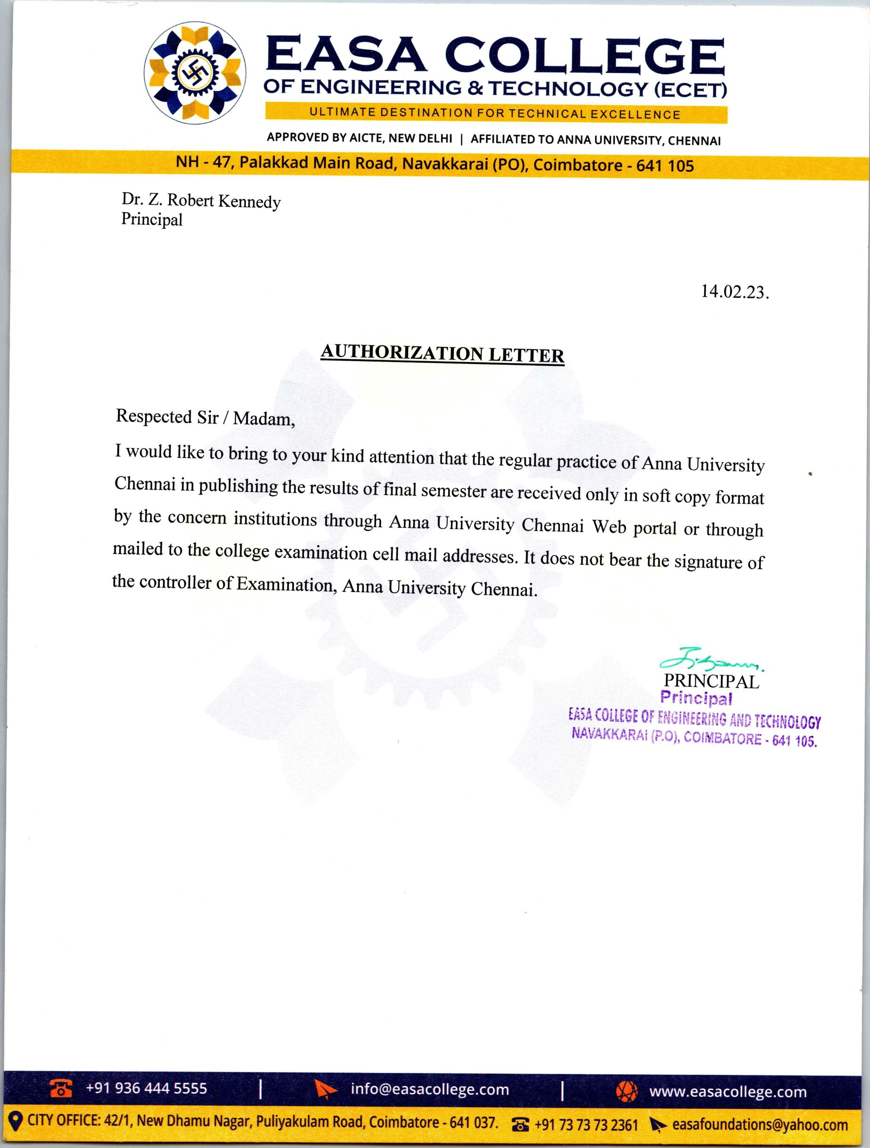



2.6.2. Students performance and learning outcomes

Metric | Parameter | LINK
2.6.2.1. | Details of Anna University Grade for the Regulation 2013& 2017 | VIEW FILE
2.6.2.2. | Number of final year students who passed the university examinations year wise during the last five years | VIEW FILE
2.6.2.3 . | Number of final year students who appeared for the university examinations year wise during the last five years | VIEW FILE

