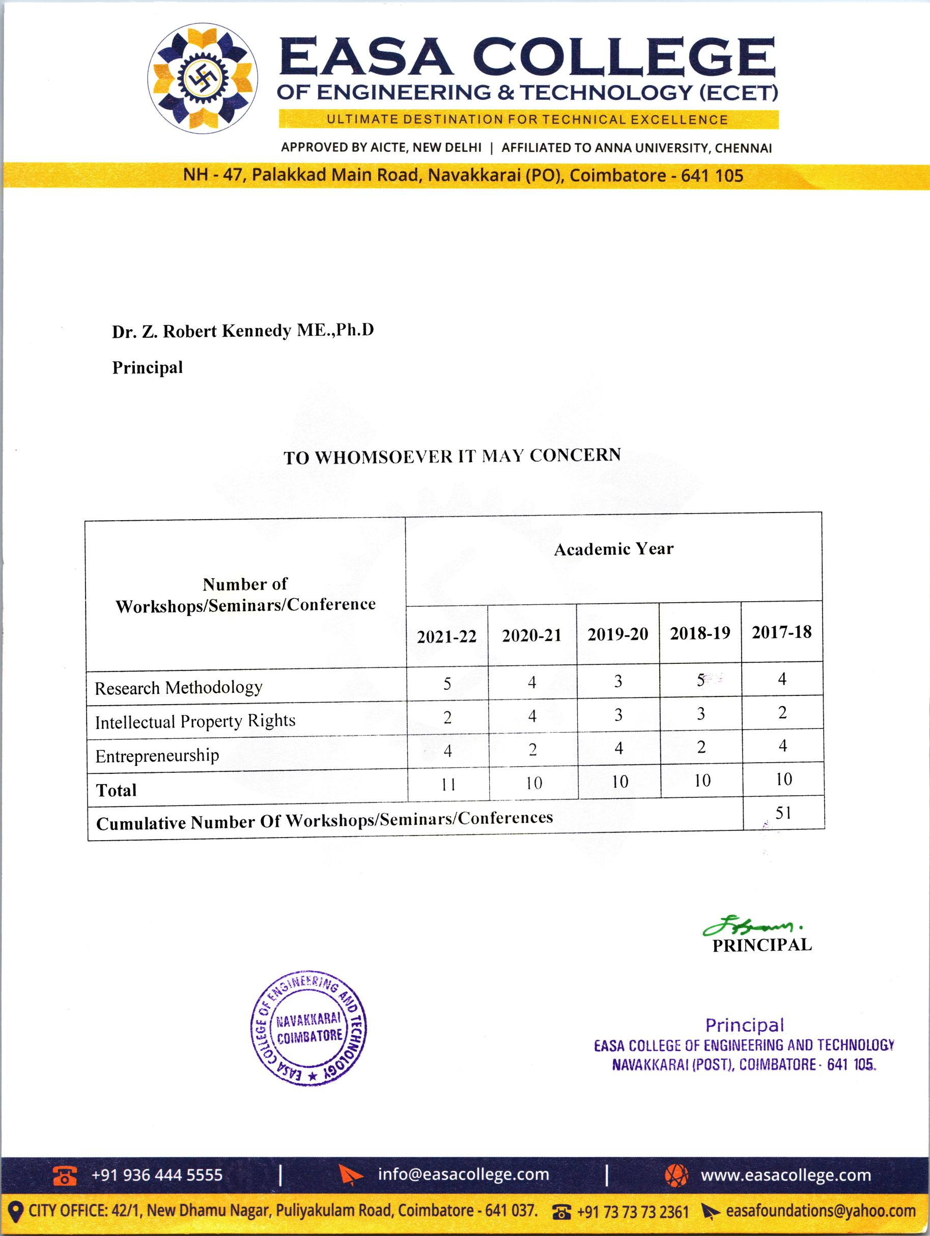

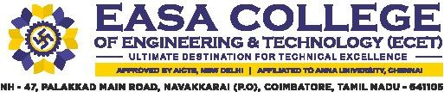

3.2.2 Number of workshops/seminars/conferences conducted on Research Methodology, Intellectual Property Rights (IPR) and entrepreneurship during the last five years

INDEX

Sl.  NO | DESCRIPTION | LINK
1 | Event Circular, Brochure, Photos, Participants Name List, Feedback | VIEW
2 | Report of the Event | VIEW
3 | Resource person Profile | VIEW

