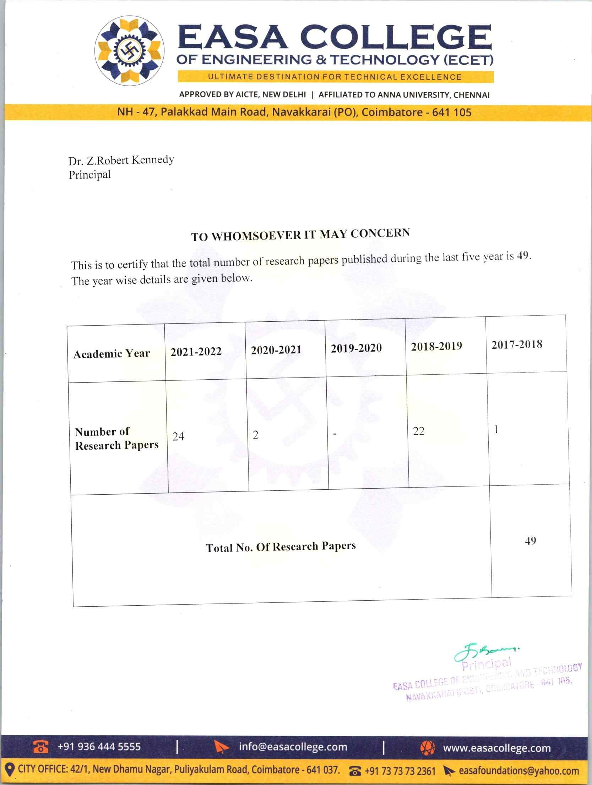



Number of research papers in the journal notified on the UGC website during the last five years (2017-2021)

Academic year | Number of Journals | Document
2021-2022 | 24 | View Document
2020-2021 | 2 | View Document
2019-2020 | - | -
2018-2019 | 22 | View Document
2017-2018 | 1 | View Document

