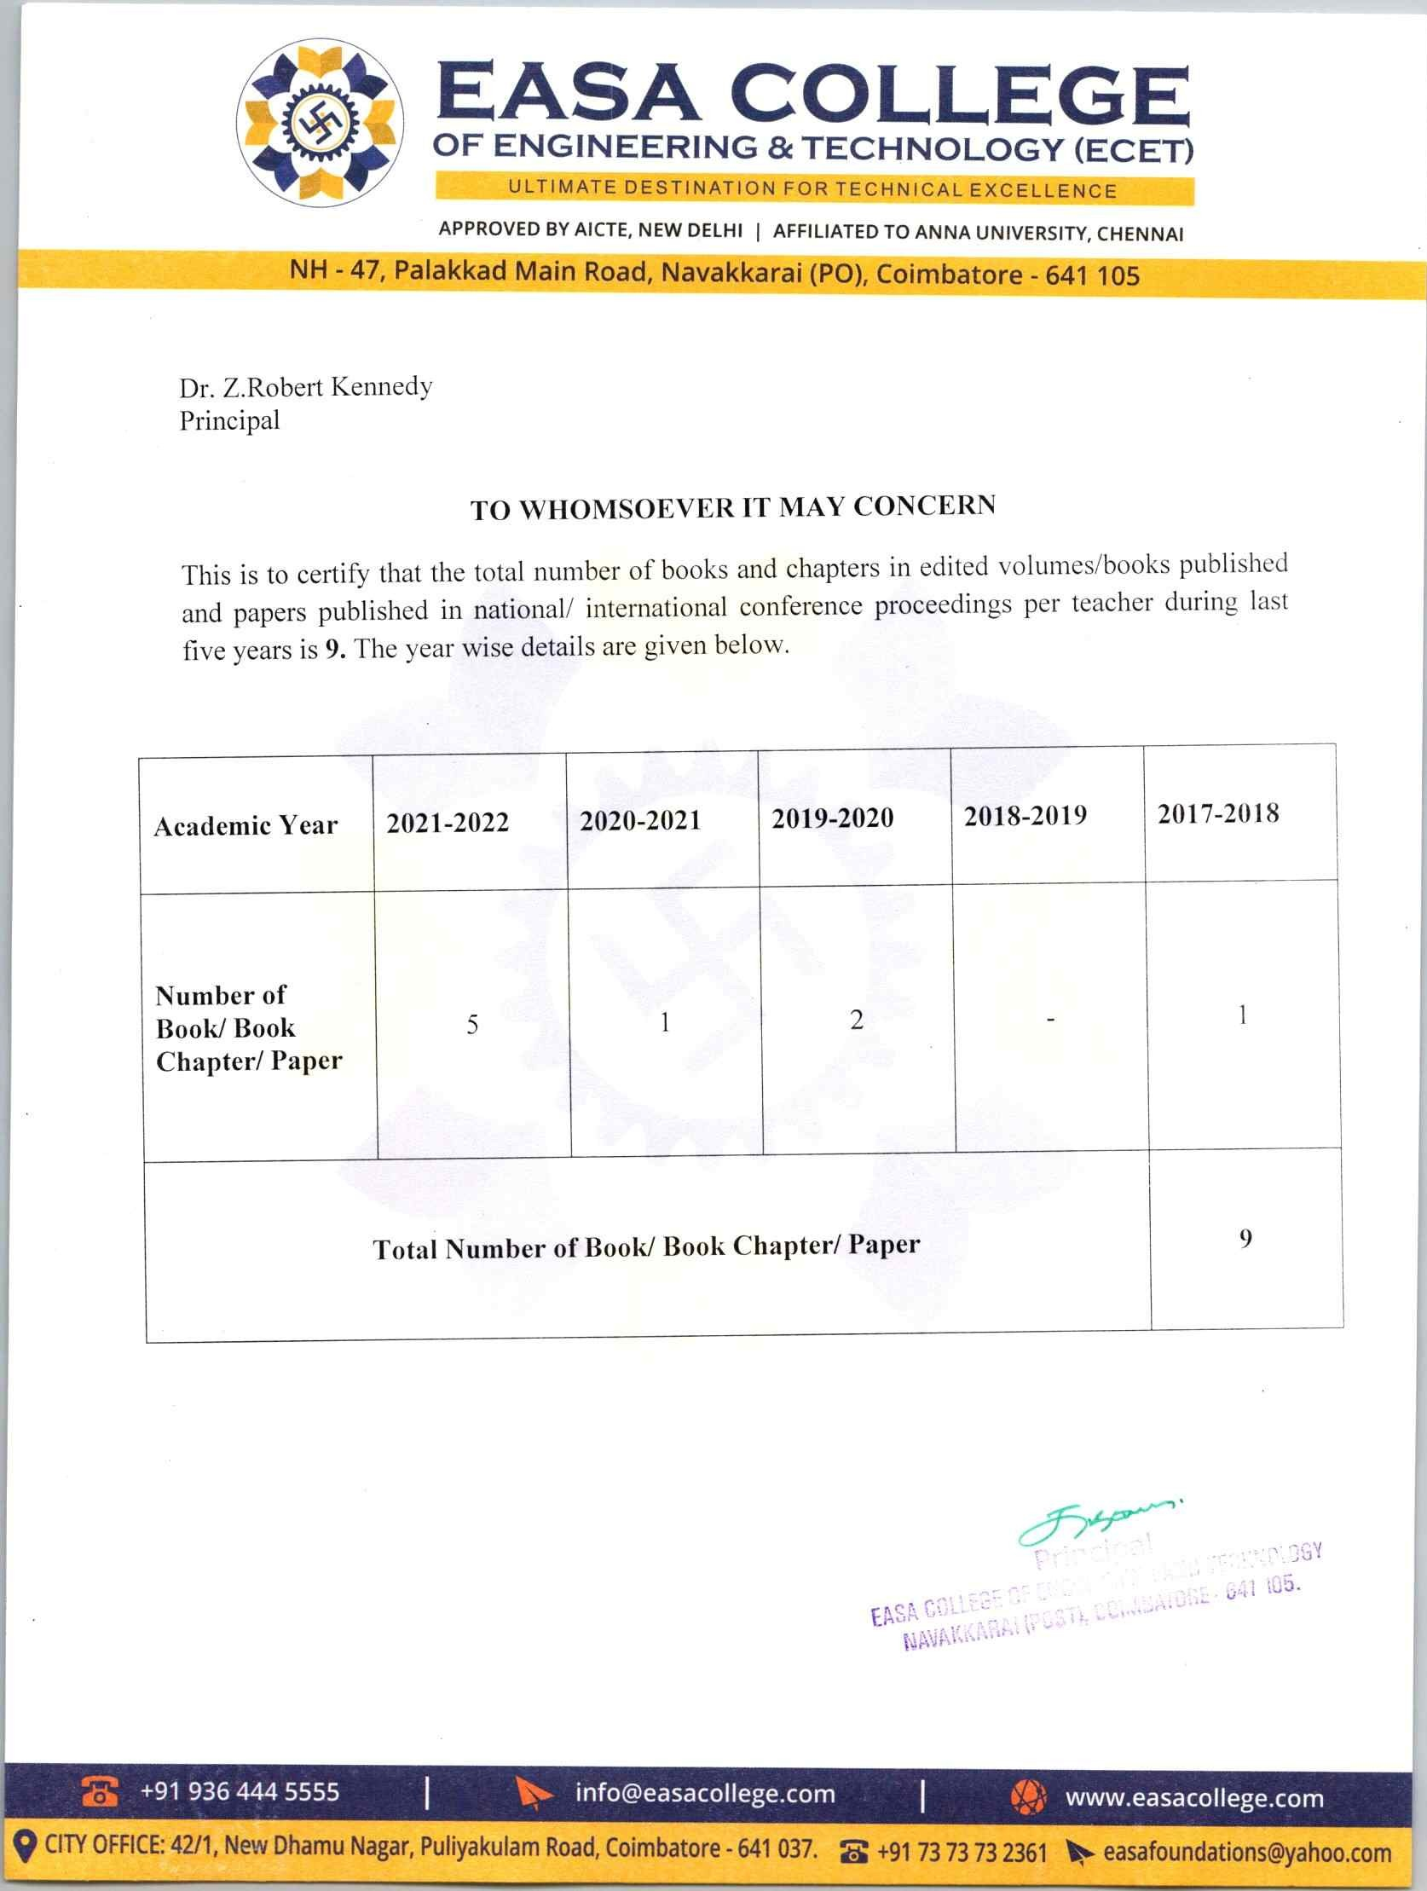



3.3.2 Number of books/book chapters in edited volumes/books published and papers published in national/ international conference proceedings per teacher during last five years during the last five years (2017-2022)

Academic year | Number of Books/ Chapter | Document
2021-2022 | 5 | View
2020-2021 | 1 | View
2019-2020 | 2 | View
2018-2019 | - | -
2017-2018 | 1 | View

