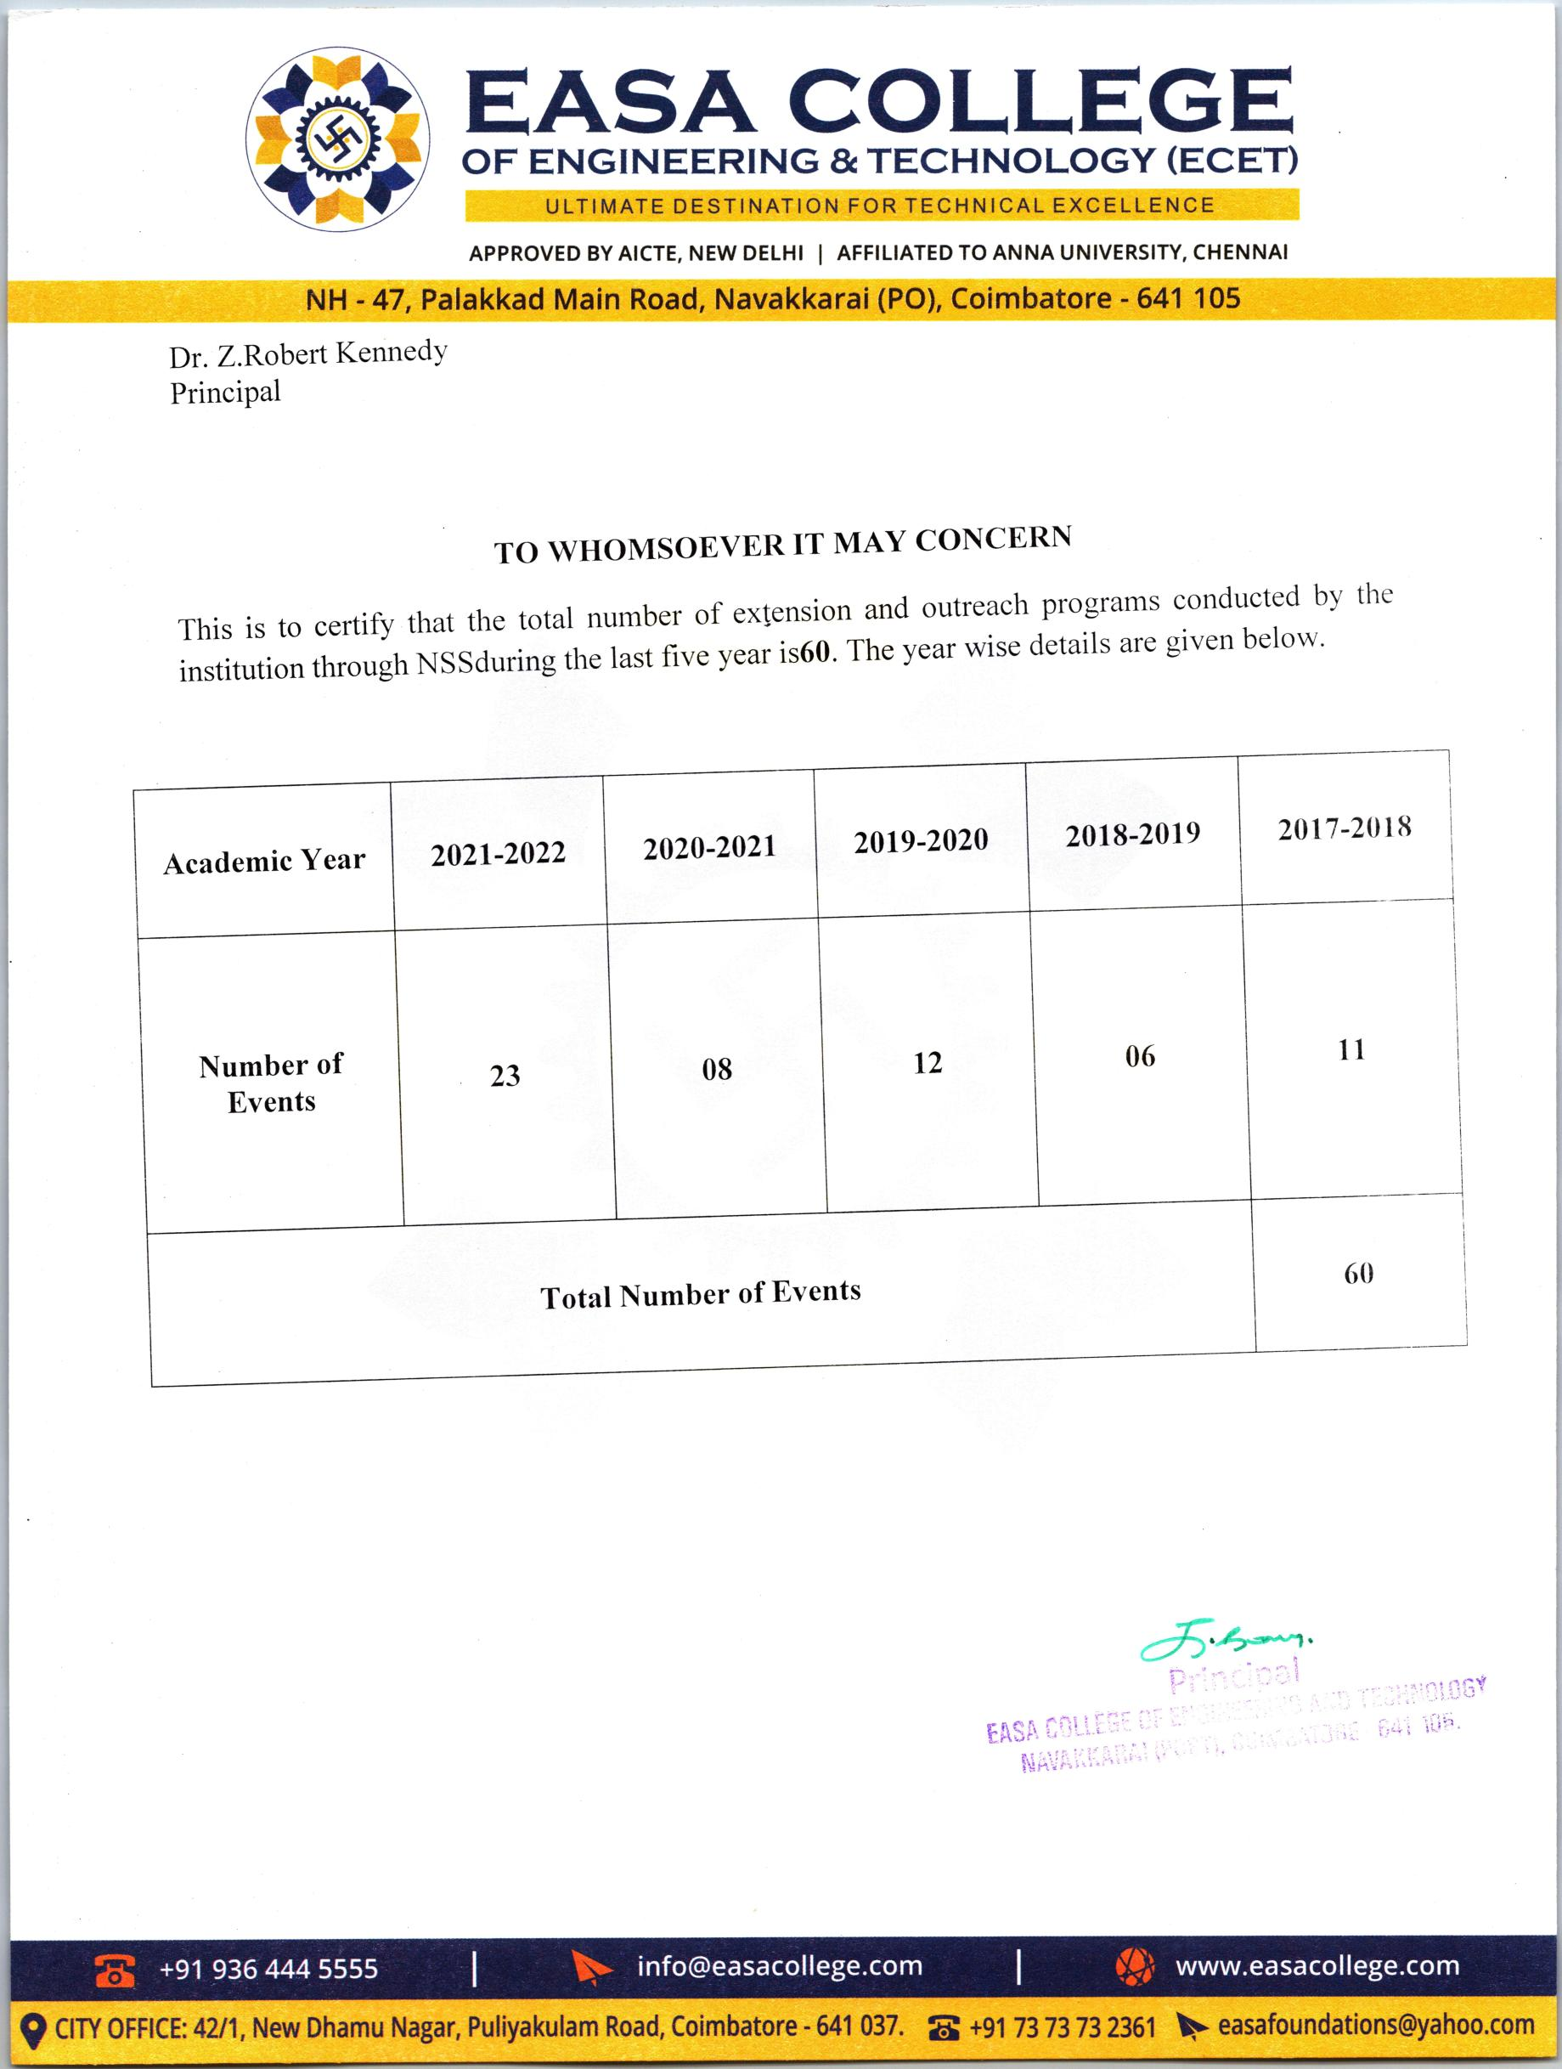

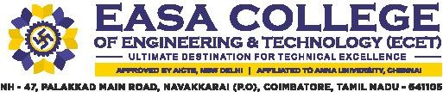

3.4.3 Number of extension and outreach programs conducted by the institution through NSS/NCC/Red cross/YRC etc., (including the programs such as Swachh Bharat, AIDS awareness, Gender issues etc. and/or those organized in collaboration with industry, community and NGOs) during the last five years.

INDEX

SI. NO | Description | Link to Relevant Document
1 | List of Extension Programs | View
2 | Geo tagged Photos | View
3 | Detailed Report | View

