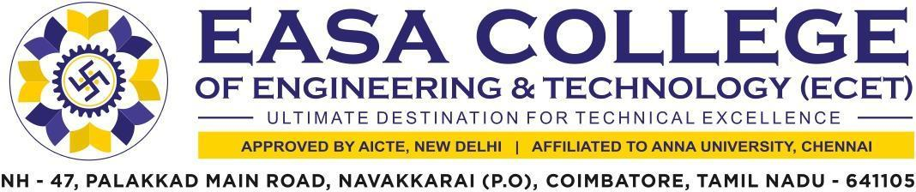

5.1.2 Capacity Building and skills enhancement initiatives taken by the institution include the following
1. Soft Skills
2. Language Skills
3. Life Skills (Yoga, Physical Fitness, health and hygiene)
4. ICT/ Computing skills

The supporting documents for this metric exceed the upload limit of 5Mb. Hence the documents are made available in HEI websiteand links for the metric is given below.

Metric | Parameter | Link to  Relevant Document
5.1.2 | Capacity Building and skills enhancement initiatives taken by the institution include the following  - Soft Skills  - Language and Communication Skills  - Life Skills (Yoga, physical fitness, health and hygiene)  - ICT/Computing skills | VIEW

