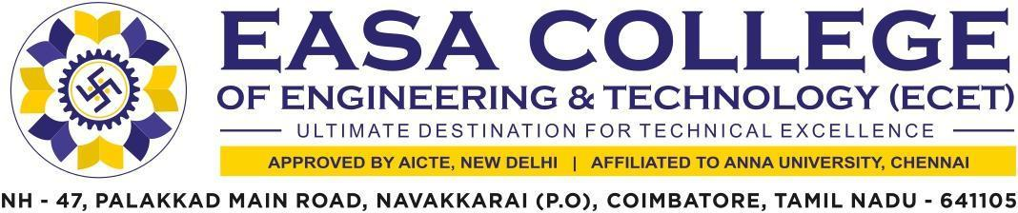

5.3.2 Average number of sports and Cultural programs in which students of the Institution participated during last five years (organized by the institution/ other institutions)

The supporting documents for this metric exceed the upload limit of 5Mb. Hence the documents are made available in HEI websiteand links for the metric is given below.

Metric | Parameter | Link to  Relevant Document
5.3.2 | Average number of sports and cultural programs in which students of the Institution participated during last five years (organized by the institution/ other institutions) | VIEW

