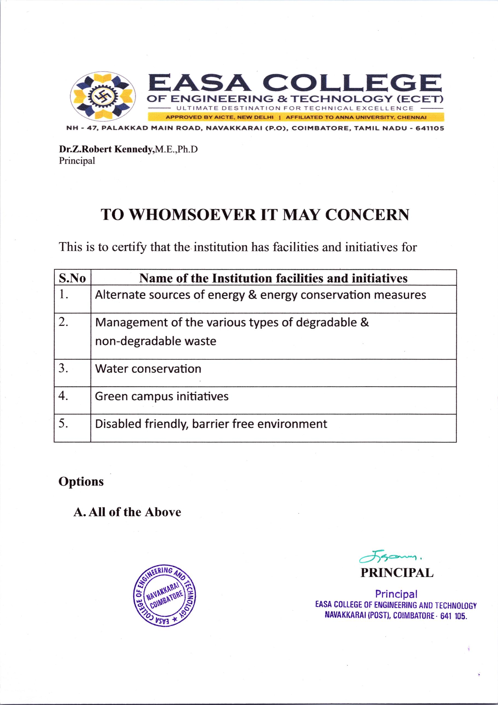

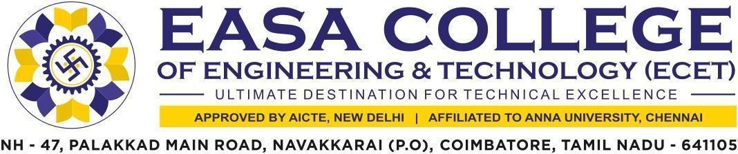

7.1.2 The institution has facilities & initiatives for Alternate sources of energy & energy conservation measures, Management of the various types of degradable & non-degradable waste, Water conservation, Green campus initiatives, Disabled – friendly, barrier free environment.
S.No | Parameter | Link
1. | Policy documents of the Institution | VIEW
2. | Geo tagged photographs and videos of the facilities with caption
 | A. Alternate sources of energy & energy conservation measures | VIEW
 | B. Management of the various types of degradable & non degradable waste | VIEW
 | C. Water Conservation | VIEW
 | D. Green campus Initiatives | VIEW
 | E. Disabled – friendly, barrier free environment | VIEW
3. | Bills for the purchase of equipment for the facilities created under this metric | VIEW
4. | Brief report of the facilities provided | VIEW
5. | Circulars | VIEW
6. | Ramps/rails/lift/wheel chair/signage board/rest room/software should include specific requirement of Divyangjan for their use. | VIEW
7. | Any other relevant proof for the selected option
 | A. Solar Energy | VIDEO LINK
 | B. Green campus | VIDEO LINK
 | C. Battery Car | VIDEO LINK
 | D. Rain Water Harvesting | VIDEO LINK
 | E. Disabled friendly, Barrier free environment | VIDEO LINK

