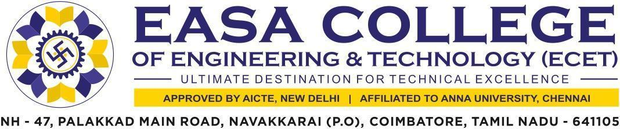

7.1.2 The Institution has facilities and initiatives for
- Alternate sources of energy & energy conservation measures
- Management of the various types of degradable & non-degradable waste
- Water conservation
- Green campus initiatives
- Disabled friendly, barrier free environment
The supporting documents for this metric exceed the upload limit of 5Mb. Hence the documents are made available in HEI website and links for the metric is given below

Metric | Parameter | Linkto  RelevantDocument
7.1.2 | The Institution has facilities and initiatives for  - Alternate sources of energy & energy conservation measures  - Management of the various types of degradable & non-degradable waste  - Water conservation  - Green campus initiatives  - Disabled friendly, barrier free environment | VIEW

