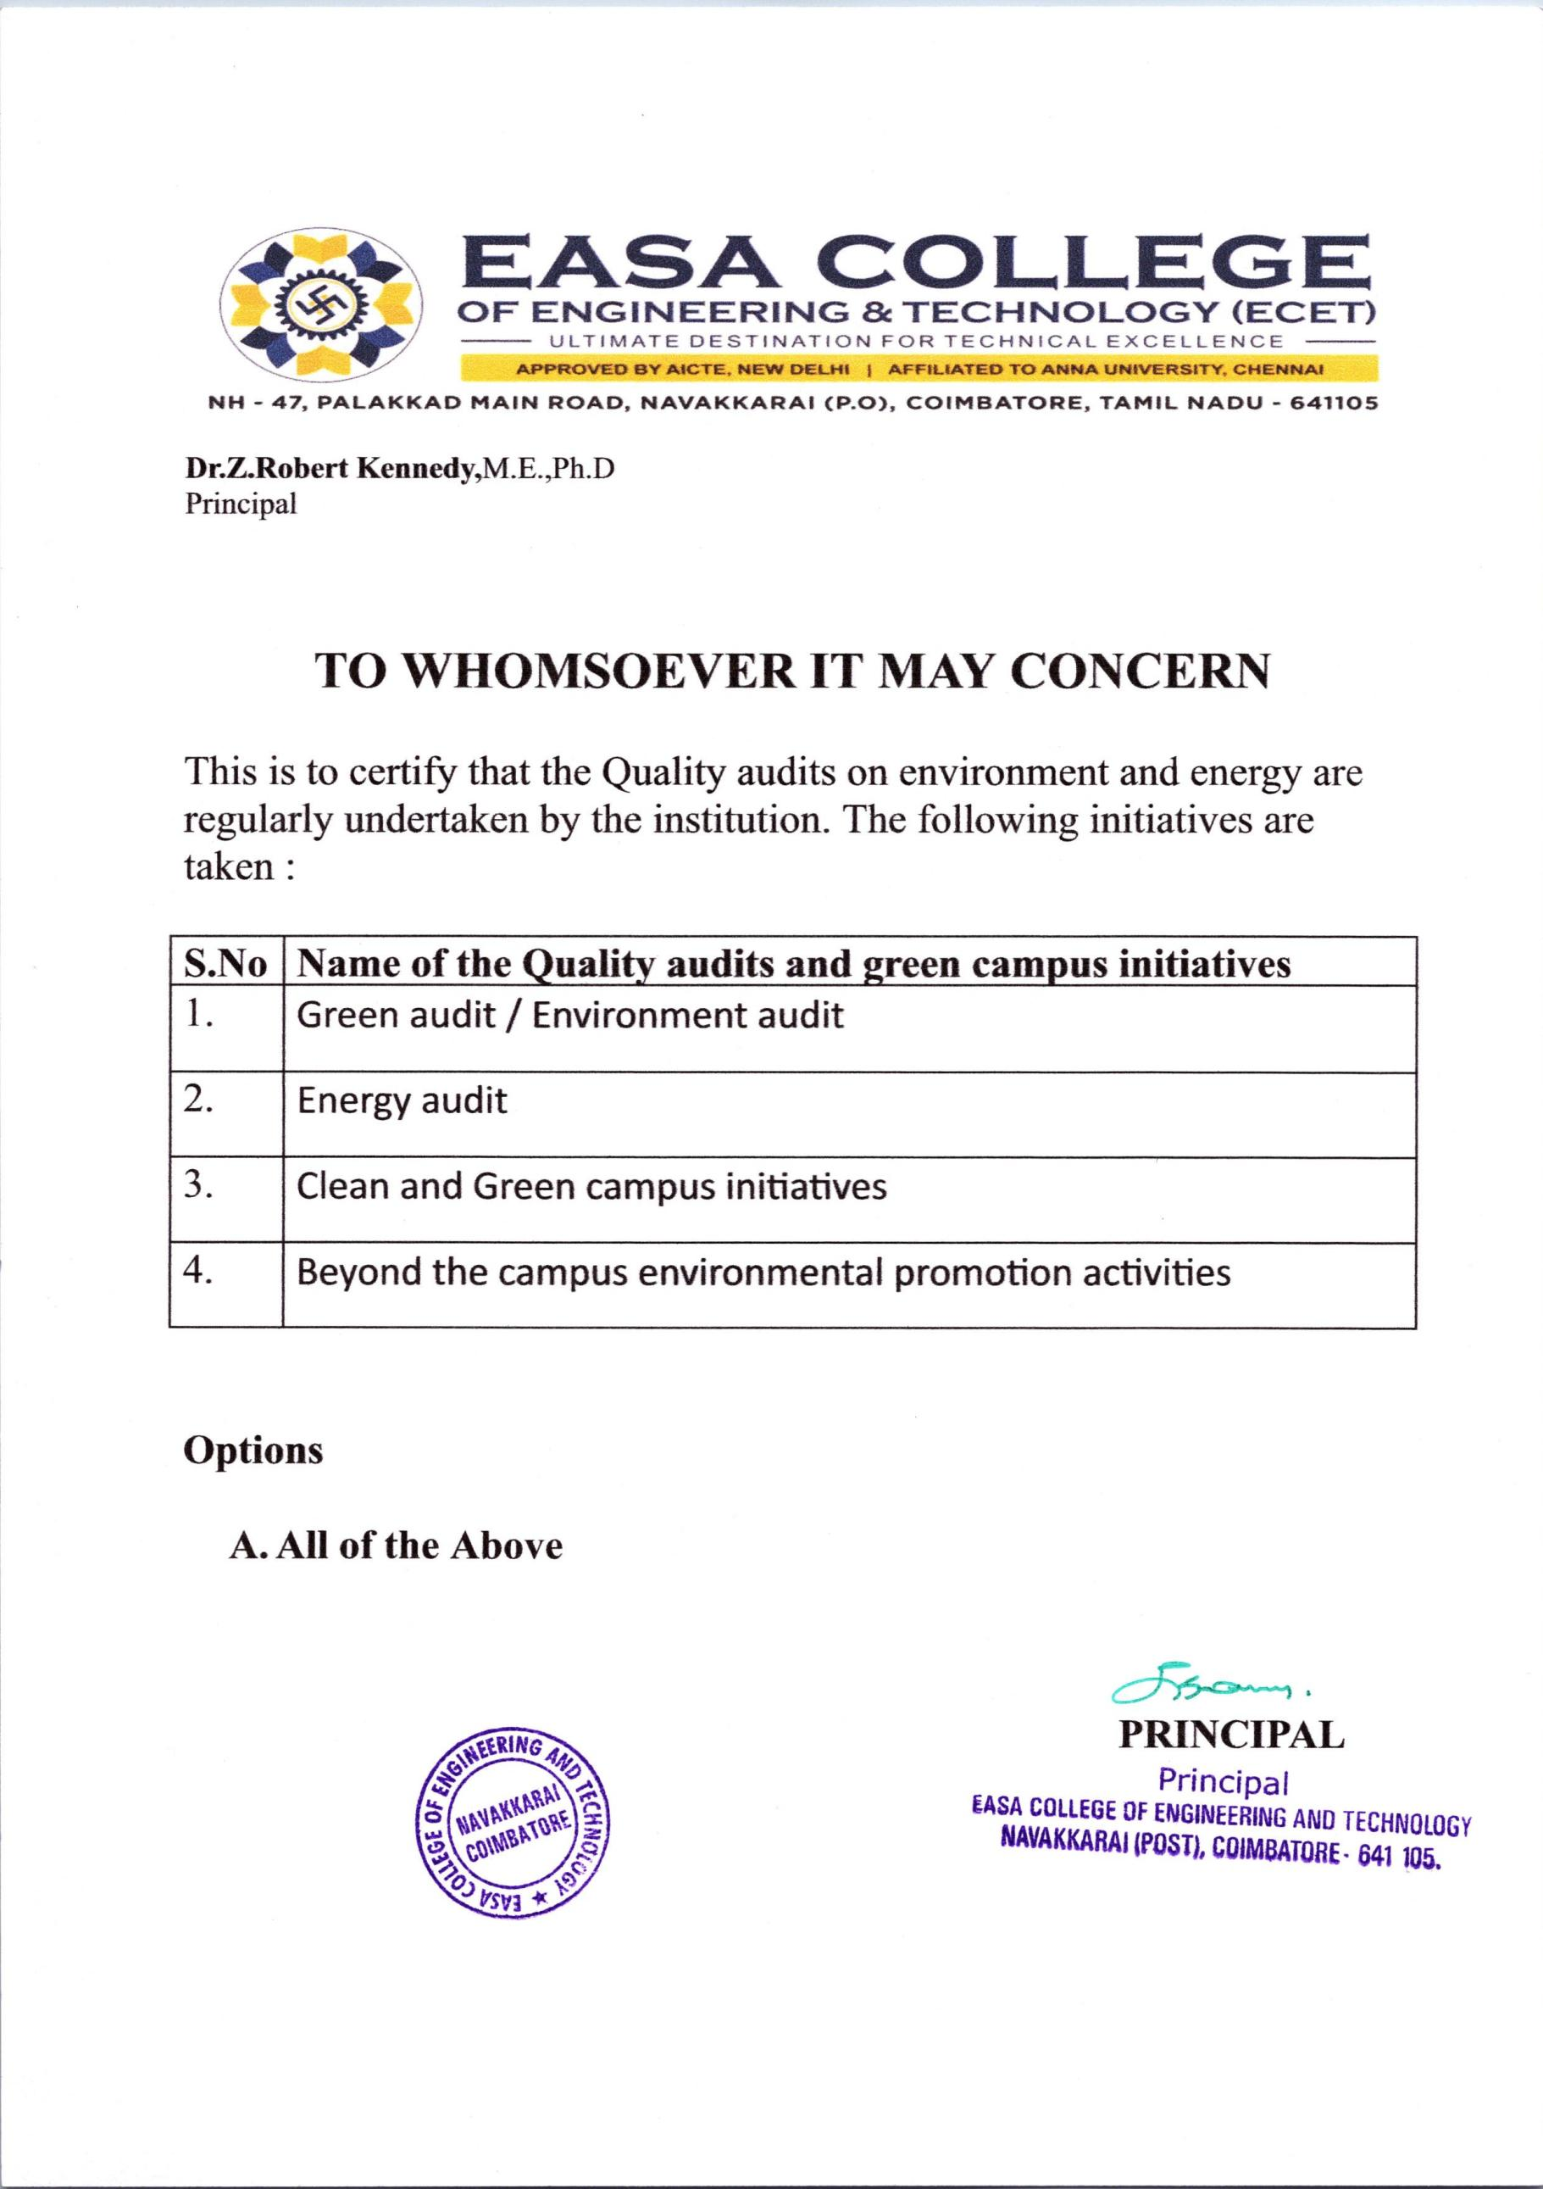



7.1.3 Quality audits on environment and energy regularly undertaken by the institution. The institutional environment and energy initiatives are confirmed through the following

S.No | Parameter | Link
1. | Policy document on environment & energy usage | VIEW
2. | A. Green audit report | VIEW
 | B. Energy audit report | VIEW
 | C. Environment audit report | VIEW
3. | Certificate from the auditing agency | VIEW
4. | Certificates of the award received from the recognized agency | VIEW
5. | Report on beyond the campus environmental promotion activities | VIEW
6. | A. Clean and Green campus initiatives | VIEW
 | B. Action taken report | VIEW
7. | Any other supporting document for the claims made | VIDEO LINK

