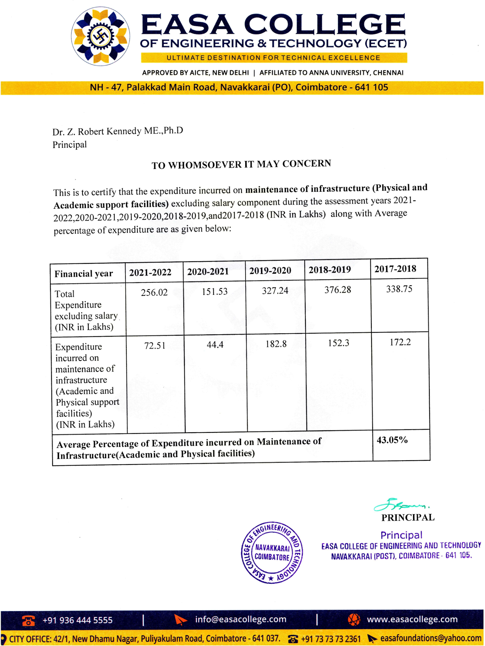


S.NO | Particulars | Link
1 | Audited Statement of total expenditure excluding salary, expenditure Infrastructure Augmentation, expenditure on maintenance of academic and physical maintenance and its facilities for financial years 2021-2022, 2020- 2021, 2019-2020, 2018- 2019, 2017-2018. | VIEW
2 | Audited Financial Statement for the year 2021-2022 | VIEW
3 | Audited Financial Statement for the year 2020-2021 | VIEW
4 | Audited Financial Statement for the year 2019-2020 | VIEW
5 | Audited Financial Statement for the year 2018-2019 | VIEW
6 | Audited Financial Statement for the year 2017-2018 | VIEW

