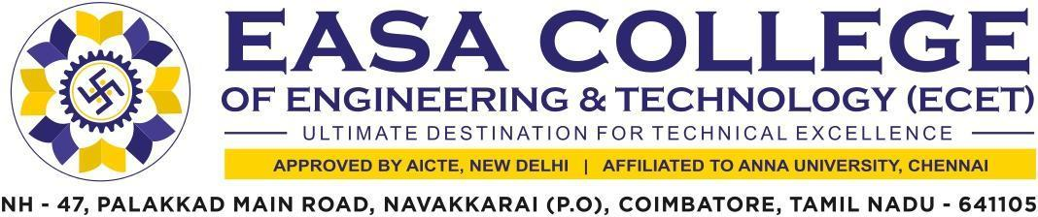

5.1.3 Participant List for Students benefited by Guidance for Competitive examinations and Career Counselling

S. No | Details | Link to the relevant document
1 | Students benefited by guidance for Competitive examinations and career counseling offered by the Institution during 2021-2022 | VIEW FILE
2 | Students benefited by guidance for Competitive examinations and career counseling offered by the Institution during 2020-2021 | VIEW FILE
3 | Students benefited by guidance for Competitive examinations and career counseling offered by the Institution during 2019-2020 | VIEW FILE
4 | Students benefited by guidance for Competitive examinations and career counseling offered by the Institution during 2018-2019 | VIEW FILE
5 | Students benefited by guidance for Competitive examinations and career counseling offered by the Institution during 2017-2018 | VIEW FILE

