**How to run tests**

1. **Right click on CalculatorTest class -> Run As -> Testng Test**

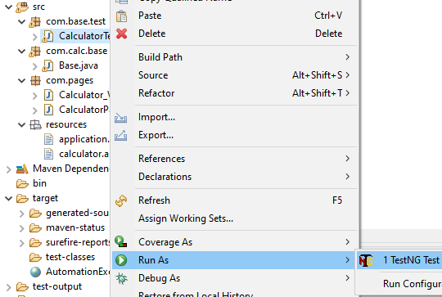

1. **Right click on tetng.xml , select Run As -> testing Test**
2. **Right click on pom.xml -> Run As -> maven test**

**Architecture**

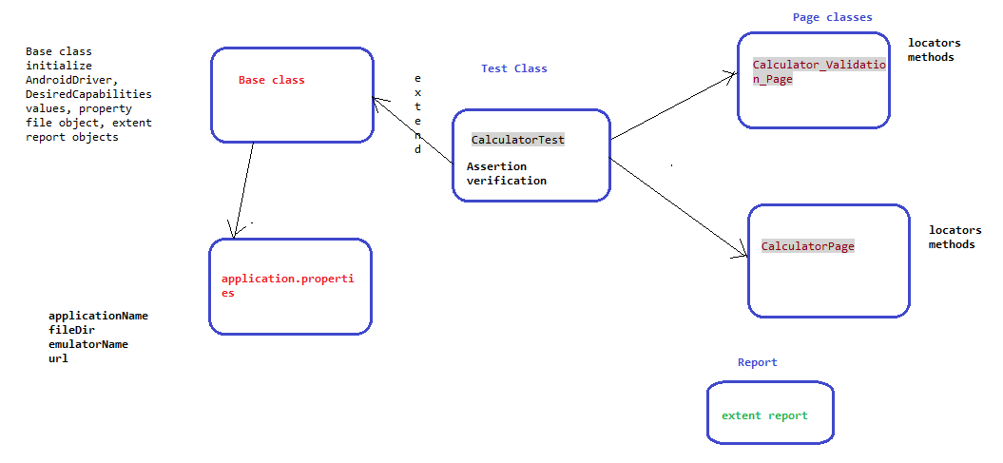

**Testing report**

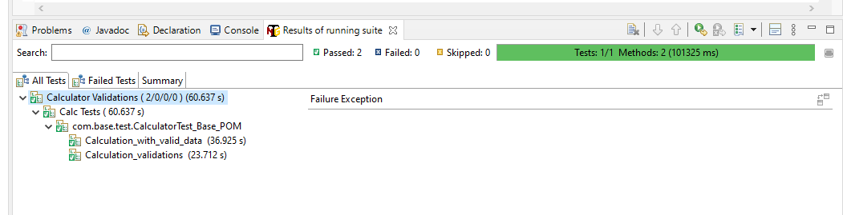

**Sample extent report**

