# REFERENCES LANDING PAGE

## 

## PROGRAM & TICKETS LANDING PAGE



* The buttons need to lead to the accurate part of the page
* buttons “send an e-mail” doesnt do anything :
* unite the size of subtitles, some are bigger and some smaller now (“How to apply” etc.)
* “Apply as Participant” need to lead to mail too

________________________

### 2nd PART: JOIN AS AN ACTIVE AUDITOR AND IMMERSE YOURSELF IN IVANA’S TECHNIQUE

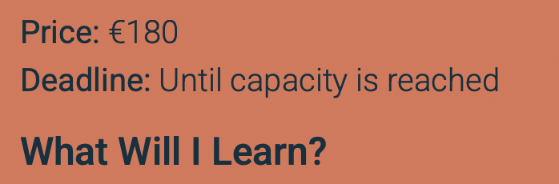

centralise

### 3rd PART: ESSENTIAL INFORMATION

### - lead here from the menu! - you deleted that from the menu

__________________________

### ESSENTIAL INFORMATION !!NEW!! BOOK LAUNCH LANDING PAG

* Title: Exclusive European Book Launch - same font as before, bigger
* add both pics of the books - updated and not updated and make it nice, not just place it there - use graphic design feel please (i liked the mock up in the first version
* button “join the masterclass” have to lead here: <https://itsugestion.com/html/Ivana/program.html>

## PRACTICAL INFORMATION - CHANGE TO “ESSENTIAL INFO”

* lead to program&ticket landing page to the bottom part not to separate landing page

______

when you give me insides to the website, please show me how to link buttons to links :)

## 

## 