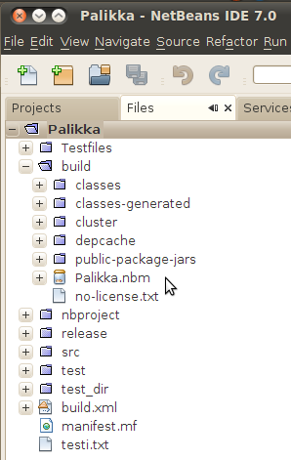
Maintenance document

How to create a Palikka plugin:
In the Projects window, right-click the Palikka project node and choose Create NBM. The new NBM file is created and you can view it in the Files window (Ctrl+2).
.

How to set default server address :
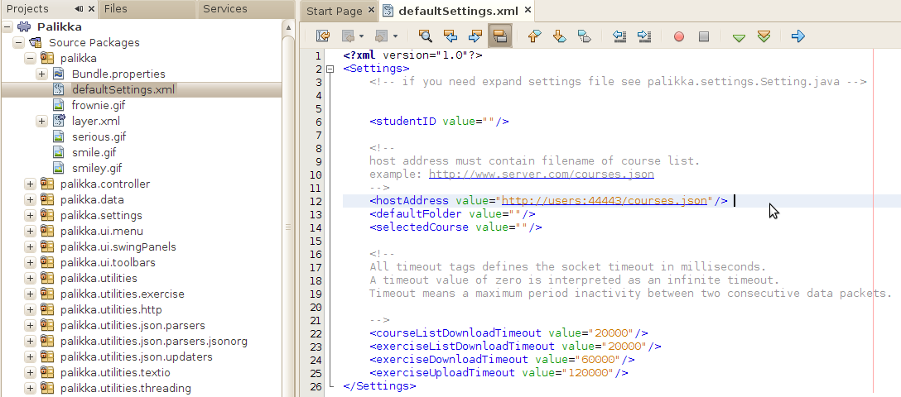
You can change default server address in defaultSettings.xml. Just write the address as hostAddress value.

Known Palikka bugs:
Sometimes when you delete a project/s from Project window and afterwards retrieve deleted exercise/s again you might get a warning as below picture. Warning is something that NetBeans creates but the actual again downloaded exercises are all usable.
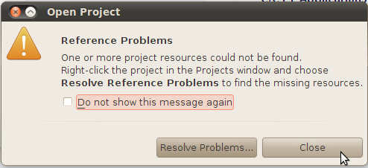

Compile time warnings:
Compiling Palikka gives some warnings that don't affect functionality of Palikka. By adding below listed libraries you can remove all the warning. We didn't add the libraries because of possible licensing issues.

activation.jar
apache-log4j-1.2.16.jar
avalon-framework-api-4.3.jar
avalon-logkit-2.1.jar
jms.jar
mail.jar
servlet-2.3.jar

