Palikka Manual

A short presentation of Palikka
Palikka is a NetBeans plug-in that was created for ohjelmointipaja. With Palikka plug-in you can load programming course's exercisebases into NetBeans platform where you can solve them. After finishing exercises you can run tests to see if your answers were correct. Palikka also allows you to return finished (and unfinished) exercises by send button.

Hardware requirments
To use Palikka plug-in you need NetBeans platform. Palikka was created in NetBeans 7.0 version. We haven't tested it but it could also work on 6.8 and earlier versions. We have tested that Palikka works in Linux and Windows operating systems.

How to install Palikka
- Download Palikka.nbm file from the location school has given you and save it to your computer.
- Open NetBeans and choose Tools > Plugins.
- Under Downloaded click Add Plugins... and browse for the Palikka.nbm file and click OK.
- Make sure Palikka is checked and then click Install button.
- On NetBeans IDE Installer click Next >. Accept the terms in all of the license agreements and click Install.
- Palikka plugin is not signed so when trying to install Palikka Validation warning window shows up. Choose Continue and after installation is done choose Finish. Palikka has been installed and you can now close Plugins window.

Introduction to Palikka
This is a view of NetBeans platform that has Palikka plug-in installed.
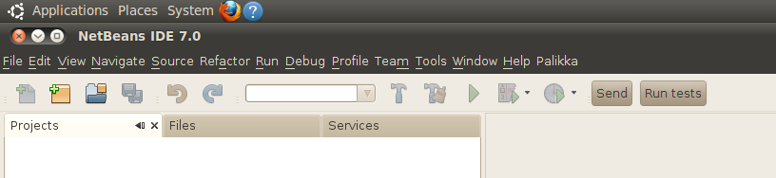
From the above picture you can see that Palikka plugin has added to NetBeans user interface three visible components. In the upper right corner is a Palikka menu, Send and Run tests buttons. Palikka Menu contains three menuitems Preferences, Show exercises and Advanced download. User can get exercises by either clicking Show exercises or using Advanced download option.
If you are using Palikka the first time you have to set preferences before you can get exercises by clicking Show exercises menuitem (Same applies to Advanced download).
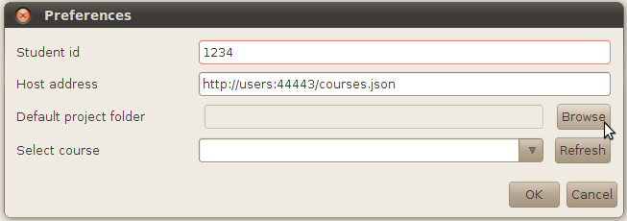
Above picture you can see the Preferences window. Before you can select a course or use a Refresh button you have to set your own student id and select Default project folder. Host address has already been set and you shouldn't change it. Refresh button retrieves courses on Select course combobox. OK button saves preferences changes and exits from the window. Cancel button exits preferences window without saving changes.

After you have set preferences you can get available exercises by clicking Show exercises menuitem. Selected course's exercises that hasn't expired opens on the Projects window.

After you have completed an exercise you can check if your solution is correct by clicking Run tests button. Make sure you have set the exercise you want to check as main project. (You can set project as main project by right clicking a project and selecting a Set as Main Project option.) Send button sends main project's exercise/s to the server.

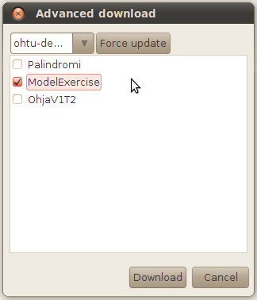
You can also retrieve exercises by using Advanced download. In Advanced download you can retrieve any exercise possible that has been put on the server even the ones whose deadline has already expired. Advanced download is only used to retrieve exercises. You can't send the completed exercises back to the server. Just remember that before you can use the Advanced download your preferences has to be set and that you have clicked the refresh button on the preferences window.
On Advanced download window you can download exercises by first choosing the course from the drop-down list and then exercise/s by clicking checkboxes. Download opens the exercises on the Project window. Force update button forces the exercise list to be updated every time a new course is selected.

Palikka has indicators on projects that shows the state of your exercise
Indicates that you haven't send your exercise.
Indicates that you have send your exercise but it hasn't passed all tests.
Indicates that you have send your exercise and all tests has passed.

