

Факультет программной̆ инженерии и компьютерной̆ техники

Проектирование вычислительных систем

Лабораторная работа №3: Таймеры и интерфейс I2C   
Вариант 2

Преподаватель: Пинкевич Василий Юрьевич

Выполнили: Тарасов Александр Станиславович, Кульбако Артемий Юрьевич Р34112

# Задание

Реализовать настраиваемый пульт включения разных режимов горения светодиодов. По нажатию кнопок клавиатуры выполняются следующие действия:

|  |  |
| --- | --- |
| **Код кнопки** | **Действие** |
| 1-9 | Зажигание светодиода в соответствии с режимом. Предыдущий режим горения отключается, новый режим держится до переключения на следующий режим. Режимы по умолчанию: 1 – зеленый, 10% яркости  2 – зеленый, 40% яркости  3 – зеленый, 100% яркости  4 – желтый, 10% яркости  5 – желтый, 40% яркости  6 – желтый, 100% яркости  7 – красный, 10% яркости  8 – красный, 40% яркости  9 – красный, 100% яркости |
| 10 | Отключить текущий режим (погасить все светодиоды). |
| 11 | Войти в меню настройки. |
| 12 | Выйти из меню настройки. |

По нажатию каждой кнопки в UART должно выводиться сообщение о том, какой режим активирован, или текущие настройки, вводимые в меню.

После входе в меню настройки сначала надо нажать кнопку, привязанный к которой режим требуется изменить, далее кнопками 1 – 3 выбирается светодиод (зеленый, желтый, красный) и кнопками 4, 5 – коэффициент заполнения от 0 до 100% с шагом 10%. По нажатию кнопки выхода из меню новый режим сохраняется.

# Настройка

Микросхема PCA9538 является внешним расширителем GPIO-портов ввода/вывода, который подключается к микроконтроллеру по интерфейсу I2C. Данная микросхема реализует подключение до 8 сигналов, каждый из которых может быть настроен как вход или выход.

Адресный байт содержит постоянную часть и два бита, следовательно, возможно одновременное подключение на шину I2C до 4 одинаковых микросхем. В SDK-1.1M имеется два устройства с адресами 0xE0 (входы прерываний устройств и др.) и 0xE2 (клавиатура). Последний бит адресного байта подчиненного устройства определяет операцию (чтение или запись), которая должна быть выполнена.

Настройка I2C:

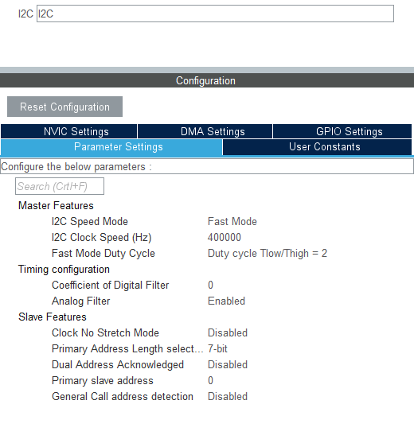

Настройка таймера TIM6:

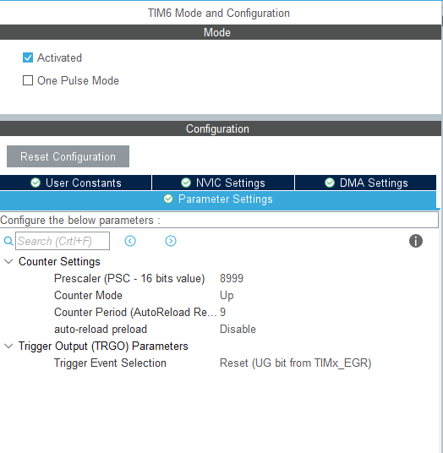

Настройка таймера TIM4:

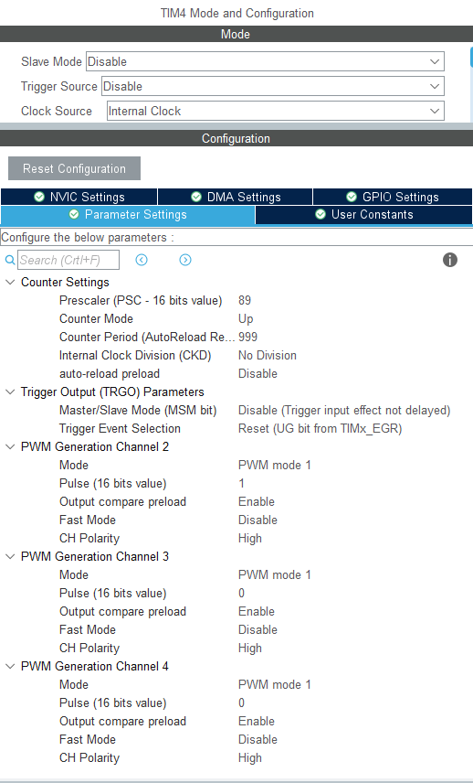

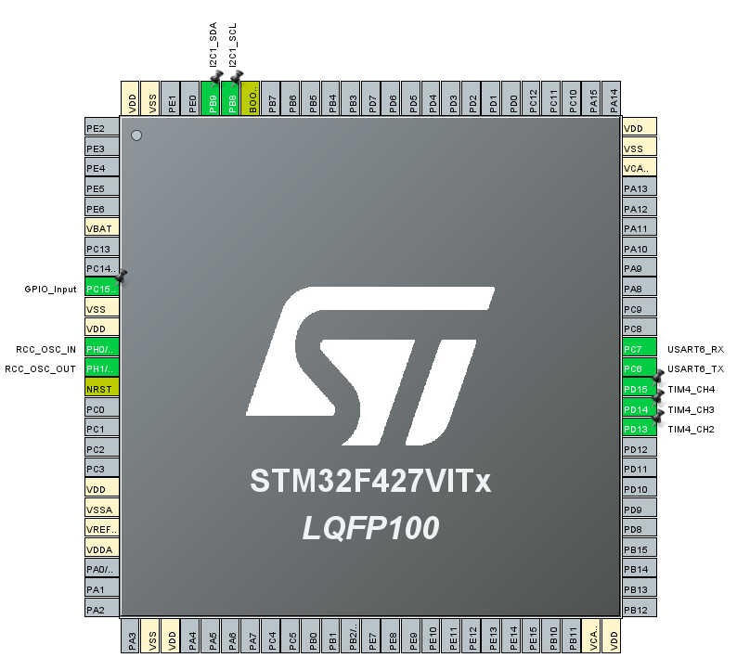Распиновка:

# Блок-схемы

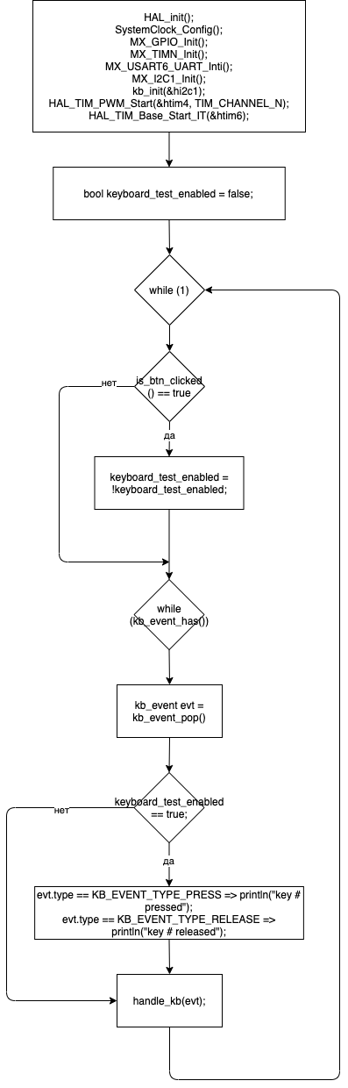Главный программный цикл:

Сканирование клавиатуры:

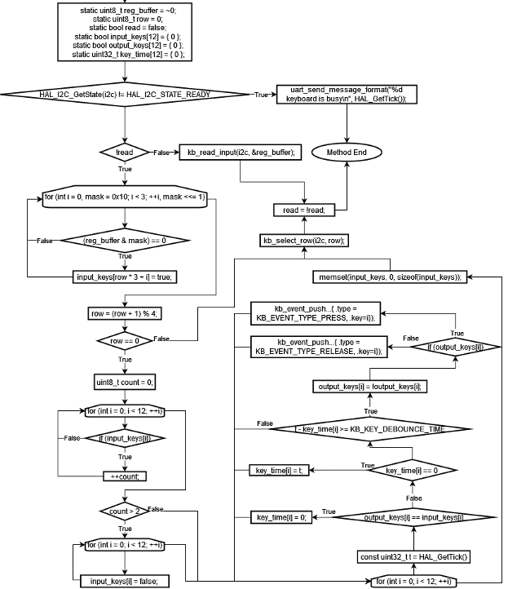

# Код

**#pragma** once

**#include** <stdint.h>

**#include** <stdbool.h>

**#include** "main.h"

**enum** kb_event_type {

*KB_EVENT_TYPE_PRESS* = 0,

*KB_EVENT_TYPE_RELEASE* = 1,

};

**enum** kb_event_key {

*KB_EVENT_KEY_1* = 0,

*KB_EVENT_KEY_2* = 1,

*KB_EVENT_KEY_3* = 2,

*KB_EVENT_KEY_4* = 3,

*KB_EVENT_KEY_5* = 4,

*KB_EVENT_KEY_6* = 5,

*KB_EVENT_KEY_7* = 6,

*KB_EVENT_KEY_8* = 7,

*KB_EVENT_KEY_9* = 8,

*KB_EVENT_KEY_10* = 9,

*KB_EVENT_KEY_11* = 10,

*KB_EVENT_KEY_12* = 11,

};

**struct** kb_event {

**enum** kb_event_type type;

**enum** kb_event_key key;

};

bool **kb_event_has**();

**struct** kb_event **kb_event_pop**();

**void** **kb_init**(I2C_HandleTypeDef * i2c);

**void** **kb_scan_step**(I2C_HandleTypeDef * i2c);

**#pragma** once

**#include** <stdint.h>

**enum** LED {

*GREEN* = 0,

*YELLOW* = 1,

*RED* = 2,

};

**struct** GarlandMode {

**enum** LED color;

uint8_t brightness;

};

**extern** **const** **char** * **const** led_names[];

**void** **led_set_brightness**(**enum** LED led, uint8_t power);

**static** **void** **led_mode_enable**(**struct** GarlandMode mode) { led_set_brightness(mode.color, mode.brightness); }

**static** **void** **led_mode_disable**(**struct** GarlandMode mode) { led_set_brightness(mode.color, 0); }

**#pragma** once

**#include** <stdint.h>

**#include** <string.h>

**void** **print**(**const** **char** * content);

**void** **println**(**const** **char** * message);

**void** **print_format**(**const** **char** * format, ...);

**#include** <KEYBOARD.h>

**#include** <stdbool.h>

**#include** <stddef.h>

**#include** <UART.h>

**#define** BUFFER_CAPACITY (32)

**#define** INC_BUFFER_IDX(__idx) **do** { (__idx) = ((__idx) + 1) % (BUFFER_CAPACITY); } **while** (0)

**#define** KB_I2C_ADDRESS (0xE2)

**#define** KB_I2C_READ_ADDRESS ((KB_I2C_ADDRESS) | 1)

**#define** KB_I2C_WRITE_ADDRESS ((KB_I2C_ADDRESS) & ~1)

**#define** KB_INPUT_REG (0x0)

**#define** KB_OUTPUT_REG (0x1)

**#define** KB_CONFIG_REG (0x3)

**#define** KB_KEY_DEBOUNCE_TIME (50)

**static** **struct** kb_event buffer[BUFFER_CAPACITY] = { 0 };

**static** size_t buffer_start_idx = 0;

**static** size_t buffer_end_idx = 0;

**static** **void** **kb_event_push**(**struct** kb_event event) {

buffer[buffer_end_idx] = event;

INC_BUFFER_IDX(buffer_end_idx);

}

bool **kb_event_has**() {

**const** uint32_t priMask = __get_PRIMASK();

__disable_irq();

**const** bool ret = buffer_start_idx != buffer_end_idx;

__set_PRIMASK(priMask);

**return** ret;

}

**struct** kb_event **kb_event_pop**() {

**const** uint32_t priMask = __get_PRIMASK();

__disable_irq();

**const** **struct** kb_event evt = buffer[buffer_start_idx];

INC_BUFFER_IDX(buffer_start_idx);

__set_PRIMASK(priMask);

**return** evt;

}

**void** **kb_init**(I2C_HandleTypeDef * i2c) {

**static** uint8_t output = 0x0;

HAL_I2C_Mem_Write(i2c, KB_I2C_WRITE_ADDRESS, KB_OUTPUT_REG, 1, &output, 1, 100);

}

**static** **void** **kb_write_config**(I2C_HandleTypeDef * i2c, uint8_t data) {

**static** uint8_t buf;

buf = data;

HAL_I2C_Mem_Write_IT(i2c, KB_I2C_WRITE_ADDRESS, KB_CONFIG_REG, 1, &buf, 1);

}

**static** **void** **kb_select_row**(I2C_HandleTypeDef * i2c, uint8_t row) {

kb_write_config(i2c, ~((uint8_t) (1 << row)));

}

**static** **void** **kb_read_input**(I2C_HandleTypeDef * i2c, uint8_t * data) {

HAL_I2C_Mem_Read_IT(i2c, KB_I2C_READ_ADDRESS, KB_INPUT_REG, 1, data, 1); }

**void** **kb_scan_step**(I2C_HandleTypeDef * i2c) {

**static** uint8_t reg_buffer = ~0;

**static** uint8_t row = 0;

**static** bool read = false;

**static** bool input_keys[12] = { 0 };

**static** bool output_keys[12] = { 0 };

**static** uint32_t key_time[12] = { 0 };

**if** (HAL_I2C_GetState(i2c) != *HAL_I2C_STATE_READY*) **return**;

**if** (!read) {

**for** (uint8_t i = 0, mask = 0x10; i < 3; ++i, mask <<= 1)

**if** ((reg_buffer & mask) == 0)

input_keys[row * 3 + i] = true;

row = (row + 1) % 4;

**if** (row == 0) {

uint8_t count = 0;

**for** (**int** i = 0; i < 12; ++i)

**if** (input_keys[i])

++count;

**if** (count > 2)

**for** (**int** i = 0; i < 12; ++i)

input_keys[i] = false;

**for** (**int** i = 0; i < 12; ++i) {

**const** uint32_t t = HAL_GetTick();

**if** (output_keys[i] == input_keys[i]) key_time[i] = 0;

**else** **if** (key_time[i] == 0) key_time[i] = t;

**else** **if** (t - key_time[i] >= KB_KEY_DEBOUNCE_TIME) {

output_keys[i] = !output_keys[i];

**if** (output_keys[i]) kb_event_push((**struct** kb_event) { .type = *KB_EVENT_TYPE_PRESS*, .key = i });

**else** kb_event_push((**struct** kb_event) { .type = *KB_EVENT_TYPE_RELEASE*, .key = i });

}

}

**memset**(input_keys, 0, **sizeof**(input_keys));

}

kb_select_row(i2c, row);

} **else** kb_read_input(i2c, &reg_buffer);

read = !read;

}

**#include** <LED.h>

**#include** "main.h"

**extern** TIM_HandleTypeDef htim4;

**const** **char** * **const** led_names[] = {

[*GREEN*] = "GREEN",

[*YELLOW*] = "YELLOW",

[*RED*] = "RED",

};

**typedef** **void** (* abstract_LED_setter)(uint16_t);

**static** **void** **set_green_LED**(uint16_t power) { htim4.Instance->CCR2 = power; }

**static** **void** **set_yellow_LED**(uint16_t power) { htim4.Instance->CCR3 = power; }

**static** **void** **set_red_LED**(uint16_t power) { htim4.Instance->CCR4 = power; }

**static** **const** abstract_LED_setter led_setters[] = {

[*GREEN*] = set_green_LED,

[*YELLOW*] = set_yellow_LED,

[*RED*] = set_red_LED,

};

**void** **led_set_brightness**(**enum** LED led, uint8_t power) {

**if** (power > 100) power = 100;

led_setters[led]((uint16_t) power * 10);

}

/* USER CODE BEGIN Header */

/**

******************************************************************************

* @file : main.c

* @brief : Main program body

******************************************************************************

* @attention

*

* <h2><center>&copy; Copyright (c) 2021 STMicroelectronics.

* All rights reserved.</center></h2>

*

* This software component is licensed by ST under BSD 3-Clause license,

* the "License"; You may not use this file except in compliance with the

* License. You may obtain a copy of the License at:

* opensource.org/licenses/BSD-3-Clause

*

******************************************************************************

*/

/* USER CODE END Header */

/* Includes ------------------------------------------------------------------*/

**#include** <KEYBOARD.h>

**#include** <LED.h>

**#include** <UART.h>

**#include** "main.h"

/* Private includes ----------------------------------------------------------*/

/* USER CODE BEGIN Includes */

/* USER CODE END Includes */

/* Private typedef -----------------------------------------------------------*/

/* USER CODE BEGIN PTD */

/* USER CODE END PTD */

/* Private define ------------------------------------------------------------*/

/* USER CODE BEGIN PD */

**#define** BTN_DEBOUNCE_TIME (100)

/* USER CODE END PD */

/* Private macro -------------------------------------------------------------*/

/* USER CODE BEGIN PM */

/* USER CODE END PM */

/* Private variables ---------------------------------------------------------*/

I2C_HandleTypeDef hi2c1;

TIM_HandleTypeDef htim4;

TIM_HandleTypeDef htim6;

UART_HandleTypeDef huart6;

/* USER CODE BEGIN PV */

/* USER CODE END PV */

/* Private function prototypes -----------------------------------------------*/

**void** **SystemClock_Config**(**void**);

**static** **void** **MX_GPIO_Init**(**void**);

**static** **void** **MX_TIM4_Init**(**void**);

**static** **void** **MX_TIM6_Init**(**void**);

**static** **void** **MX_USART6_UART_Init**(**void**);

**static** **void** **MX_I2C1_Init**(**void**);

/* USER CODE BEGIN PFP */

/* USER CODE END PFP */

/* Private user code ---------------------------------------------------------*/

/* USER CODE BEGIN 0 */

**static** **struct** GarlandMode led_modes[9] = {

{ .color = *GREEN*, .brightness = 10 },

{ .color = *GREEN*, .brightness = 40 },

{ .color = *GREEN*, .brightness = 100 },

{ .color = *YELLOW*, .brightness = 10 },

{ .color = *YELLOW*, .brightness = 40 },

{ .color = *YELLOW*, .brightness = 100 },

{ .color = *RED*, .brightness = 10 },

{ .color = *RED*, .brightness = 40 },

{ .color = *RED*, .brightness = 100 },

};

**static** bool **is_button_clicked**() {

**static** bool output_btn = false;

**static** uint32_t btn_time = 0;

**const** bool input_btn = HAL_GPIO_ReadPin(GPIOC, GPIO_PIN_15) == *GPIO_PIN_RESET*;

**const** uint32_t t = HAL_GetTick();

**if** (input_btn == output_btn) btn_time = 0;

**else** **if** (btn_time == 0) btn_time = t;

**else** **if** (btn_time - t >= BTN_DEBOUNCE_TIME) {

output_btn = !output_btn;

**if** (output_btn) **return** true;

}

**return** false;

}

**static** bool **handle_kb_menu**(**struct** kb_event evt) {

**static** **struct** GarlandMode new_mode = { 0 };

**static** uint8_t new_mode_number = 0;

**static** bool is_number_selected = false;

**static** bool is_color_selected = false;

**static** bool may_reset = false;

**switch** (evt.key) {

**case** *KB_EVENT_KEY_1*:

**case** *KB_EVENT_KEY_2*:

**case** *KB_EVENT_KEY_3*:

**case** *KB_EVENT_KEY_4*:

**case** *KB_EVENT_KEY_5*:

**case** *KB_EVENT_KEY_6*:

**case** *KB_EVENT_KEY_7*:

**case** *KB_EVENT_KEY_8*:

**case** *KB_EVENT_KEY_9*:

**if** (!is_number_selected) {

new_mode_number = evt.key;

is_number_selected = true;

**break**;

}

**switch** (evt.key) {

**case** *KB_EVENT_KEY_1*:

**case** *KB_EVENT_KEY_2*:

**case** *KB_EVENT_KEY_3*:

is_color_selected = true;

new_mode.color = (**enum** LED) evt.key;

**break**;

**case** *KB_EVENT_KEY_4*:

**if** (new_mode.brightness >= 10) new_mode.brightness = new_mode.brightness - 10;

**break**;

**case** *KB_EVENT_KEY_5*:

new_mode.brightness = (new_mode.brightness + 10) % 110;

**break**;

**default**:

// do nothing

**break**;

}

**break**;

**case** *KB_EVENT_KEY_10*:

**case** *KB_EVENT_KEY_11*:

// do nothing

**break**;

**case** *KB_EVENT_KEY_12*:

**if** (is_number_selected && is_color_selected) {

println("new mode saved");

led_modes[new_mode_number] = new_mode;

}

**else** **if** (may_reset) println("discarding all changes");

**else** {

may_reset = true;

**if** (!is_number_selected) println("you should provide number of new mode");

**if** (!is_color_selected) println("you should provide color of new mode");

println("nothing to save, press again to discard and leave");

**return** true;

}

println("config mode == OFF");

**return** false;

}

**if** (!is_number_selected && !is_color_selected) print_format("new mode params: number is not selected, color is not selected, brightness = %d%%\r\n", new_mode.brightness);

**else** **if** (!is_number_selected) print_format("new mode params: number is not selected, color = %s, brightness = %d%%\r\n", led_names[new_mode.color], new_mode.brightness);

**else** **if** (!is_color_selected) print_format("new mode params: number = %d, color is not selected, brightness = %d%%\r\n", new_mode_number + 1, new_mode.brightness);

**else** print_format("new mode params: number = %d, color = %s, brightness = %d%%\r\n", new_mode_number + 1, led_names[new_mode.color], new_mode.brightness);

may_reset = false;

**return** true;

}

**static** **void** **handle_kb**(**struct** kb_event evt) {

**static** uint8_t current_mode = 9;

**static** bool in_menu = false;

**if** (evt.type == *KB_EVENT_TYPE_PRESS*) {

**if** (in_menu) in_menu = handle_kb_menu(evt);

**else** **switch** (evt.key) {

**case** *KB_EVENT_KEY_1*:

**case** *KB_EVENT_KEY_2*:

**case** *KB_EVENT_KEY_3*:

**case** *KB_EVENT_KEY_4*:

**case** *KB_EVENT_KEY_5*:

**case** *KB_EVENT_KEY_6*:

**case** *KB_EVENT_KEY_7*:

**case** *KB_EVENT_KEY_8*:

**case** *KB_EVENT_KEY_9*:

**case** *KB_EVENT_KEY_10*:

**if** (current_mode < 9) led_mode_disable(led_modes[current_mode]);

current_mode = evt.key;

**if** (current_mode < 9) {

led_mode_enable(led_modes[current_mode]);

print_format("activated LED mode #%d\r\n", current_mode + 1);

} **else** println("disabled LEDs");

**break**;

**case** *KB_EVENT_KEY_11*:

println("config mode == ON");

in_menu = true;

**break**;

**case** *KB_EVENT_KEY_12*:

// do nothing

**break**;

}

}

}

/* USER CODE END 0 */

/**

* @brief The application entry point.

* @retval int

*/

**int** **main**(**void**)

{

/* USER CODE BEGIN 1 */

/* USER CODE END 1 */

/* MCU Configuration--------------------------------------------------------*/

/* Reset of all peripherals, Initializes the Flash interface and the Systick. */

HAL_Init();

/* USER CODE BEGIN Init */

/* USER CODE END Init */

/* Configure the system clock */

SystemClock_Config();

/* USER CODE BEGIN SysInit */

/* USER CODE END SysInit */

/* Initialize all configured peripherals */

MX_GPIO_Init();

MX_TIM4_Init();

MX_TIM6_Init();

MX_USART6_UART_Init();

MX_I2C1_Init();

/* USER CODE BEGIN 2 */

kb_init(&hi2c1);

HAL_TIM_PWM_Start(&htim4, TIM_CHANNEL_2);

HAL_TIM_PWM_Start(&htim4, TIM_CHANNEL_3);

HAL_TIM_PWM_Start(&htim4, TIM_CHANNEL_4);

HAL_TIM_Base_Start_IT(&htim6);

/* USER CODE END 2 */

/* Infinite loop */

/* USER CODE BEGIN WHILE */

bool keyboard_test_enabled = false;

**while** (1) {

/* USER CODE END WHILE */

**if** (is_button_clicked()) {

**if** (keyboard_test_enabled) println("keyboard test == ON");

**else** println("keyboard test == OFF");

keyboard_test_enabled = !keyboard_test_enabled;

}

/* USER CODE BEGIN 3 */

**while** (kb_event_has()) {

**struct** kb_event evt = kb_event_pop();

**if** (keyboard_test_enabled) {

**switch** (evt.type) {

**case** *KB_EVENT_TYPE_PRESS*:

print_format("key %d pressed\r\n", evt.key + 1);

**break**;

**case** *KB_EVENT_TYPE_RELEASE*:

print_format("key %d released\r\n", evt.key + 1);

**break**;

}

} **else** handle_kb(evt);

}

} /* USER CODE END 3 */

}

/**

* @brief System Clock Configuration

* @retval None

*/

**void** **SystemClock_Config**(**void**)

{

RCC_OscInitTypeDef RCC_OscInitStruct = {0};

RCC_ClkInitTypeDef RCC_ClkInitStruct = {0};

/** Configure the main internal regulator output voltage

*/

__HAL_RCC_PWR_CLK_ENABLE();

__HAL_PWR_VOLTAGESCALING_CONFIG(PWR_REGULATOR_VOLTAGE_SCALE1);

/** Initializes the CPU, AHB and APB busses clocks

*/

RCC_OscInitStruct.OscillatorType = RCC_OSCILLATORTYPE_HSE;

RCC_OscInitStruct.HSEState = RCC_HSE_ON;

RCC_OscInitStruct.PLL.PLLState = RCC_PLL_ON;

RCC_OscInitStruct.PLL.PLLSource = RCC_PLLSOURCE_HSE;

RCC_OscInitStruct.PLL.PLLM = 15;

RCC_OscInitStruct.PLL.PLLN = 216;

RCC_OscInitStruct.PLL.PLLP = RCC_PLLP_DIV2;

RCC_OscInitStruct.PLL.PLLQ = 4;

**if** (HAL_RCC_OscConfig(&RCC_OscInitStruct) != *HAL_OK*)

{

Error_Handler();

}

/** Activate the Over-Drive mode

*/

**if** (HAL_PWREx_EnableOverDrive() != *HAL_OK*)

{

Error_Handler();

}

/** Initializes the CPU, AHB and APB busses clocks

*/

RCC_ClkInitStruct.ClockType = RCC_CLOCKTYPE_HCLK|RCC_CLOCKTYPE_SYSCLK

|RCC_CLOCKTYPE_PCLK1|RCC_CLOCKTYPE_PCLK2;

RCC_ClkInitStruct.SYSCLKSource = RCC_SYSCLKSOURCE_PLLCLK;

RCC_ClkInitStruct.AHBCLKDivider = RCC_SYSCLK_DIV1;

RCC_ClkInitStruct.APB1CLKDivider = RCC_HCLK_DIV4;

RCC_ClkInitStruct.APB2CLKDivider = RCC_HCLK_DIV2;

**if** (HAL_RCC_ClockConfig(&RCC_ClkInitStruct, FLASH_LATENCY_5) != *HAL_OK*)

{

Error_Handler();

}

}

/**

* @brief I2C1 Initialization Function

* @param None

* @retval None

*/

**static** **void** **MX_I2C1_Init**(**void**)

{

/* USER CODE BEGIN I2C1_Init 0 */

/* USER CODE END I2C1_Init 0 */

/* USER CODE BEGIN I2C1_Init 1 */

/* USER CODE END I2C1_Init 1 */

hi2c1.Instance = I2C1;

hi2c1.Init.ClockSpeed = 400000;

hi2c1.Init.DutyCycle = I2C_DUTYCYCLE_2;

hi2c1.Init.OwnAddress1 = 0;

hi2c1.Init.AddressingMode = I2C_ADDRESSINGMODE_7BIT;

hi2c1.Init.DualAddressMode = I2C_DUALADDRESS_DISABLE;

hi2c1.Init.OwnAddress2 = 0;

hi2c1.Init.GeneralCallMode = I2C_GENERALCALL_DISABLE;

hi2c1.Init.NoStretchMode = I2C_NOSTRETCH_DISABLE;

**if** (HAL_I2C_Init(&hi2c1) != *HAL_OK*)

{

Error_Handler();

}

/** Configure Analogue filter

*/

**if** (HAL_I2CEx_ConfigAnalogFilter(&hi2c1, I2C_ANALOGFILTER_ENABLE) != *HAL_OK*)

{

Error_Handler();

}

/** Configure Digital filter

*/

**if** (HAL_I2CEx_ConfigDigitalFilter(&hi2c1, 0) != *HAL_OK*)

{

Error_Handler();

}

/* USER CODE BEGIN I2C1_Init 2 */

/* USER CODE END I2C1_Init 2 */

}

/**

* @brief TIM4 Initialization Function

* @param None

* @retval None

*/

**static** **void** **MX_TIM4_Init**(**void**)

{

/* USER CODE BEGIN TIM4_Init 0 */

/* USER CODE END TIM4_Init 0 */

TIM_ClockConfigTypeDef sClockSourceConfig = {0};

TIM_MasterConfigTypeDef sMasterConfig = {0};

TIM_OC_InitTypeDef sConfigOC = {0};

/* USER CODE BEGIN TIM4_Init 1 */

/* USER CODE END TIM4_Init 1 */

htim4.Instance = TIM4;

htim4.Init.Prescaler = 89;

htim4.Init.CounterMode = TIM_COUNTERMODE_UP;

htim4.Init.Period = 999;

htim4.Init.ClockDivision = TIM_CLOCKDIVISION_DIV1;

htim4.Init.AutoReloadPreload = TIM_AUTORELOAD_PRELOAD_DISABLE;

**if** (HAL_TIM_Base_Init(&htim4) != *HAL_OK*)

{

Error_Handler();

}

sClockSourceConfig.ClockSource = TIM_CLOCKSOURCE_INTERNAL;

**if** (HAL_TIM_ConfigClockSource(&htim4, &sClockSourceConfig) != *HAL_OK*)

{

Error_Handler();

}

**if** (HAL_TIM_PWM_Init(&htim4) != *HAL_OK*)

{

Error_Handler();

}

sMasterConfig.MasterOutputTrigger = TIM_TRGO_RESET;

sMasterConfig.MasterSlaveMode = TIM_MASTERSLAVEMODE_DISABLE;

**if** (HAL_TIMEx_MasterConfigSynchronization(&htim4, &sMasterConfig) != *HAL_OK*)

{

Error_Handler();

}

sConfigOC.OCMode = TIM_OCMODE_PWM1;

sConfigOC.Pulse = 0;

sConfigOC.OCPolarity = TIM_OCPOLARITY_HIGH;

sConfigOC.OCFastMode = TIM_OCFAST_DISABLE;

**if** (HAL_TIM_PWM_ConfigChannel(&htim4, &sConfigOC, TIM_CHANNEL_2) != *HAL_OK*)

{

Error_Handler();

}

**if** (HAL_TIM_PWM_ConfigChannel(&htim4, &sConfigOC, TIM_CHANNEL_3) != *HAL_OK*)

{

Error_Handler();

}

**if** (HAL_TIM_PWM_ConfigChannel(&htim4, &sConfigOC, TIM_CHANNEL_4) != *HAL_OK*)

{

Error_Handler();

}

/* USER CODE BEGIN TIM4_Init 2 */

/* USER CODE END TIM4_Init 2 */

HAL_TIM_MspPostInit(&htim4);

}

/**

* @brief TIM6 Initialization Function

* @param None

* @retval None

*/

**static** **void** **MX_TIM6_Init**(**void**)

{

/* USER CODE BEGIN TIM6_Init 0 */

/* USER CODE END TIM6_Init 0 */

TIM_MasterConfigTypeDef sMasterConfig = {0};

/* USER CODE BEGIN TIM6_Init 1 */

/* USER CODE END TIM6_Init 1 */

htim6.Instance = TIM6;

htim6.Init.Prescaler = 8999;

htim6.Init.CounterMode = TIM_COUNTERMODE_UP;

htim6.Init.Period = 9;

htim6.Init.AutoReloadPreload = TIM_AUTORELOAD_PRELOAD_DISABLE;

**if** (HAL_TIM_Base_Init(&htim6) != *HAL_OK*)

{

Error_Handler();

}

sMasterConfig.MasterOutputTrigger = TIM_TRGO_RESET;

sMasterConfig.MasterSlaveMode = TIM_MASTERSLAVEMODE_DISABLE;

**if** (HAL_TIMEx_MasterConfigSynchronization(&htim6, &sMasterConfig) != *HAL_OK*)

{

Error_Handler();

}

/* USER CODE BEGIN TIM6_Init 2 */

/* USER CODE END TIM6_Init 2 */

}

/**

* @brief USART6 Initialization Function

* @param None

* @retval None

*/

**static** **void** **MX_USART6_UART_Init**(**void**)

{

/* USER CODE BEGIN USART6_Init 0 */

/* USER CODE END USART6_Init 0 */

/* USER CODE BEGIN USART6_Init 1 */

/* USER CODE END USART6_Init 1 */

huart6.Instance = USART6;

huart6.Init.BaudRate = 115200;

huart6.Init.WordLength = UART_WORDLENGTH_8B;

huart6.Init.StopBits = UART_STOPBITS_1;

huart6.Init.Parity = UART_PARITY_NONE;

huart6.Init.Mode = UART_MODE_TX_RX;

huart6.Init.HwFlowCtl = UART_HWCONTROL_NONE;

huart6.Init.OverSampling = UART_OVERSAMPLING_16;

**if** (HAL_UART_Init(&huart6) != *HAL_OK*)

{

Error_Handler();

}

/* USER CODE BEGIN USART6_Init 2 */

/* USER CODE END USART6_Init 2 */

}

/**

* @brief GPIO Initialization Function

* @param None

* @retval None

*/

**static** **void** **MX_GPIO_Init**(**void**)

{

GPIO_InitTypeDef GPIO_InitStruct = {0};

/* GPIO Ports Clock Enable */

__HAL_RCC_GPIOC_CLK_ENABLE();

__HAL_RCC_GPIOH_CLK_ENABLE();

__HAL_RCC_GPIOD_CLK_ENABLE();

__HAL_RCC_GPIOB_CLK_ENABLE();

/*Configure GPIO pin : PC15 */

GPIO_InitStruct.Pin = GPIO_PIN_15;

GPIO_InitStruct.Mode = GPIO_MODE_INPUT;

GPIO_InitStruct.Pull = GPIO_NOPULL;

HAL_GPIO_Init(GPIOC, &GPIO_InitStruct);

}

/* USER CODE BEGIN 4 */

**void** **HAL_TIM_PeriodElapsedCallback**(TIM_HandleTypeDef * htim) {

**if** (htim->Instance == TIM6) {

kb_scan_step(&hi2c1);

}

}

/* USER CODE END 4 */

/**

* @brief This function is executed in case of error occurrence.

* @retval None

*/

**void** **Error_Handler**(**void**)

{

/* USER CODE BEGIN Error_Handler_Debug */

/* User can add his own implementation to report the HAL error return state */

/* USER CODE END Error_Handler_Debug */

}

**#ifdef** USE_FULL_ASSERT

/**

* @brief Reports the name of the source file and the source line number

* where the assert_param error has occurred.

* @param file: pointer to the source file name

* @param line: assert_param error line source number

* @retval None

*/

**void** assert_failed(uint8_t *file, uint32_t line)

{

/* USER CODE BEGIN 6 */

/* User can add his own implementation to report the file name and line number,

tex: printf("Wrong parameters value: file %s on line %d\r\n", file, line) */

/* USER CODE END 6 */

}

**#endif** /* USE_FULL_ASSERT */

/************************ (C) COPYRIGHT STMicroelectronics *****END OF FILE****/

**#include** <stdbool.h>

**#include** <stdarg.h>

**#include** <stdio.h>

**#include** <UART.h>

**#include** "main.h"

**extern** UART_HandleTypeDef huart6;

**static** **inline** bool **uart_is_ready**() { **return** HAL_UART_GetState(&huart6) == *HAL_UART_STATE_READY*; }

**void** **print**(**const** **char** * content) {

**while** (!uart_is_ready());

HAL_UART_Transmit_IT(&huart6, (**void** *) content, **strlen**(content));

}

**void** **println**(**const** **char** * message) {

print(message);

print("\r\n");

}

**void** **print_format**(**const** **char** * format, ...) {

**static** **char** buffer[1024];

**while** (!uart_is_ready());

va_list ap;

va_start(ap, format);

**vsnprintf**(buffer, **sizeof**(buffer), format, ap);

va_end(ap);

print(buffer);

}

# Выводы

В процессе выполнения лабораторной работы мы научились работать с клавиатурным блоком стенда SDK-1.1M, считывать нажатие и отпускание клавиш с него. Научились пользоваться таймерами стенда и с их помощью имитировать яркость светодиодов.