AgniRakshak AI

“Predict. Protect. Preserve.”

Problem Statement
Forest fires can destroy forests, wildlife habitats, property, and nearby communities. Detecting a fire early is critical because a small fire can become much harder to control as it spreads. Traditional approaches such as patrols, watchtowers, and remote sensing can be valuable but may not provide continuous, local, real-time information.
The need is for a low-cost, continuous early-warning system that monitors forest conditions and identifies abnormal patterns before a suspected fire becomes severe.

Proposed Solution
EcoSentinel AI is an IoT- and AI-based forest monitoring system. Small sensor stations placed in a forest continuously measure conditions such as:
- Temperature
- Humidity
- Smoke/gas levels
- Light
- Optional air-quality indicators
When unusual conditions are detected, the system can request an image from a camera. AI then analyses the environmental data and image together to determine whether the area should be classified as Normal, Warning, or High Fire Risk.
The system follows four stages:
Sense → Analyse → Verify → Alert
Sensor data → AI risk analysis → Camera/AI verification → Location-based alert
Research supports the use of IoT sensor networks, machine learning, and sensor fusion for wildfire detection and prediction.

Main Objectives
- Detect abnormal environmental conditions at an early stage.
- Estimate wildfire risk using AI rather than relying on a single sensor.
- Use camera-based verification to help reduce false alarms.
- Provide the location and severity of a suspected event to responders.
- Design a low-power, solar-assisted system suitable for remote areas.
- Develop an affordable prototype that can later be scaled.

Beneficiaries
The primary beneficiaries are:
Forest departments, forest rangers, firefighters, nearby communities, wildlife, national parks, and the wider environment.

System Architecture
Sensor Node
Temperature + Humidity + Smoke/Gas + Light
↓
ESP32 Microcontroller
↓
AI Risk Analysis
↓
Camera Verification
↓
LoRa/Internet Communication
↓
Dashboard & Map
↓
🚨 Alert to Responsible Personnel
For remote locations, low-power long-range communication such as LoRa can be useful. Research and field implementations have demonstrated solar-powered LoRa-based environmental monitoring in areas with limited conventional connectivity.

Artificial Intelligence
The project can use two complementary AI approaches.
A. Sensor-data AI
A machine-learning model such as Random Forest can analyse combinations of temperature, humidity, smoke and other measurements.
The output could be:
🟢 Normal
🟡 Warning
🔴 High Risk
Recent research has investigated IoT-based wildfire monitoring combined with machine-learning models such as Random Forest and XGBoost.
B. Computer Vision
A camera can capture images when unusual sensor readings occur. A computer-vision model can analyse the image for visible smoke or flames.
The prototype can use a lightweight object-detection model such as YOLO, running on a laptop or suitable edge device.

Key Innovation
The main innovation is not simply detecting smoke.
EcoSentinel AI uses a layered verification approach:
Environmental anomaly → AI risk score → visual verification → intelligent alert
Using multiple information sources can help reduce false alarms compared with depending on a single sensor. Research on IoT/AI wildfire systems has specifically explored environmental sensing and sensor fusion with visual detection.

Prototype
The school prototype can consist of:
- ESP32
- Temperature/humidity sensor
- Smoke/gas sensor
- Flame sensor
- ESP32-CAM
- LoRa module
- Small solar panel
- Rechargeable battery
- Laptop-based AI dashboard
- Miniature forest model
The prototype does not need to be deployed in a real forest. A miniature model can demonstrate the complete working process safely.
Expected Impact
EcoSentinel AI aims to help authorities receive earlier and more reliable information about possible wildfire events.
Expected benefits include:
- Earlier detection of suspicious conditions
- Faster awareness for responders
- Better identification of the affected location
- Reduced dependence on manual observation
- Low-power operation using solar energy
- Potentially lower deployment cost than complex large-scale systems
- Better protection of forests, wildlife, and nearby communities

Implementation Plan
Phase 1: Build and test the sensor station.
Phase 2: Collect normal and simulated high-risk environmental data.
Phase 3: Train a basic risk-classification model.
Phase 4: Add camera-based fire/smoke detection.
Phase 5: Build a dashboard showing sensor values, risk level, and alerts.
Phase 6: Test the complete system using a miniature forest model.
Testing should measure precision, recall, F1-score, false-alarm rate, detection time, and system uptime.

Safety & Limitations
EcoSentinel AI is intended as an early-warning and decision-support prototype, not as a replacement for trained firefighters or official wildfire-management systems.
The prototype will not claim to predict the exact time or location at which a wildfire will start. Instead, AI will estimate risk and detect anomalies, followed by visual verification where possible.
Real deployment would require field validation, reliable communications, weather-resistant hardware, calibration, regulatory compliance, and cooperation with forest authorities.

Future Development
Future versions could include:
AI drone verification → aerial assessment of suspected fires
GIS mapping → live wildfire-risk maps
More sensor nodes → larger forest coverage
Edge AI → faster local processing
Weather integration → improved risk estimation
Mobile alerts → faster communication with authorised responders
Flowchart:
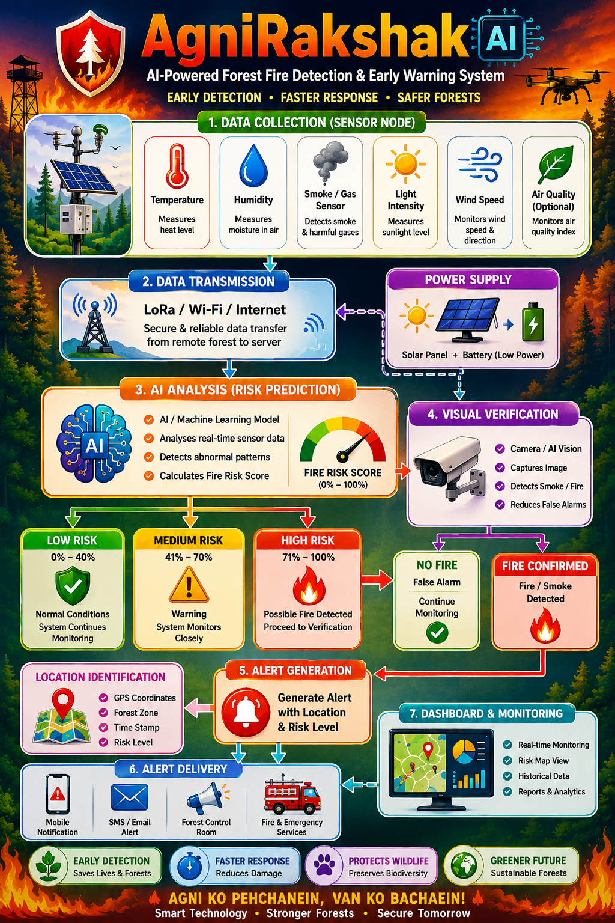

Estimated Prototype Cost
A basic one-node school prototype can be built using relatively inexpensive components such as an ESP32, environmental sensors and an ESP32-CAM. Indian-market examples show these components are available at relatively low hobbyist prices.
A realistic student prototype with multiple nodes, communication hardware and a gateway would be approximately ₹15,000–₹25,000, depending on component choices.

Conclusion
EcoSentinel AI combines AI, IoT, computer vision, low-power electronics, and real-time communication to create a practical early-warning concept for forest fires.
Its core principle is:

“Predict. Protect. Preserve.”
Rather than waiting for a large visible fire, EcoSentinel AI aims to identify early warning signals, verify them intelligently, and provide actionable information to the people responsible for protecting forests and communities.

