Salt Fridge – Natural Eco-Friendly Refrigerator

Introduction
We are students of Class 7th , GHPS NOSENUR. We developed the Salt Fridge, a low-cost, electricity-free cooling system that helps preserve fruits, vegetables, and dairy products using natural evaporative cooling. It is designed for rural and off-grid communities where electricity is limited or unavailable.

Objective
- Preserve food without electricity.
- Reduce food spoilage and wastage.
- Provide an affordable refrigerator for rural families.
- Promote eco-friendly and sustainable cooling.
- Improve food security using locally available materials.

Team Members
- pavan
- aryamba

Problem Statement
In many rural and off-grid areas, people struggle to preserve fruits, vegetables, milk, and dairy products because they do not have access to electricity or refrigerators. Conventional refrigerators are expensive, consume electricity, and are not suitable for remote villages. As a result, food spoils quickly, leading to wastage, financial loss, and reduced food security.

Proposed Solution
The Salt Fridge is a simple and natural cooling system made using two clay pots, sand, salt, and water. It works on the principle of evaporative cooling and requires no electricity. The wet sand between the two pots evaporates slowly, removing heat from the inner pot and keeping food cool and fresh for a longer time. It is affordable, eco-friendly, and easy to build using locally available materials.

Components Used
- Large Clay Pot
- Small Clay Pot
- Clean Sand
- Salt
- Water
- Cotton Cloth or Lid

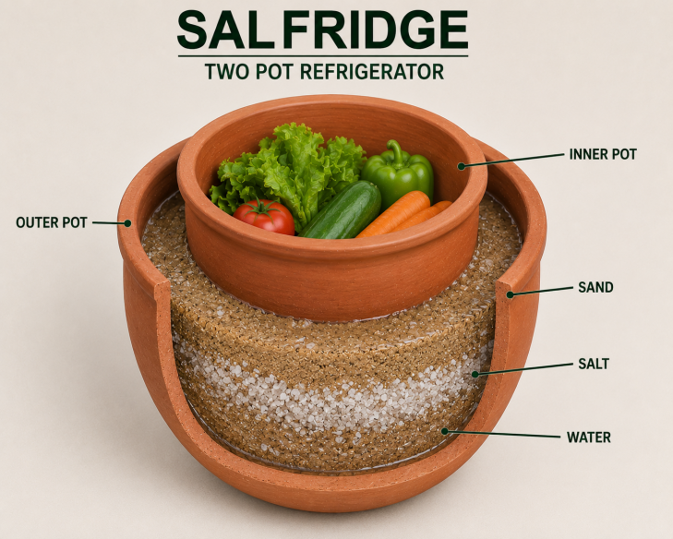
Schematic Diagram
Cotton Cloth / Lid
___________________
| |
| Fruits & Vegetables|
|___________________|
| Small Clay Pot |
|---------------------|
| Wet Sand + Salt |
| (Cooling Layer) |
|---------------------|
| Large Clay Pot |
|_____________________|
Water
(Added to Wet Sand)

Working Principle
The Salt Fridge works on the evaporative cooling principle.
- Water is poured into the sand mixed with salt between the two clay pots.
- The water slowly evaporates through the porous outer clay pot.
- During evaporation, heat is absorbed from the inner pot.
- This natural process lowers the temperature inside the inner pot by approximately 3–5°C, depending on the surrounding weather conditions.
- The lower temperature helps keep fruits, vegetables, and dairy products fresh for a longer time.
- Cooler conditions also slow the growth of bacteria and microorganisms, reducing food spoilage and waste.

Expected Impact

Social Impact
- Helps rural and low-income families preserve food.
- Improves food availability.
- Reduces food waste.

Environmental Impact
- Uses no electricity.
- Produces zero carbon emissions.
- Promotes sustainable living.

Economic Impact
- Saves money by reducing food spoilage.
- Low-cost alternative to electric refrigerators.
- Uses locally available materials.

Advantages
- No electricity required.
- Low-cost and affordable.
- Eco-friendly.
- Easy to build.
- Portable.
- Suitable for villages and remote areas.
- Extends the freshness of fruits, vegetables, and dairy products.

Conclusion
The Salt Fridge is a simple, affordable, and eco-friendly solution for preserving food in rural and off-grid areas. By using natural evaporative cooling instead of electricity, it reduces food spoilage, saves money, and promotes sustainable living. This project demonstrates how simple scientific principles and locally available materials can solve real-life problems and improve the quality of life in rural communities.

