Child-Friendly Auto TV Shut-Off/On System

Introduction
We are students of Class 6, GHPS NOSENUR. We developed the Child-Friendly Auto TV Shut-Off/On System, a smart and low-cost safety device that automatically turns the TV OFF when a child sits too close to the screen and turns it ON again when the child moves to a safe distance. This system uses an ultrasonic sensor to detect the viewing distance, helping to prevent eye strain, headaches, and vision problems while encouraging healthy TV-watching habits. It is designed to protect children's eyesight and create a safer home environment

Objective
- To protect children's eyesight from harmful TV viewing habits.
- To reduce eye strain, headaches, and vision-related problems.
- To encourage children to maintain a safe viewing distance.
- To automatically switch OFF the TV when someone sits too close.
- To automatically switch ON the TV when the child moves to a safe distance.
- To create a simple, low-cost, and child-friendly safety device.

Team Name :Screen Smart Squad

Team Members
- mantesh– 7th Standard
- sanjana– 7tth Standard
School: GHPS NOSENUR

Problem Statement
Many children watch television from a very close distance for long periods. This can cause eye strain, dry eyes, headaches, blurred vision, and long-term vision problems. Parents cannot always monitor children continuously. There is a need for an automatic safety system that protects children by ensuring they maintain a safe distance from the TV.

Proposed Solution
We propose a Child-Friendly Auto TV Shut-Off/On System using an Ultrasonic Distance Sensor and an Arduino Uno.
- The ultrasonic sensor continuously measures the distance between the child and the TV.
- If the child comes closer than the safe distance (for example, less than 1.5 metres), the Arduino switches OFF the TV using a relay and activates a warning buzzer or LED.
- When the child moves back beyond the safe distance, the TV automatically turns ON again.
This system helps children develop healthy TV-watching habits without constant supervision.
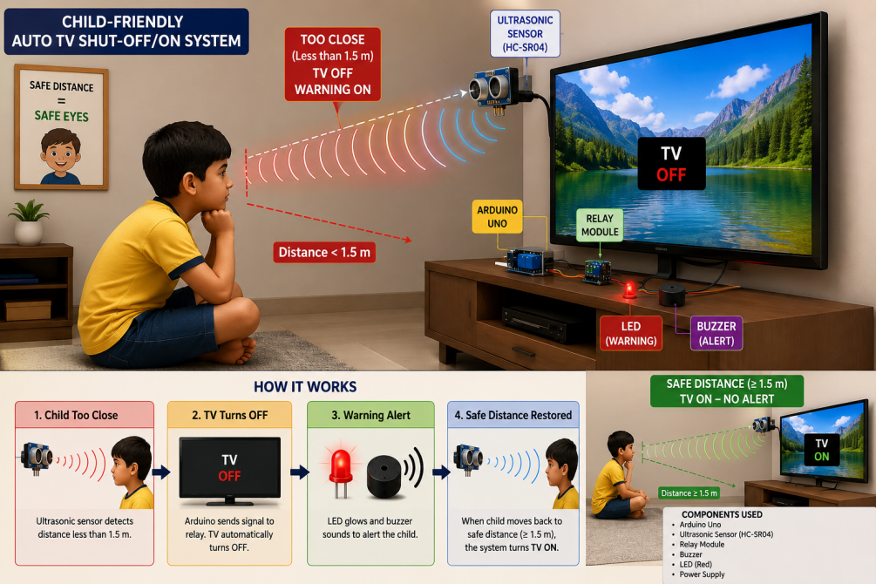

Working Principle

Components Used
- Arduino Uno
- Ultrasonic Sensor (HC-SR04)
- Relay Module
- Buzzer
- LED Indicator
- Power Supply
- TV (connected through relay)
Schematic Diagram
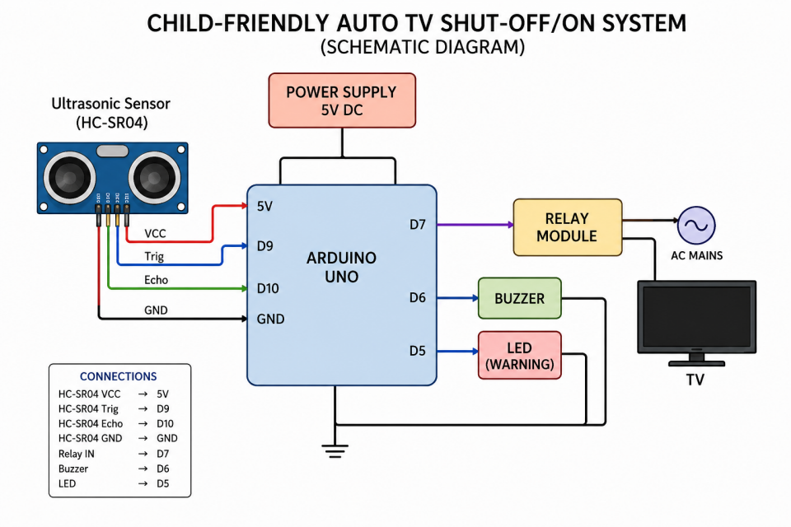

Working
- The ultrasonic sensor continuously measures the distance from the TV.
- The Arduino receives the distance data.
- If the measured distance is less than the safe limit, the Arduino:
  - Switches OFF the TV through the relay.
  - Turns ON the buzzer and warning LED.
- When the child moves back to a safe distance:
  - The buzzer stops.
  - The LED turns OFF.
  - The TV automatically turns ON again.

Applications
- Homes
- Schools
- Children's libraries
- Anganwadi centres
- Child care centres
- Hospitals (paediatric waiting rooms)
- Smart classrooms
- Educational TV rooms

Conclusion
The Child-Friendly Auto TV Shut-Off/On System is a simple, affordable, and effective solution to protect children's eyesight. It encourages children to maintain a safe viewing distance while watching television. By automatically turning the TV OFF when a child sits too close and turning it ON again when the child moves back, the system promotes healthy habits and reduces the risk of eye strain and vision problems. This project can help create a safer and healthier environment for children at home and in schools

