Expandable Umbrella
Problem: During rainy season, students use umbrellas when it is raining heavily. An average umbrella can protect only 1 person. As such, even if one friend joins, they all get wet and drenched while going to school!
Solution: We have designed an expandable umbrella which can be opened like flaps from inside the regular umbrella when 4-5 students are to be accommodated. it helps them go to school without getting drenched! When not needed, the flaps can be folded inside the umbrella and fully folded and banded. The handle can also be extended as desired.
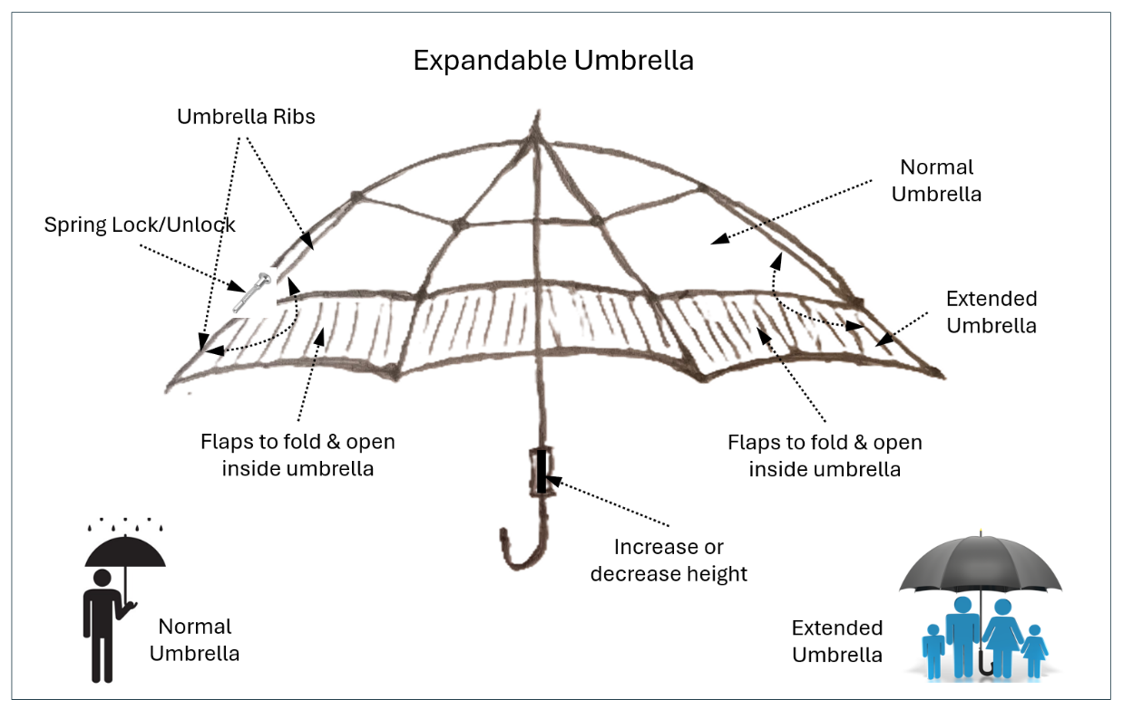

Student Name : R. Vaitheeswar Narayanan
School : The Malleshwaram Shishu Vihar, Bangalore
Class : IX Std
Photo :

Bank Details :

