EcoCooler 2.0 – Smart Sustainable Cooling System

A Low-Cost Passive Cooling Solution with Smart Temperature Monitoring

Introduction
We are Class 7TH students from Government Primary School (GHPS), NOSENUR. Our project, EcoCooler 2.0, is a low-cost, eco-friendly cooling system made from recycled plastic bottles with smart temperature monitoring. It provides an affordable and sustainable cooling solution for rural homes, schools, and communities

Team Members
Pallavi ,Shravani Likith

Objective
To develop an affordable, electricity-saving, and environmentally friendly cooling system that:
- Reduces indoor temperature naturally.
- Reuses plastic waste.
- Monitors room temperature using sensors.
- Alerts users when the temperature becomes too high.
- Promotes sustainable living and energy conservation.

Problem Statement
During summer, temperatures inside homes and classrooms become extremely high, especially in rural and low-income communities. Many families cannot afford air conditioners due to their high purchase and electricity costs. Even electric fans become ineffective during extreme heat or power cuts. Traditional cooling systems consume large amounts of electricity, increasing energy bills and carbon emissions. Therefore, there is a need for a simple, affordable, eco-friendly, and electricity-free cooling system that can naturally cool indoor spaces while helping users monitor rising temperatures.

Proposed Solution
EcoCooler 2.0 is a smart passive cooling device built using recycled plastic bottles mounted on a window panel.
The bottle design works on Bernoulli's Principle, allowing hot air entering through the bottle to increase in speed and slightly reduce in temperature before entering the room.
To make the system smarter, an Arduino Uno and DHT11 Temperature Sensor continuously monitor the room temperature.
When the temperature exceeds 30°C, the Arduino automatically activates:
- LED Indicator
- Buzzer Alert
This warns users that the room is becoming too hot.
The project provides cooling without electricity while offering smart heat monitoring

Working Principle

Passive Cooling
- Hot outside air enters the wider side of the bottle.
- Air passes through the narrow bottle neck.
- Air velocity increases while pressure decreases (Bernoulli's Principle).
- The air becomes slightly cooler before entering the room.

Smart Temperature Monitoring
- DHT11 continuously measures room temperature.
- Arduino compares the measured temperature with the preset value.
- If temperature exceeds 30°C:
  - LED turns ON.
  - Buzzer sounds.
- When temperature drops below the threshold:
  - LED and buzzer turn OFF automatically.

Block Diagram / System Schematic
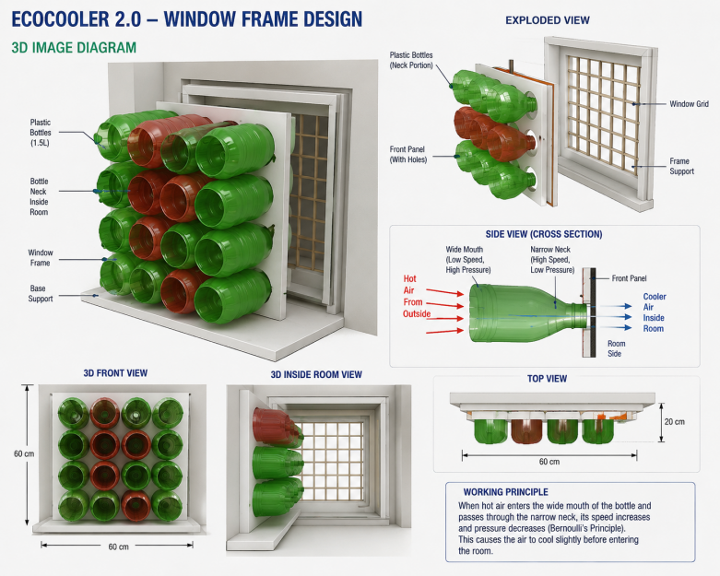
Hot Air
↓
Plastic Bottle Array
↓
Passive Cooling Effect
↓
Cooler Air Enters Room

DHT11 Sensor
↓
Arduino Uno
↓
-----------------------
| |
LED Indicator Buzzer Alert

Who Faces This Problem?
- Rural families
- Low-income households
- Government schools
- Students studying in hot classrooms
- Small shop owners
- Workshop workers
- Elderly people
- Children
- Communities facing frequent power cuts

Expected Impact:

Social Impact
- Improves comfort in homes and classrooms.
- Helps low-income families.
- Reduces heat-related discomfort.
- Creates awareness about sustainable living.

Environmental Impact
- Reuses plastic waste.
- Reduces electricity consumption.
- Lowers carbon emissions.
- Promotes recycling.

Benefits
- No electricity required for cooling.
- Affordable for rural communities.
- Eco-friendly.
- Low maintenance.
- Uses recycled plastic bottles.
- Smart heat alert system.
- Easy to build and demonstrate.
- Reduces indoor temperature by approximately 3–5°C under suitable conditions.
- Saves energy.
- Supports sustainable development.

Expected Outcomes
- Reduce indoor temperature naturally.
- Improve comfort during summer.
- Help families save electricity.
- Increase awareness about recycling.
- Promote sustainable engineering solutions.
- Encourage students to build eco-friendly innovations.

Conclusion
EcoCooler 2.0 is an innovative, affordable, and environmentally friendly cooling solution that combines passive cooling with smart temperature monitoring. By using recycled plastic bottles and simple electronics, it reduces indoor heat while promoting energy conservation and sustainability. The project demonstrates that practical engineering and scientific principles can solve real-life problems in a cost-effective way, making it especially valuable for rural communities, schools, and low-income households.

