Solar Dryer System for Farm Items
Problem Often farmers have the need to keep certain farm-grown items dry. Otherwise if these items are exposed to rain or dampness, they will likely get damaged or spoiled thus causing heavy revenue losses to them.
Solution A solar powered, air-circulated heater system will help farmers to have a storage system which will keep their items dry even during monsoon seasons. The system takes power from solar panels; it charges a battery pack managed by a UPS based system and provides power to the fan and heaters. The hot air helps in keeping dry any farm items kept in the room.
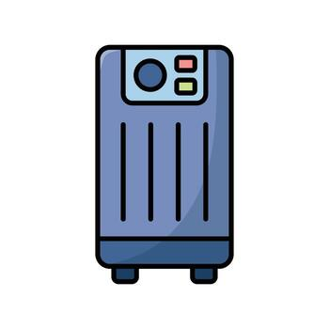

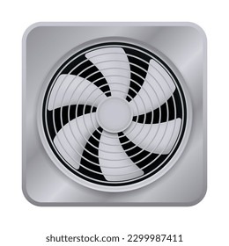

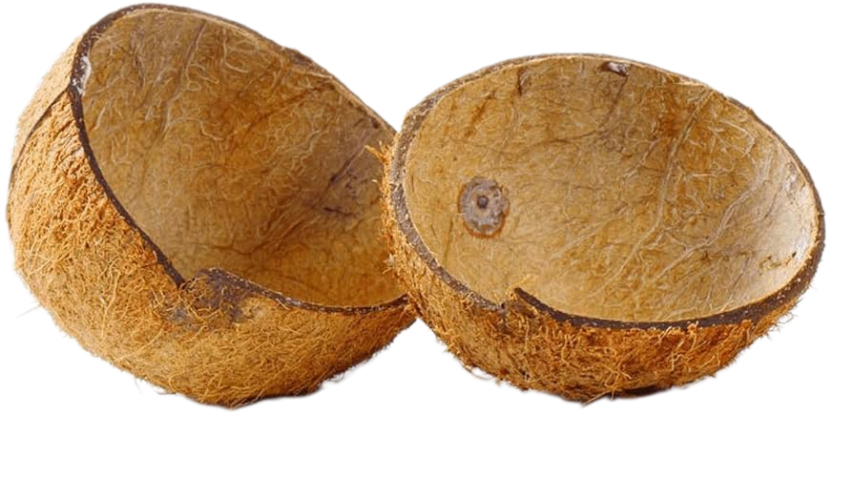
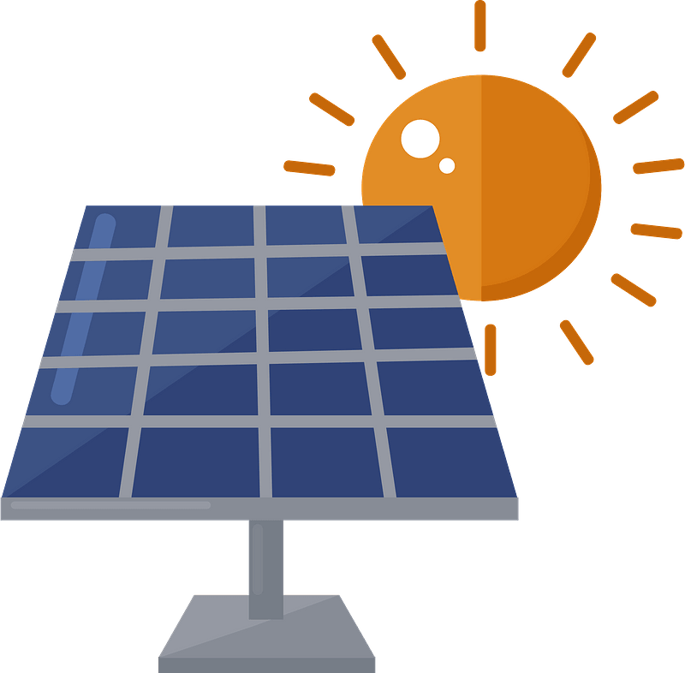
Solar Dryer System for Farm Items
Solar Panels
Lithium-Ion Battery pack
Solar Charging
UPS System
Heater System
Coconut Shells
Air Circulation Fan
Coconut Shells Drying Room

Student Name: Saniya
Class:
DOB :
School: The Malleshwaram Shishu Vihar, Bangalore
Photo :

Bank Details :

Solar Dryer System for Farm Items
For Video Recording
My name is Saniya and I am studying in xxxx Std. of Malleshwaram Shishu Vihar School, Bangalore. I will now be talking about the Solar Dryer System for Farm Items.
The Problem:
The Solution:
Features:

