EOG-Based RC Robot Control Using BioAmp Signals
Abstract
This project presents an Eye Movement Controlled RC Robot using Electrooculography (EOG) signals. The system captures the electrical signals generated by eye movements using a BioAmp EXG Pill sensor. These signals are amplified, filtered, and processed by a microcontroller such as an ESP32 or Arduino. Based on the detected eye movement, the robot performs different actions such as moving forward, turning left, turning right, and stopping. The project demonstrates how biomedical signals can be used for hands-free robot control, making it useful for assistive technology and healthcare applications.

1. Introduction
Human body organs generate tiny electrical signals during their normal functioning. These signals can be measured and analyzed to develop intelligent systems. Biomedical signals such as Electrooculography (EOG), Electrocardiography (ECG), and Electroencephalography (EEG) are widely used in medicine and engineering.
This project focuses on EOG signals to control an RC robot using eye movements. The robot can be operated without touching any controller, making it beneficial for people with physical disabilities.

2. Objectives
- To capture eye movement signals using a BioAmp EXG Pill.
- To process EOG signals using a microcontroller.
- To control an RC robot using eye movements.
- To demonstrate the use of biomedical signals in robotics.

3. What is EOG?
Electrooculography (EOG) measures the electrical potential generated by eye movements. The human eye behaves like a small battery, where the front of the eye is slightly positive and the back is slightly negative. When the eyes move, the electrical potential changes, which can be detected using electrodes.
Frequency Range : 0.1–30 Hz
Amplitude : 50 µV–3.5 mV

Applications
- Eye-controlled wheelchairs
- Robot control
- Human-computer interaction
- Assistive technology
- Eye tracking systems

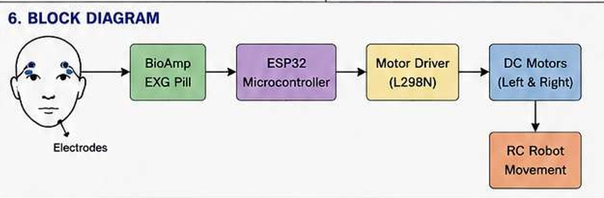

4. Working Principle

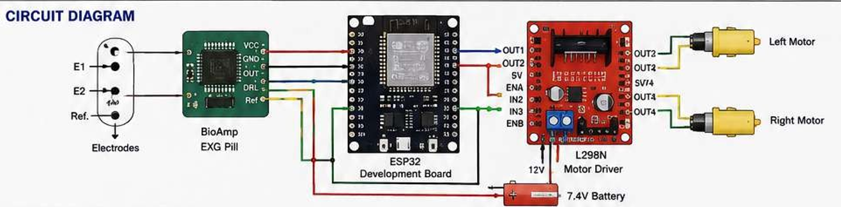
The BioAmp EXG Pill electrodes are placed around the eyes to detect electrical signals generated during eye movements.
The captured signals are amplified and filtered before being sent to an ESP32 or Arduino microcontroller. The microcontroller recognizes different eye movement patterns and sends commands to the RC robot.

Robot Movements
Eye Movement | Robot Action
Look front | Move Forward
Look Left | Turn Left
Look Right | Turn Right
Blink or Look Down | Stop

5. Hardware Components
- BioAmp EXG Pill
- Disposable Electrodes
- ESP32 / Arduino
- RC Robot Chassis
- Motor Driver
- DC Motors
- Battery
- Connecting Wires

6. Other Biomedical Signals
Electrocardiography (ECG)
ECG records the electrical activity of the heart. It is commonly used to monitor heart health and diagnose heart-related diseases.
Frequency Range: 0.05–150 Hz
Amplitude: 0.5–5 mV
Applications
- Heart rate monitoring
- Arrhythmia detection
- Heart attack diagnosis
- Patient monitoring

Electroencephalography (EEG)
EEG records the electrical activity of the brain using electrodes placed on the scalp.
Frequency Range: 0.5–100 Hz
Amplitude: 10–100 µV
EEG Frequency Bands
Band | Frequency | Function
Delta | 0.5–4 Hz | Deep sleep
Theta | 4–8 Hz | Drowsiness and meditation
Alpha | 8–13 Hz | Relaxed state
Beta | 13–30 Hz | Active thinking
Gamma | 30–100 Hz | Learning and memory

Applications
- Epilepsy diagnosis
- Brain disorder monitoring
- Sleep analysis
- Brain-Computer Interface (BCI)

7. Advantages
- Hands-free robot control.
- Easy to operate.
- Useful for physically disabled people.
- Low-cost implementation.
- Demonstrates biomedical signal processing.

8. Future Applications
- Smart wheelchairs
- Medical rehabilitation systems
- Smart home automation
- Human-computer interaction
- Gaming
- Military robots
- Rescue robots
- Industrial automation

9. Conclusion
The EOG-Based RC Robot demonstrates how eye movement signals can be converted into robot control commands using BioAmp technology and a microcontroller. The project combines biomedical engineering, electronics, and robotics to create an assistive system that improves accessibility and human-machine interaction. This technology has significant potential in healthcare, rehabilitation, smart automation, and future robotic systems.

10. References
- https://bhawnasehgal.github.io/upsidedownlabs.github.io/hardware/bioamp/bioamp-exg-pill/index.html?utm_source=chatgpt.com
- https://www.crowdsupply.com/upside-down-labs/bioamp-exg-pill?utm_source=chatgpt.com
- https://robu.in/wp-content/uploads/2024/04/BioAmp-EXG-Pill-Data-Sheet.pdf?utm_source=chatgpt.com
- https://www.instructables.com/Visualizing-Electrical-Impulses-of-Eyes-EOG-Using-/?utm_source=chatgpt.com
- https://www.instructables.com/Eye-Blink-Detection-by-Recording-EOG-Using-BioAmp-/?utm_source=chatgpt.com
- https://www.circuitstate.com/tutorials/upside-down-labs-bioamp-exg-pill-v0-7-biopotential-afe-hardware-overview-and-interfacing-with-arduino/?utm_source=chatgpt.com

