Double Sided Torch
Problem: - Many peoples are walking in the dark, while holding a standard flashlight often forces people to choose between looking straight ahead and looking down at their feet to avoid tripping. So this project will get the solution for that problem.
Dual-Beam Flashlights: Torches equipped with two separate light sources. One beam shines straight ahead to spot distant obstacles, while a secondary angled beam illuminates the ground directly in front of the user's feet.
Solution:-
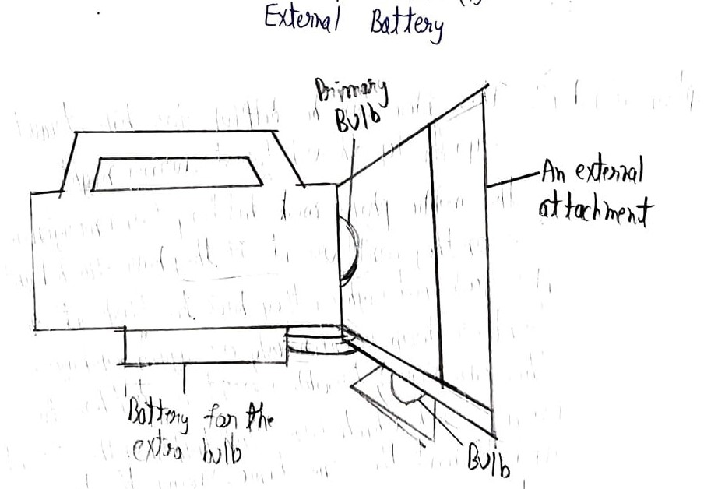
Description: - This idea can be helpful for hike, travelers or a passes by through forest during night. The mobile phone must battery for emergencies so they can’t use it, if they have flash light it is good but lighter they have to flash it on front or down continuously or again and again this can cause trouble so it is better to use a torch which can flash light on the front and down t the same time.

