<http://localhost:4200/>

Any Page will redirect to login page as per routing module

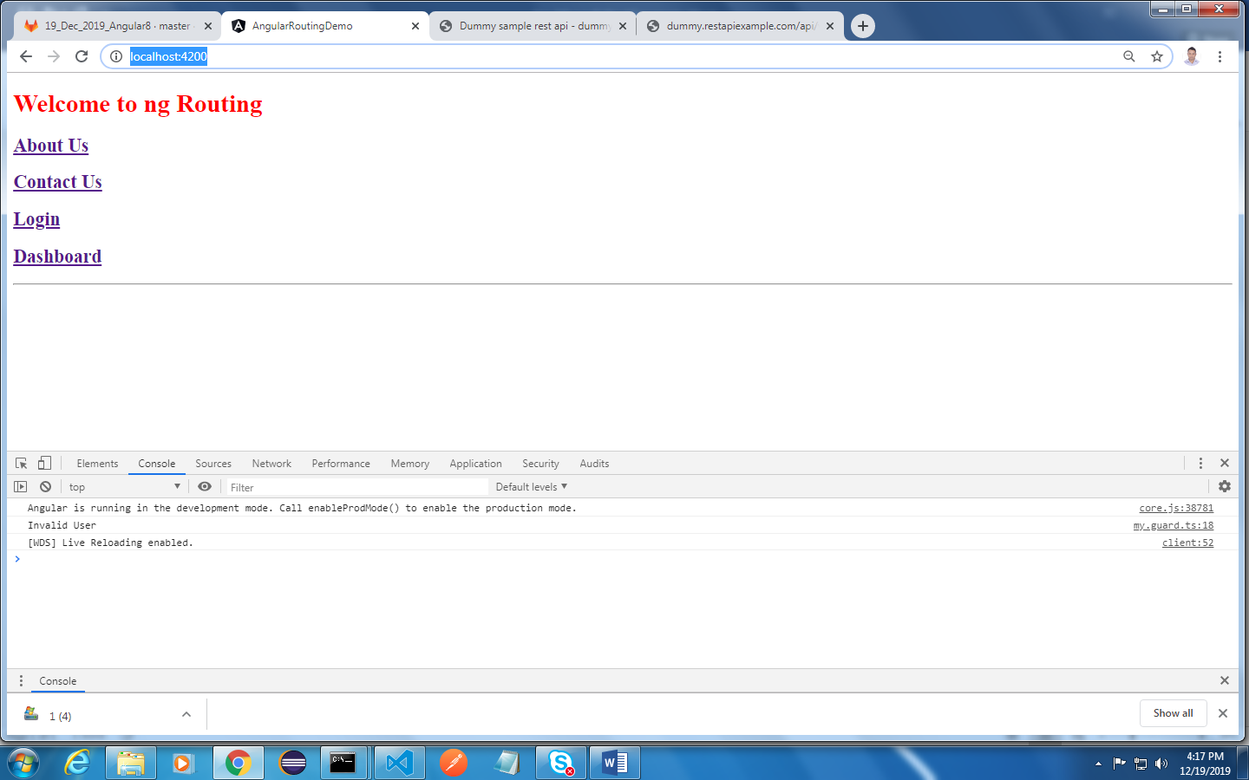

<http://localhost:4200/aboutus>

This page you can access without login session

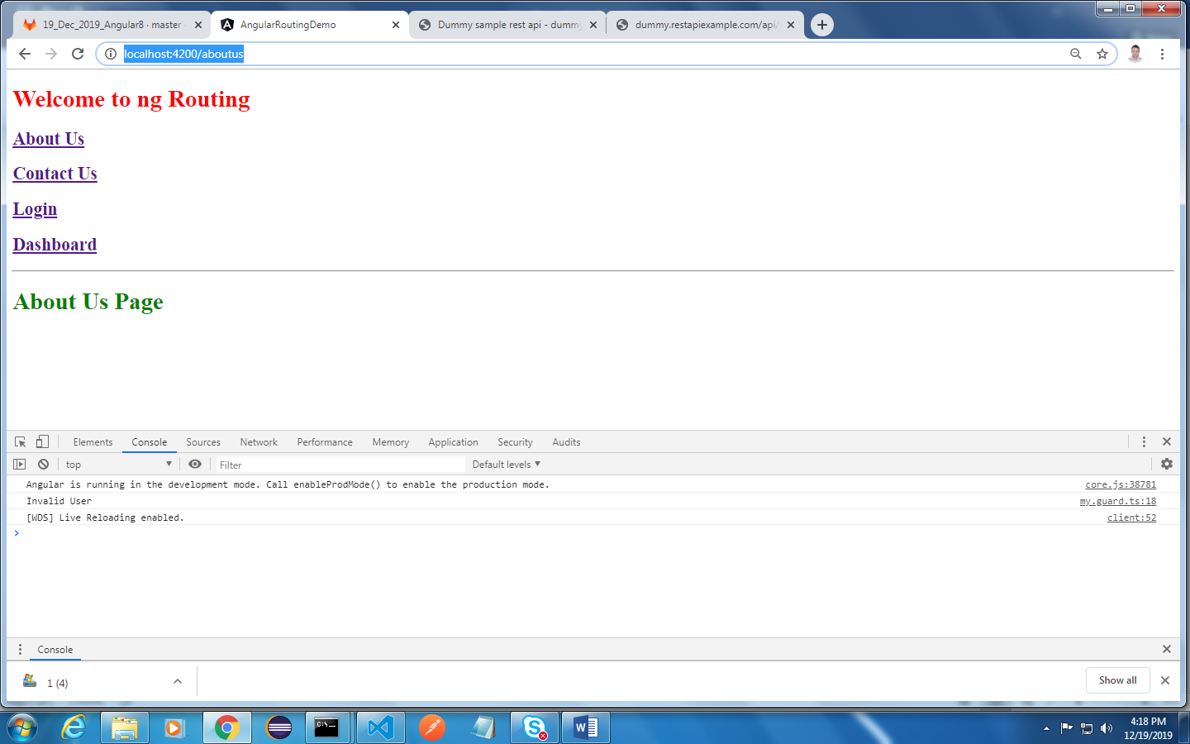

<http://localhost:4200/contactus>

This page you can access without login session

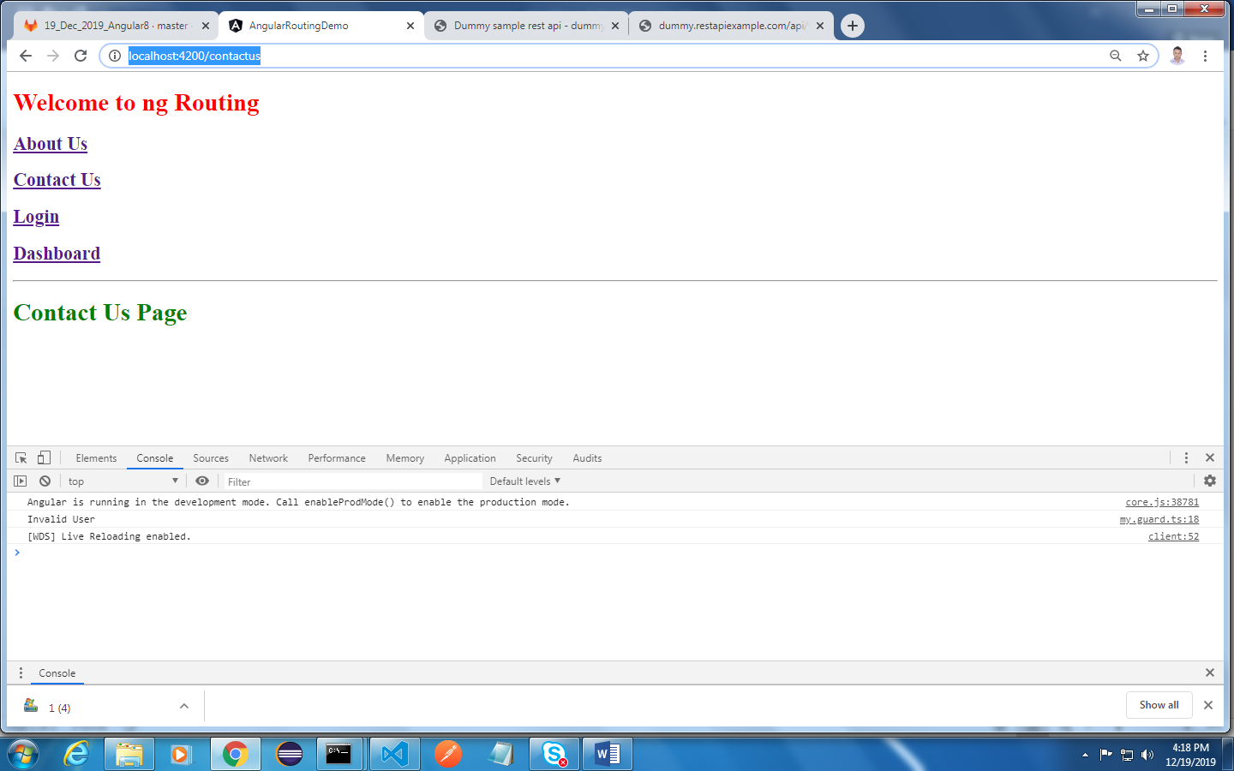

<http://localhost:4200/login>

API Used <http://dummy.restapiexample.com/api/v1/employees>

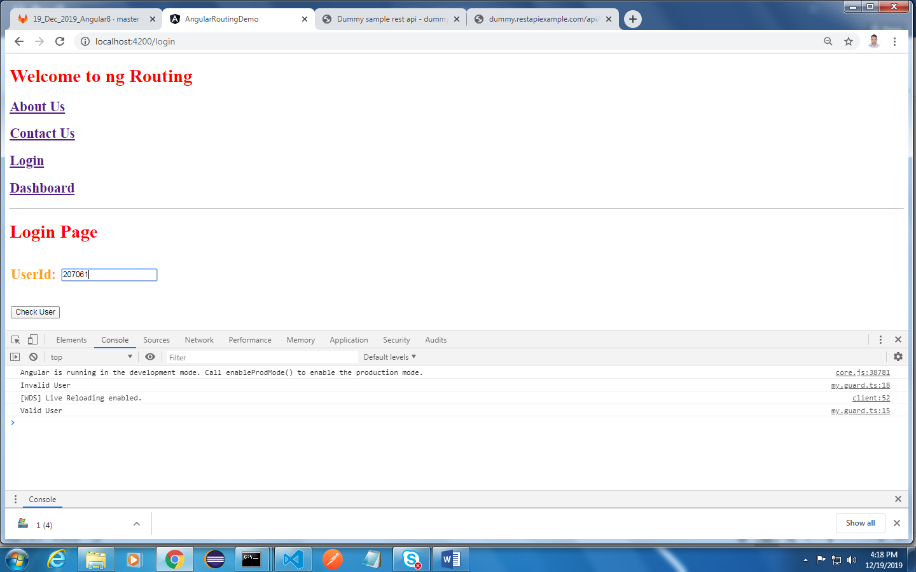

Once Login is successful you are redirected to dashboard home page

<http://localhost:4200/home>

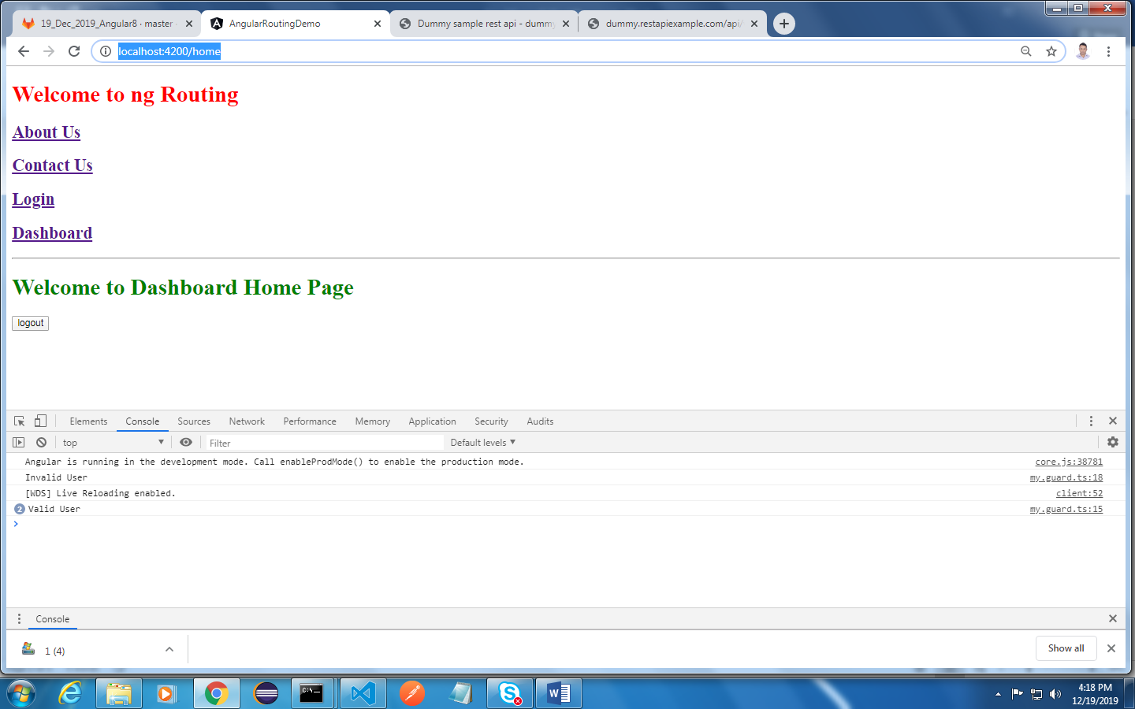

On click of logout you are redirected to login page again

<http://localhost:4200/login>

