Git Tutorial
Diffs between SVN and GIT

http://boxysystems.com/index.php/5-fundamental-differences-between-git-svn/

http://www.codeforest.net/git-vs-svn

1.In a distributed VCS like Git every user has a complete copy of the repository data stored locally, thereby making access to file history extremely fast, as well as allowing full functionality when disconnected from the network. It also means every user has a complete backup of the repository. Have 20 users? You probably have more than 20 complete backups of the repository as some users tend to keep more than one repository for the same project. If any repository is lost due to system failure only the changes which were unique to that repository are lost. If users frequently push and fetch changes with each other this tends to be a small amount of loss, if any.
In a centralized VCS like Subversion only the central repository has the complete history. This means that users must communicate over the network with the central repository to obtain history about a file. Backups must be maintained independently of the VCS. If the central repository is lost due to system failure it must be restored from backup and changes since that last backup are likely to be lost.
2.Compared to SVN, the git init command is an incredibly easy way to create new version-controlled projects. Git doesn’t require you to create a repository, import files, and check out a working copy. All you have to do is cd into your project folder and run git init, and you’ll have a fully functional Git repository.
However, for most projects, git init only needs to be executed once to create a central repository—developers typically don‘t use git init to create their local repositories. Instead, they’ll usually use git clone to copy an existing repository onto their local machine.

Snapshots, Not Differences
3.Aside from the practical distinctions between SVN and Git, their underlying implementation also follow entirely divergent design philosophies. Whereas SVN tracks differences of a file, Git’s version control model is based on snapshots. For example, an SVN commit consists of a diff compared to the original file added to the repository. Git, on the other hand, records the entire contents of each file in every commit.
4.Repo-To-Repo Collaboration
It’s important to understand that Git’s idea of a “working copy” is very different from the working copy you get by checking out code from an SVN repository. Unlike SVN, Git makes no distinction between the working copy and the central repository—they are all full-fledged Git repositories.
This makes collaborating with Git fundamentally different than with SVN. Whereas SVN depends on the relationship between the central repository and the working copy, Git’s collaboration model is based on repository-to-repository interaction. Instead of checking a working copy into SVN’s central repository, you push or pull commits from one repository to another.
Discussion
Snapshots are always committed to the local repository. This is fundamentally different from SVN, wherein the working copy is committed to the central repository. In contrast, Git doesn’t force you to interact with the central repository until you’re ready. Just as the staging area is a buffer between the working directory and the project history, each developer’s local repository is a buffer between their contributions and the central repository.
This changes the basic development model for Git users. Instead of making a change and committing it directly to the central repo, Git developers have the opportunity to accumulate commits in their local repo. This has many advantages over SVN-style collaboration: it makes it easier to split up a feature into atomic commits, keep related commits grouped together, and clean up local history before publishing it to the central repository. It also lets developers work in an isolated environment, deferring integration until they’re at a convenient break point.

Snapshots, Not Differences
5.Aside from the practical distinctions between SVN and Git, their underlying implementation also follow entirely divergent design philosophies. Whereas SVN tracks differences of a file, Git’s version control model is based on snapshots. For example, an SVN commit consists of a diff compared to the original file added to the repository. Git, on the other hand, records the entire contents of each file in every commit.
This makes many Git operations much faster than SVN, since a particular version of a file doesn’t have to be “assembled” from its diffs—the complete revision of each file is immediately available from Git's internal database.
Git's snapshot model has a far-reaching impact on virtually every aspect of its version control model, affecting everything from its branching and merging tools to its collaboration workflows.
The git status command is a relatively straightforward command. It simply shows you what's been going on with git add and git commit. Status messages also include relevant instructions for staging/unstaging files.
How to get size of a git repo.
git bundle create tmp.bundle --all
du -sh tmp.bundle
GARBHATI-M-346B:git_repository_staged garbhati$ git bundle create tmp.bundle --all
Counting objects: 2087, done.
Delta compression using up to 8 threads.
Compressing objects: 100% (902/902), done.
Writing objects: 100% (2087/2087), 8.74 MiB | 0 bytes/s, done.
Total 2087 (delta 1132), reused 2087 (delta 1132)
GARBHATI-M-346B:git_repository_staged garbhati$ du -sh tmp.bundle
8.7M tmp.bundle
GARBHATI-M-346B:git_repository_staged garbhati$ pwd
/Users/garbhati/gitmigration/VSOM_Gitmigration/gis_maps/MyGitProject/git_repository_staged
Size of SVN repository
GARBHATI-M-346B:gis_maps garbhati$ svn list -vR http://psbu-wiki/repos/gis_maps/ | awk '{if ($3 !="") sum+=$3; i++} END {print "\ntotal size= " sum/1024000" MB" "\nnumber of files= " i/1000 " K"}'

total size= 172.385 MB
number of files= 11.891 K
http://vcs.atspace.co.uk/2012/11/05/which-repository-is-more-compact-git-or-svn/
- Git repo creation
git init command to create an empty repo

The git init command creates a new Git repository. It can be used to convert an existing, unversioned project to a Git repository or initialize a new empty repository.
Executing git init creates a .git subdirectory in the project root, which contains all of the necessary metadata for the repo. Aside from the .git directory, an existing project remains unaltered (unlike SVN, Git doesn't require a .git folder in every subdirectory).
git init --bare <directory>
Initialize an empty Git repository, but omit the working directory. Shared repositories should always be created with the --bare flag (see discussion below). Conventionally, repositories initialized with the --bare flag end in .git. For example, the bare version of a repository called my-project should be stored in a directory called my-project.git.
it will create an empty repo in .git folder
run git status command —-
Gargis-MacBook-Pro:repo1 gargi$ git status
On branch master

Initial commit

nothing to commit (create/copy files and use "git add" to track)

Add one file here a1.txt
Gargis-MacBook-Pro:repo1 gargi$ ls -later
total 8
drwxr-xr-x 3 gargi staff 102 Oct 16 10:44 ..
drwxr-xr-x 10 gargi staff 340 Oct 16 10:44 .git
drwxr-xr-x 4 gargi staff 136 Oct 16 10:45 .
-rw-r--r-- 1 gargi staff 6 Oct 16 10:45 a1.txt

now run git status command again

Gargis-MacBook-Pro:repo1 gargi$ git status
On branch master

Initial commit

Untracked files:
(use "git add <file>..." to include in what will be committed)

a1.txt

nothing added to commit but untracked files present (use "git add" to track)

now run git add command to add tis file to staging area

Gargis-MacBook-Pro:repo1 gargi$ git add .
Gargis-MacBook-Pro:repo1 gargi$ ls -latr
total 8
drwxr-xr-x 3 gargi staff 102 Oct 16 10:44 ..
drwxr-xr-x 4 gargi staff 136 Oct 16 10:45 .
-rw-r--r-- 1 gargi staff 6 Oct 16 10:45 a1.txt
drwxr-xr-x 11 gargi staff 374 Oct 16 10:47 .git

now run git status command again

Gargis-MacBook-Pro:repo1 gargi$ git status
On branch master

Initial commit

Changes to be committed:
(use "git rm --cached <file>..." to unstage)

new file: a1.txt
1.6 Committing
Notice how Git says changes to be committed? The files listed here are in the Staging Area, and they are not in our repository yet. We could add or remove files from the stage before we store them in the repository.
To store our staged changes we run the commit command with a message describing what we've changed. Let's do that now by typing:
Gargis-MacBook-Pro:repo1 gargi$ git commit -m "adding a new file:
> "
[master (root-commit) c92e86e] adding a new file:

1.7 Adding All Changes
Great! You also can use wildcards if you want to add many files of the same type. Notice that I've added a bunch of .txt files into your directory below.
I put some in a directory named "octofamily" and some others ended up in the root of our "octobox" directory. Luckily, we can add all the new files using a wildcard with git add. Don't forget the quotes!
git add ‘*.txt'
1.8 Committing All Changes
Okay, you've added all the text files to the staging area. Feel free to run git status to see what you're about to commit.
If it looks good, go ahead and run:
git commit -m 'Add all the octocat txt files’

1.9 History
So we've made a few commits. Now let's browse them to see what we changed.
Fortunately for us, there's git log. Think of Git's log as a journal that remembers all the changes we've committed so far, in the order we committed them. Try running it now:
git log

Gargis-MacBook-Pro:repo1 gargi$ git log
commit 70920bea2f252a89c8d27589a52edf422e623f6d
Author: Gargi <gargi@Gargis-MacBook-Pro.local>
Date: Thu Oct 16 10:57:16 2014 -0700

add all files

commit c92e86e127697b63af71262f5fd49c8b2e3e70ec
Author: Gargi <gargi@Gargis-MacBook-Pro.local>
Date: Thu Oct 16 10:52:48 2014 -0700

adding a new file:

1.10 Remote Repositories
Great job! We've gone ahead and created a new empty GitHub repository for you to use with Try Git at https://github.com/try-git/try_git.git. To push our local repo to the GitHub server we'll need to add a remote repository.
This command takes a remote name and a repository URL, which in your case is https://github.com/try-git/try_git.git.
Go ahead and run git remote add with the options below:
git remote add origin https://github.com/try-git/try_git.git

1.11 Pushing Remotely
The push command tells Git where to put our commits when we're ready, and boy we're ready. So let's push our local changes to our origin repo (on GitHub).
The name of our remote is origin and the default local branch name is master. The -u tells Git to remember the parameters, so that next time we can simply run git push and Git will know what to do. Go ahead and push it!
git push -u origin master
1.12 Pulling Remotely
Let's pretend some time has passed. We've invited other people to our github project who have pulled your changes, made their own commits, and pushed them.
We can check for changes on our GitHub repository and pull down any new changes by running:
git pull origin master
Updating 3852b4d..3e70b0f
Fast-forward
yellow_octocat.txt | 1 +
1 file changed, 1 insertion(+)
create mode 100644 yellow_octocat.txt

1.13 Differences
Uh oh, looks like there have been some additions and changes to the octocat family. Let's take a look at what is different from our last commit by using the git diff command.
In this case we want the diff of our most recent commit, which we can refer to using the HEAD pointer.
git diff HEAD
diff --git a/octocat.txt b/octocat.txt
index 7d8d808..e725ef6 100644
--- a/octocat.txt
+++ b/octocat.txt
@@ -1 +1 @@
-A Tale of Two Octocats
+[mA Tale of Two Octocats and an Octodog

Success!
1.14 Staged Differences
Another great use for diff is looking at changes within files that have already been staged. Remember, staged files are files we have told git that are ready to be committed.
Let's use git add to stage octofamily/octodog.txt, which I just added to the family for you.
git add octofamily/octodog.txt

1.15 Staged Differences (cont'd)
Good, now go ahead and run git diff with the --staged option to see the changes you just staged. You should see that octodog.txt was created.
git diff —staged
diff --git a/octofamily/octodog.txt b/octofamily/octodog.txt
new file mode 100644
index 0000000..cfbc74a
--- /dev/null
+++ b/octofamily/octodog.txt
@@ -0,0 +1 @@
+[mwoof

1.16 Resetting the Stage
So now that octodog is part of the family, octocat is all depressed. Since we love octocat more than octodog, we'll turn his frown around by removing octodog.txt.
You can unstage files by using the git reset command. Go ahead and remove octofamily/octodog.txt.
git reset octofamily/octodog.txt

1.17 Undo
git reset did a great job of unstaging octodog.txt, but you'll notice that he's still there. He's just not staged anymore. It would be great if we could go back to how things were before octodog came around and ruined the party.
Files can be changed back to how they were at the last commit by using the command: git checkout -- <target>. Go ahead and get rid of all the changes since the last commit for octocat.txt
git checkout -- octocat.txt
1.18 Branching Out
When developers are working on a feature or bug they'll often create a copy (aka. branch) of their code they can make separate commits to. Then when they're done they can merge this branch back into their main master branch.
We want to remove all these pesky octocats, so let's create a branch called clean_up, where we'll do all the work:
git branch clean_up
1.19 Switching Branches
Great! Now if you type git branch you'll see two local branches: a main branch named master and your new branch named clean_up.
You can switch branches using the git checkout <branch> command. Try it now to switch to the clean_up branch:
git checkout clean_up
1.20 Removing All The Things
Ok, so you're in the clean_up branch. You can finally remove all those pesky octocats by using the git rm command which will not only remove the actual files from disk, but will also stage the removal of the files for us.
You're going to want to use a wildcard again to get all the octocats in one sweep, go ahead and run:
git rm ‘*.txt'
rm 'blue_octocat.txt'
rm 'octocat.txt'
rm 'octofamily/baby_octocat.txt'
rm 'octofamily/momma_octocat.txt'
rm ‘red_octocat.txt'

1.21 Commiting Branch Changes
Now that you've removed all the cats you'll need to commit your changes.
Feel free to run git status to check the changes you're about to commit.
git commit -m "Remove all the cats”
[clean_up 63540fe] Remove all the cats
5 files changed, 5 deletions(-)
delete mode 100644 blue_octocat.txt
delete mode 100644 octocat.txt
delete mode 100644 octofamily/baby_octocat.txt
delete mode 100644 octofamily/momma_octocat.txt
delete mode 100644 red_octocat.txt
1.22 Switching Back to master
Great, you're almost finished with the cat... er the bug fix, you just need to switch back to the master branch so you can copy (or merge) your changes from the clean_up branch back into the master branch.
Go ahead and checkout the master branch:
git checkout master
1.23 Preparing to Merge
Alrighty, the moment has come when you have to merge your changes from the clean_up branch into the master branch. Take a deep breath, it's not that scary.
We're already on the master branch, so we just need to tell Git to merge the clean_up branch into it:
git merge clean_up

Updating 3852b4d..ec6888b
Fast-forward
blue_octocat.txt | 1 -
octocat.txt | 1 -
octofamily/baby_octocat.txt | 1 -
octofamily/momma_octocat.txt | 1 -
red_octocat.txt | 1 -
5 files changed, 5 deletions(-)
delete mode 100644 blue_octocat.txt
delete mode 100644 octocat.txt
delete mode 100644 octofamily/baby_octocat.txt
delete mode 100644 octofamily/momma_octocat.txt
delete mode 100644 red_octocat.txt
1.24 Keeping Things Clean
Congratulations! You just accomplished your first successful bugfix and merge. All that's left to do is clean up after yourself. Since you're done with the clean_up branch you don't need it anymore.
You can use git branch -d <branch name> to delete a branch. Go ahead and delete the clean_up branch now:
git branch -d clean_up
Deleted branch clean_up (was ec6888b).

1.25 The Final Push
Here we are, at the last step. I'm proud that you've made it this far, and it's been great learning Git with you. All that's left for you to do now is to push everything you've been working on to your remote repository, and you're done!
git push
To https://github.com/try-git/try_git.git
3e70b0f..efe204a master -> master

Success!

Bare Repositories
The --bare flag creates a repository that doesn’t have a working directory, making it impossible to edit files and commit changes in that repository. Central repositories should always be created as bare repositories because pushing branches to a non-bare repository has the potential to overwrite changes. Think of --bare as a way to mark a repository as a storage facility, opposed to a development environment. This means that for virtually all Git workflows, the central repository is bare, and developers local repositories are non-bare.
Example
Since git clone is a more convenient way to create local copies of a project, the most common use case for git init is to create a central repository:
ssh <user>@<host>
cd path/above/repo
git init --bare my-project.git
First, you SSH into the server that will contain your central repository. Then, you navigate to wherever you’d like to store the project. Finally, you use the --bare flag to create a central storage repository. Developers would then [clone](/tutorials/setting-up-a-repository/git-clone) my-project.git to create a local copy on their development machine.
git clone
The git clone command copies an existing Git repository. This is sort of like svn checkout, except the “working copy” is a full-fledged Git repository—it has its own history, manages its own files, and is a completely isolated environment from the original repository.
As a convenience, cloning automatically creates a remote connection called origin pointing back to the original repository. This makes it very easy to interact with a central repository.
Usage
git clone <repo>
Clone the repository located at <repo> onto the local machine. The original repository can be located on the local filesystem or on a remote machine accessible via HTTP or SSH.
git clone <repo> <directory>
Clone the repository located at <repo> into the folder called <directory> on the local machine.

Repo-To-Repo Collaboration
It’s important to understand that Git’s idea of a “working copy” is very different from the working copy you get by checking out code from an SVN repository. Unlike SVN, Git makes no distinction between the working copy and the central repository—they are all full-fledged Git repositories.
This makes collaborating with Git fundamentally different than with SVN. Whereas SVN depends on the relationship between the central repository and the working copy, Git’s collaboration model is based on repository-to-repository interaction. Instead of checking a working copy into SVN’s central repository, you push or pull commits from one repository to another.

git config
The git config command lets you configure your Git installation (or an individual repository) from the command line. This command can define everything from user info to preferences to the behavior of a repository. Several common configuration options are listed below.
Usage
git config user.name <name>
Define the author name to be used for all commits in the current repository. Typically, you’ll want to use the --global flag to set configuration options for the current user.
git config --global user.name <name>
Define the author name to be used for all commits by the current user.
git config --global user.email <email>
Define the author email to be used for all commits by the current user.
git config --global alias.<alias-name> <git-command>
Create a shortcut for a Git command.
git config --system core.editor <editor>
Define the text editor used by commands like git commit for all users on the current machine. The <editor> argument should be the command that launches the desired editor (e.g., vi).

Git stores configuration options in three separate files, which lets you scope options to individual repositories, users, or the entire system:
• <repo>/.git/config – Repository-specific settings.
• ~/.gitconfig – User-specific settings. This is where options set with the --global flag are stored.
• $(prefix)/etc/gitconfig – System-wide settings.
When options in these files conflict, local settings override user settings, which override system-wide. If you open any of these files, you’ll see something like the following:

The git add and git commit commands compose the fundamental Git workflow. These are the two commands that every Git user needs to understand, regardless of their team’s collaboration model. They are the means to record versions of a project into the repository’s history.
Developing a project revolves around the basic edit/stage/commit pattern. First, you edit your files in the working directory. When you’re ready to save a copy of the current state of the project, you stage changes with git add. After you’re happy with the staged snapshot, you commit it to the project history with git commit.

The git add command should not be confused with svn add, which adds a file to the repository. Instead, git add works on the more abstract level of changes. This means that git add needs to be called every time you alter a file, whereas svn add only needs to be called once for each file. It may sound redundant, but this workflow makes it much easier to keep a project organized.
The Staging Area
The staging area is one of Git's more unique features, and it can take some time to wrap your head around it if you’re coming from an SVN (or even a Mercurial) background. It helps to think of it as a buffer between the working directory and the project history.
Instead of committing all of the changes you've made since the last commit, the stage lets you group related changes into highly focused snapshots before actually committing it to the project history. This means you can make all sorts of edits to unrelated files, then go back and split them up into logical commits by adding related changes to the stage and commit them piece-by-piece. As in any revision control system, it’s important to create atomic commits so that it’s easy to track down bugs and revert changes with minimal impact on the rest of the project.
git commit
The git commit command commits the staged snapshot to the project history. Committed snapshots can be thought of as “safe” versions of a project—Git will never change them unless you explicity ask it to. Along with git add, this is one of the most important Git commands.
git log
The git log command displays committed snapshots. It lets you list the project history, filter it, and search for specific changes. While git status lets you inspect the working directory and the staging area, git log only operates on the committed history.

Usage
git log
Display the entire commit history using the default formatting. If the output takes up more than one screen, you can use Space to scroll and q to exit.
git log -n <limit>
Limit the number of commits by <limit>. For example, git log -n 3 will display only 3 commits.
git log --oneline
Condense each commit to a single line. This is useful for getting a high-level overview of the project history.
git log —stat

git checkout
The git checkout command serves three distinct functions: checking out files, checking out commits, and checking out branches. In this module, we’re only concerned with the first two configurations.
Checking out a commit makes the entire working directory match that commit. This can be used to view an old state of your project without altering your current state in any way. Checking out a file lets you see an old version of that particular file, leaving the rest of your working directory untouched.
Usage
git checkout master
Return to the master branch. Branches are covered in depth in the next module, but for now, you can just think of this as a way to get back to the “current” state of the project.
git checkout <commit> <file>
Check out a previous version of a file. This turns the <file> that resides in the working directory into an exact copy of the one from <commit> and adds it to the staging area.
git checkout <commit>
Update all files in the working directory to match the specified commit. You can use either a commit hash or a tag as the <commit> argument. This will put you in a detached HEAD state.
Discussion
The whole idea behind any version control system is to store “safe” copies of a project so that you never have to worry about irreparably breaking your code base. Once you’ve built up a project history, git checkout is an easy way to “load” any of these saved snapshots onto your development machine.
Checking out an old commit is a read-only operation. It’s impossible to harm your repository while viewing an old revision. The “current” state of your project remains untouched in the master branch (see the Branches Module for details). During the normal course of development, the HEAD usually points to master or some other local branch, but when you check out a previous commit, HEAD no longer points to a branch—it points directly to a commit. This is called a “detached HEAD” state, and it can be visualized as the following:

On the other hand, checking out an old file does affect the current state of your repository. You can re-commit the old version in a new snapshot as you would any other file. So, in effect, this usage of git checkout serves as a way to revert back to an old version of an individual file.

Undoing Changes

git revert
The git revert command undoes a committed snapshot. But, instead of removing the commit from the project history, it figures out how to undo the changes introduced by the commit and appends a new commit with the resulting content. This prevents Git from losing history, which is important for the integrity of your revision history and for reliable collaboration.
Gargis-MacBook-Pro:repo1 gargi$ git revert 32005c0c65310a1fd6b6de52a9ba48ea649ffb73
[master 49e9d3f] Revert "add a new file"
1 file changed, 1 deletion(-)
delete mode 100644 rev1

Discussion
Reverting should be used when you want to remove an entire commit from your project history. This can be useful, for example, if you’re tracking down a bug and find that it was introduced by a single commit. Instead of manually going in, fixing it, and committing a new snapshot, you can use git revert to automatically do all of this for you.
Reverting vs. Resetting
It's important to understand that git revert undoes a single commit—it does not “revert” back to the previous state of a project by removing all subsequent commits. In Git, this is actually called a reset, not a revert.
Reverting has two important advantages over resetting. First, it doesn’t change the project history, which makes it a “safe” operation for commits that have already been published to a shared repository. For details about why altering shared history is dangerous, please see the git reset page.
Second, git revert is able to target an individual commit at an arbitrary point in the history, whereas git reset can only work backwards from the current commit. For example, if you wanted to undo an old commit with git reset, you would have to remove all of the commits that occurred after the target commit, remove it, then re-commit all of the subsequent commits. Needless to say, this is not an elegant undo solution.
git reset
If git revert is a “safe” way to undo changes, you can think of git reset as the dangerous method. When you undo with git reset(and the commits are no longer referenced by any ref or the reflog), there is no way to retrieve the original copy—it is a permanent undo. Care must be taken when using this tool, as it’s one of the only Git commands that has the potential to lose your work.
Like git checkout, git reset is a versatile command with many configurations. It can be used to remove committed snapshots, although it’s more often used to undo changes in the staging area and the working directory. In either case, it should only be used to undo local changes—you should never reset snapshots that have been shared with other developers.

Whereas reverting is designed to safely undo a public commit, git reset is designed to undo local changes. Because of their distinct goals, the two commands are implemented differently: resetting completely removes a changeset, whereas reverting maintains the original changeset and uses a new commit to apply the undo.

The point is, make sure that you’re using git reset <commit> on a local experiment that went wrong—not on published changes. If you need to fix a public commit, the git revert command was designed specifically for this purpose.
Discussion
The git reset --hard and git clean -f commands are your best friends after you’ve made some embarrassing developments in your local repository and want to burn the evidence. Running both of them will make your working directory match the most recent commit, giving you a clean slate to work with.
The git clean command can also be useful for cleaning up the working directory after a build. For example, it can easily remove the .o and .exe binaries generated by a C compiler. This is occasionally a necessary step before packaging a project for release. The -x option is particularly convenient for this purpose.

Git Notes from Ry tutorial

Gerrit is a web based code review system, facilitating online code reviews for projects using the Git version control system.
Gerrit makes reviews easier by showing changes in a side-by-side display, and allowing inline comments to be added by any reviewer.
Gerrit simplifies Git based project maintainership by permitting any authorized user to submit changes to the master Git repository, rather than requiring all approved changes to be merged in by hand by the project maintainer. This functionality enables a more centralized usage of Git.
Sonar is an open source Platform used by development teams to manage source code quality. Sonar has been developed with a main objective in mind: make code quality management accessible to everyone with minimal effort.
SonarQube is an open platform to manage code quality. As such, it covers the 7 axes of code quality:
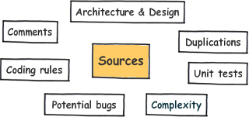

SonarQube is a web-based application. Rules, alerts, thresholds, exclusions, settings… can be configured online.

Checkstyle[1] is a static code analysis tool used in software development for checking if Java source code complies with coding rules.
For example, checkstyle can examine:
• Javadoc comments for classes, attributes and methods;
• Naming conventions of attributes and methods;
• Limit of the number of function parameters, line lengths;

FindBugs is an open source program created by Bill Pugh and David Hovemeyer which looks for bugs in Java code.[1][2] It uses static analysis[1][3] to identify hundreds of different potential types of errors[1] in Java programs.

PMD is a static rule-set based Java source code analyzer that identifies potential problems like:
• Possible bugs—Empty try/catch/finally/switch blocks.
• Dead code—Unused local variables, parameters and private methods.
• Empty if/while statements.
Duplicate code

Unit Testing: The testing done to a unit or to a smallest piece of software. Done to verify if it satisfies its functional specification or its intended design structure.
Integration Testing: Testing the related modules together for its combined functionality.
Regression Testing: Testing the application to verify that modifications have not caused unintended effects.
Smoke Testing: Smoke testing is verified whether the build is testable or not.

User Acceptance Tests
This is a suite of tests that demonstrates to the client (the user)
that the object of the testing is able to accomplish the tasks it was
designed for, at least in a minimum way.

Smoke tests
It is a small (and usually fast in time) subset of tests executed over
the product just to ensure that it works in a first instance. Usually,
a smoke test is executed just after a build. If the smoke test is not
passed, the QA team should be capable of rejecting this version of the
product.
- Rundeck is open source software that helps you automate ad-hoc and routine procedures in data center or cloud environments.
- Allows us to run tasks on any number of nodes from a web-based or command-line interface.
- Also includes other features that make it easy to scale up your scripting efforts including: access control, workflow building, scheduling, logging, and integration with external sources for node and option data.

Gerrit
Gerrit is a free, web-based team code collaboration tool. Software developers in a team can review each other's modifications on their source code using a Web browser and approve or reject those changes. It integrates closely with Git, a distributed version control system.

multijob plugin
copy artifact plugin
build pipeline plugin
delivery pipeline plugin
Parametrized Trigger Plugin
Parameterized Build plugin

http://stackoverflow.com/questions/7528894/how-to-build-a-pipeline-of-jobs-in-jenkins?rq=1
http://stackoverflow.com/questions/9704677/jenkins-passing-variables-between-jobs?rq=1
http://stackoverflow.com/questions/26779798/jenkins-increase-number-of-executors-for-one-job-only
http://stackoverflow.com/questions/24997498/how-do-you-manage-multiple-releases-in-multiple-environments-in-continuous-integ?rq=1
http://stackoverflow.com/questions/11543752/running-sequentially-job-tasks-on-several-environments-using-jenkins?rq=1

how to setup a node
Number of executors
This controls the number of concurrent builds that Jenkins can perform. So the value affects the overall system load Jenkins may incur. A good value to start with would be the number of processors on your system.
Increasing this value beyond that would cause each build to take longer, but it could increase the overall throughput, because it allows CPU to build one project while another build is waiting for I/O.
When using Jenkins in the master/slave mode, setting this value to 0 would prevent the master from doing any building on its own. Slaves may not have zero executors, but may be temporarily disabled using the button on the slave's status page.

Labels (AKA tags) are used for grouping multiple slaves into one logical group. Use spaces between each label. For instance 'regression java6' will assign a node the labels 'regression' and 'java6'.
For example, if you have multiple Windows slaves and you have jobs that require Windows, then you can configure all your Windows slaves to have the label 'windows', then tie the job to the 'windows' label. This allows your job to run on any of your Windows slaves but not on anywhere else.

CI Setup

Master-slave

Slave setup

Install Java,maven,ant and tomcat and put Jenkins war on the tomcat web folder in the slave machine.

set .profile in home folder as below.
cat .profile
export JAVA_HOME=/Library/Java/JavaVirtualMachines/jdk1.8.0_45.jdk/Contents/Home
export ANT_OPTS="-Xmx1024m -XX:MaxPermSize=512m"
#export JVM_ARGS=-Xmx2096m
#export JAVA_OPTS="-Xms1024m -Xmx4g -XX:MaxPermSize=2048m"

export ANT_HOME=//Users/appleidqa15/apache-ant-1.9.4
export PATH=$PATH://Users/appleidqa15/apache-ant-1.9.4/bin

export M2_HOME=/Users/appleidqa15/apache-maven-3.0.5
export M2=/Users/appleidqa15/apache-maven-3.0.5/bin
export PATH=$M2:$PATH

export SONAR_RUNNER_HOME=/Users/appleidqa15/sonar-runner-2.4/
PATH=$PATH:$SONAR_RUNNER_HOME/bin

Configure Slave in master Jenkins

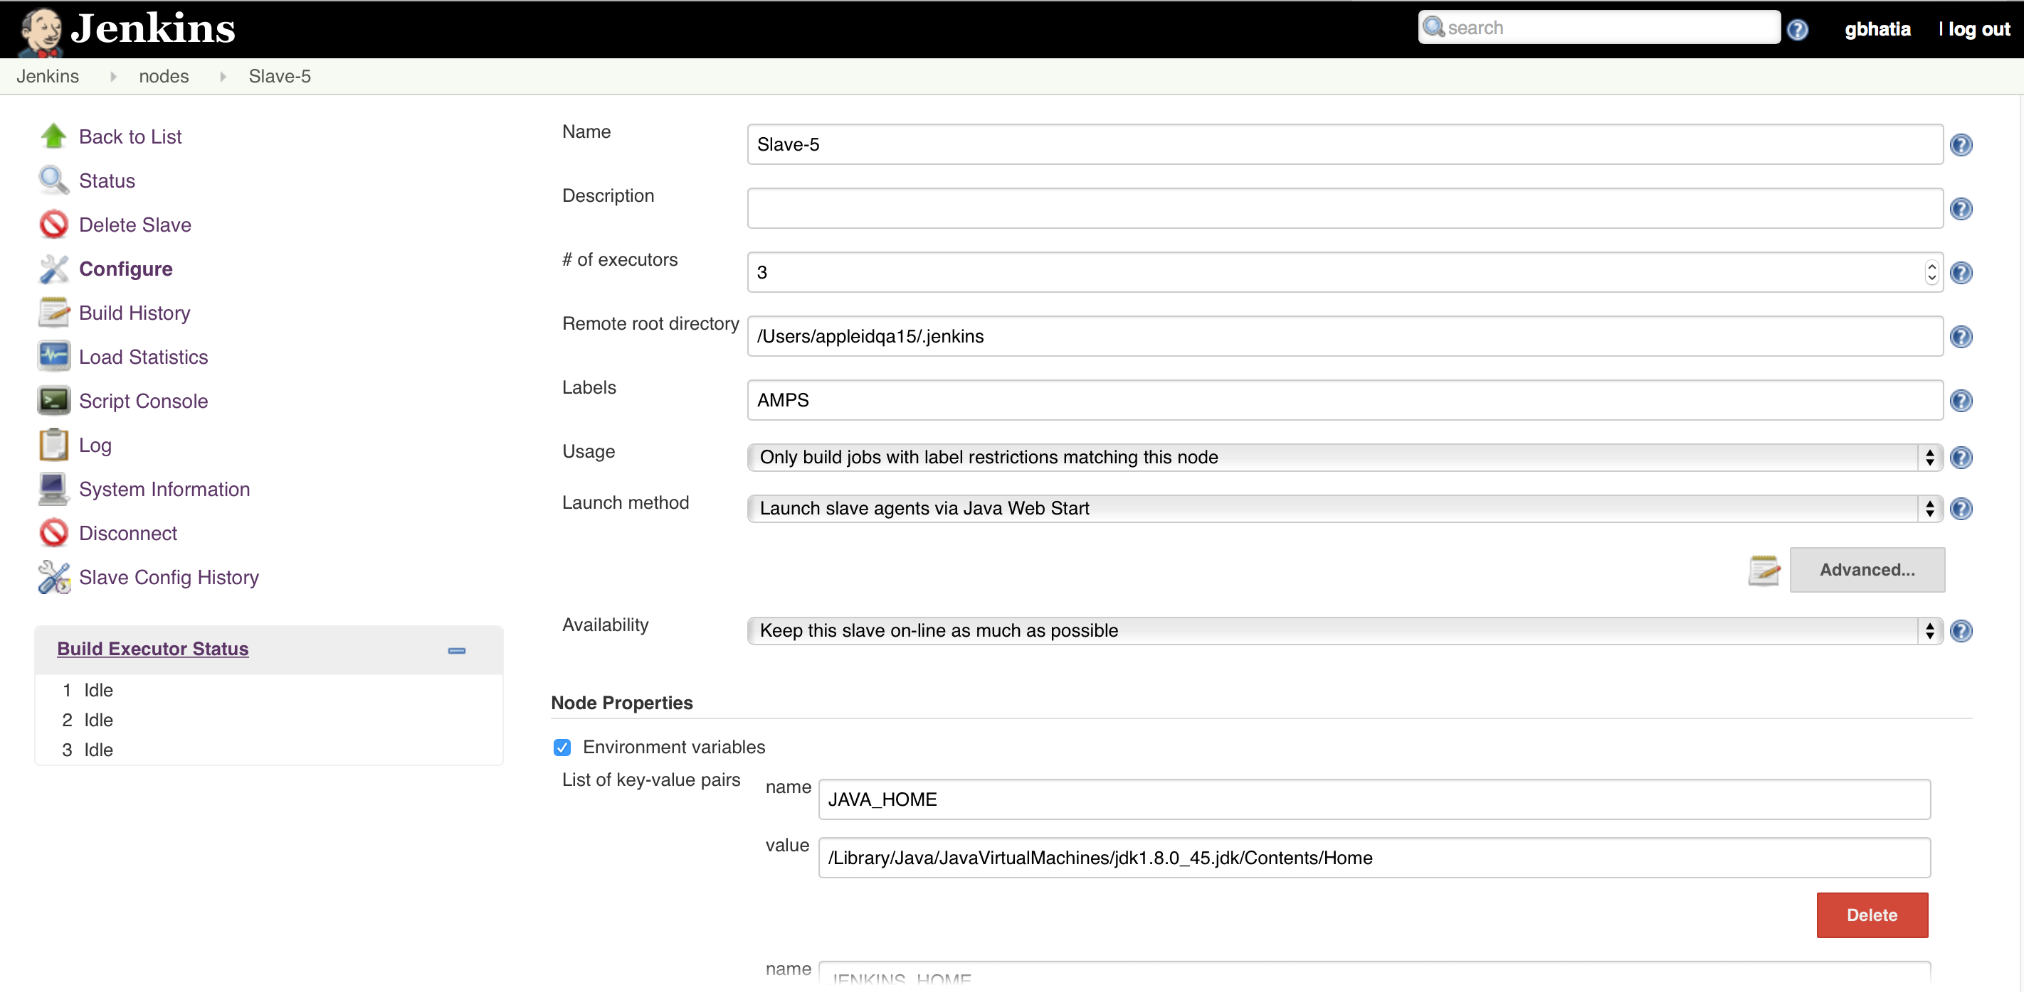

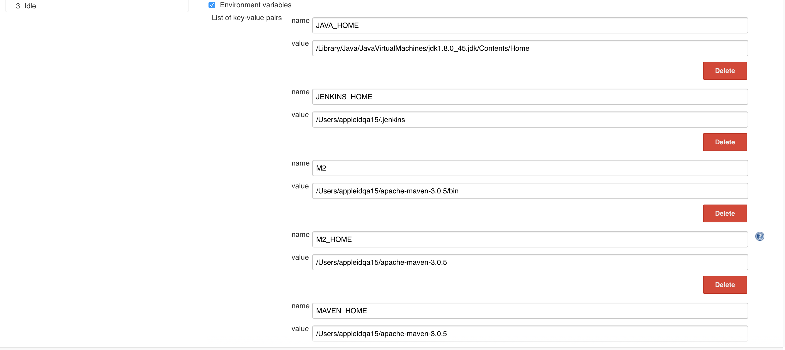

After selecting the launch menthod,
copy slave.jar from master Jenkins when you configure slave in master Jenkins

and have a script slavestart.sh in the same location.
cat slavestart.sh

appleidqa15:~ appleidqa15$ cat slavestart.sh
#!/bin/bash

umask 022

JHOST="appleidqa15.apple.com"
cd /Users/appleidqa15/
echo `pwd`

start()
{
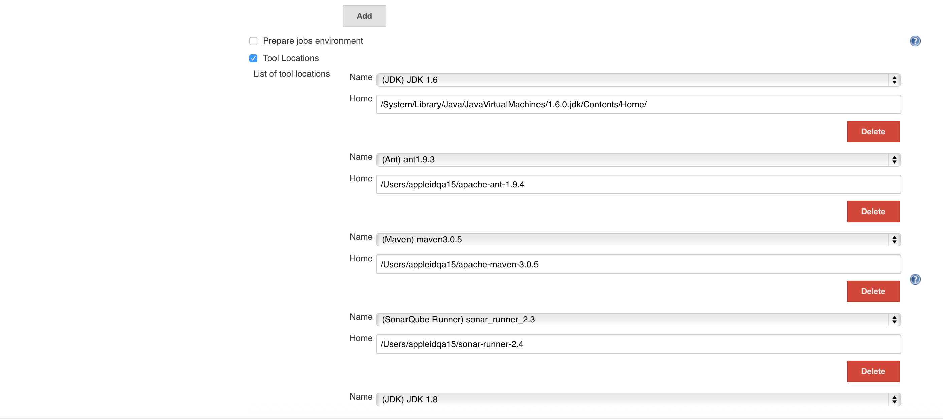
echo $"Starting Jenkins BuildSlave:$JHOST "

nohup java -Xms1024m -Xmx4g -XX:MaxPermSize=2048m -XX:+UseParallelOldGC -XX:ParallelGCThreads=4 -Djava.awt.headless=true -jar slave.jar -jnlpUrl http://idms-jenkins.apple.com:9080/computer/Slave-5/slave-agent.jnlp -secret 29fad8bf4292b4ba945bc741e7de805552ddd3bbb754a1d2ee17a9cde913972b > jenkins-slave.log 2>&1 &

}

stop()
{
echo "Stopping Jenkins BuildSlave:$JHOST "
PID=`ps -aef | grep java | grep slave.jar | grep jnlp | grep -v grep | awk '{print $2}'`
if [ $? -eq 0 ]
then
echo "Killing Jenkins slave: $PID"
kill -9 $PID
else
echo $"jenkins slave not running..nothing to stop "
fi
}

case "$1" in
start)
start
;;
stop)
stop
;;
restart|reload)
stop
start
;;
status)
status java
;;
*)
echo $"Usage: $0 {start|stop|restart|reload}"
exit 1
esac

exit 0

Example of a Jenkins job configuration with sonar setup,clover,editable email configured.

