# SQL Query Questions with Outputs

Q1. Use of union all operation findind employee who has age between 30 to 35 and 40 to 50

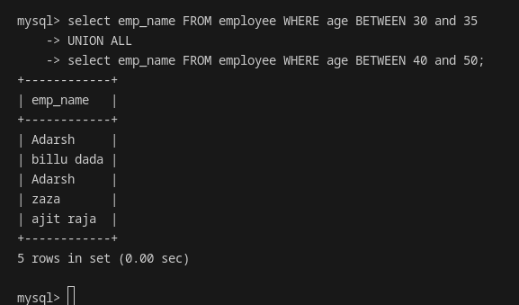

Q2. Use of intersection all to find all employee who are from ranchi and age > 30

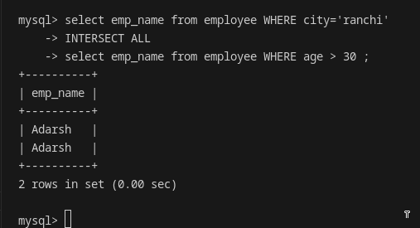

Q3. Use of except all

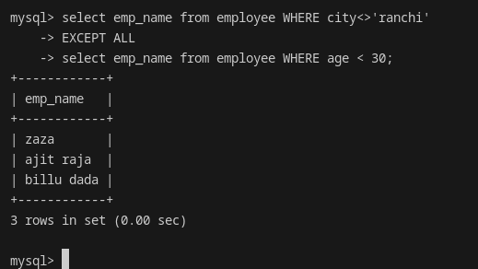

Q4. show employee name where name is not null

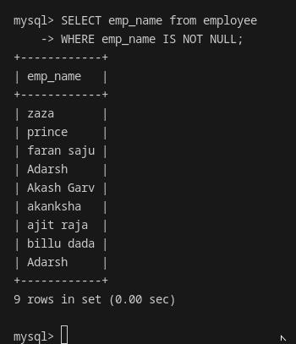

Q5. List details of eployee who's age is null or city is NULL

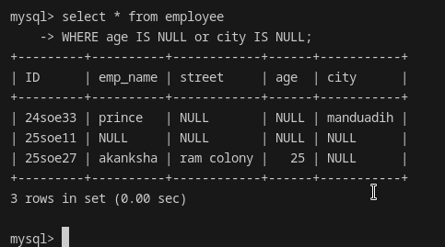

Q6. List all tuples who have null in any tupple

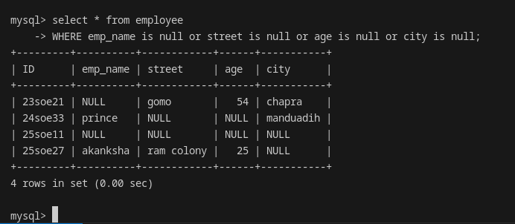

Q7. Perform not operation

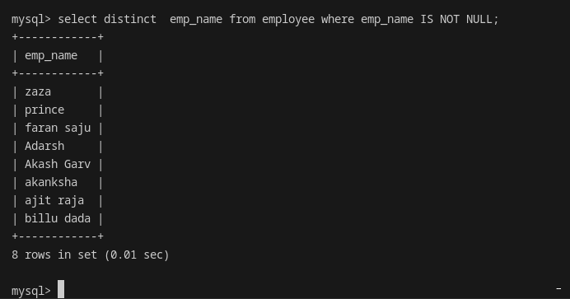

Q8. find average of salary

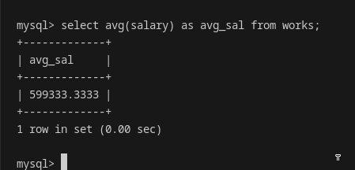

Q9. find avg of salary without null

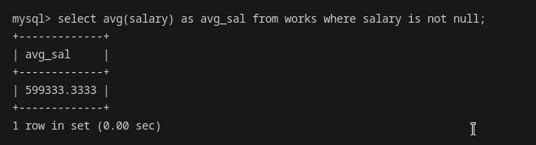

Q10. find name of employee who earns maximum salary

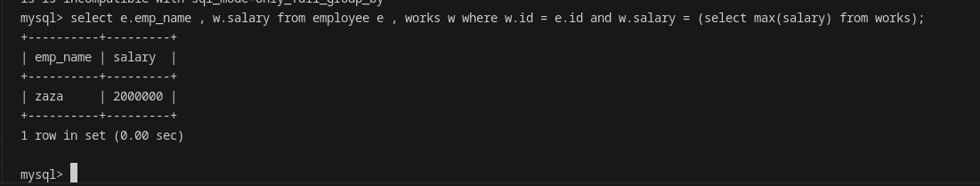

Q11. Calculate total of salary

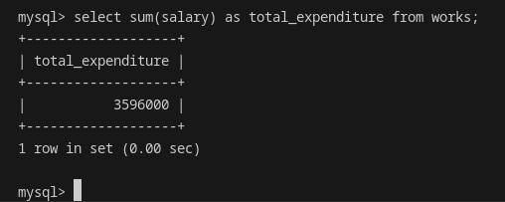

Q12. Get name of employee who work in some organisation using exists

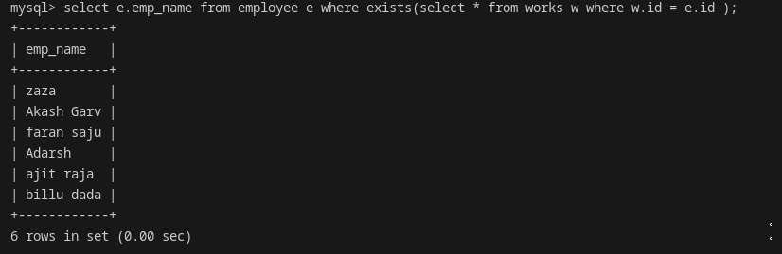

Q13. count no of tuples incluing null

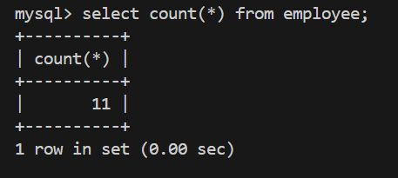

Q14. count no of tuples excluding null

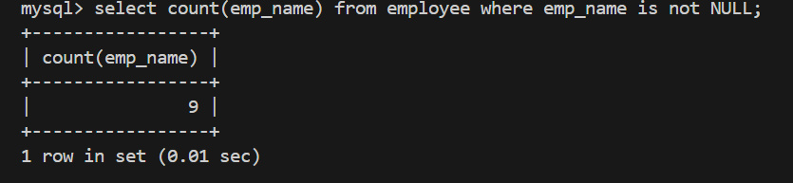

Q15. use of min : aggrigate

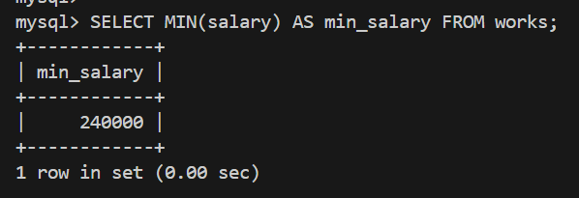

Q16. use of as clause with aggrigate function

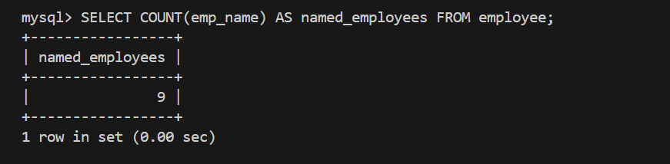

Q17. use of where caluse with aggrigate function

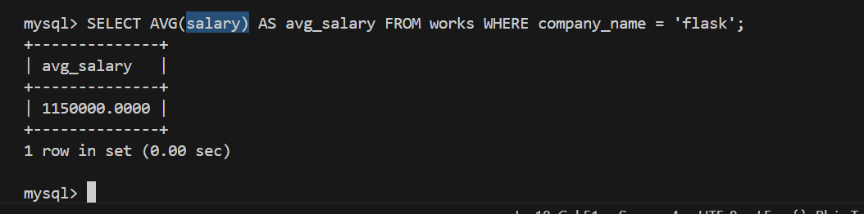

Q18. Use of COUNT(DISTINCT) with WHERE clause

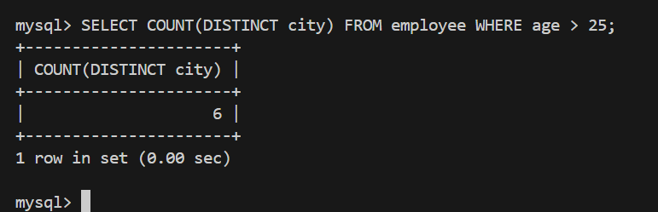

Q19. Use of COUNT with column and WHERE clause

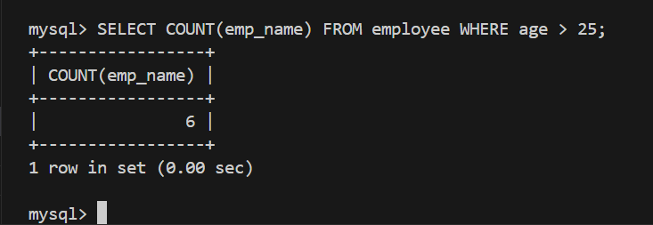

Q20. Use of GROUP BY with AVG and AS alias

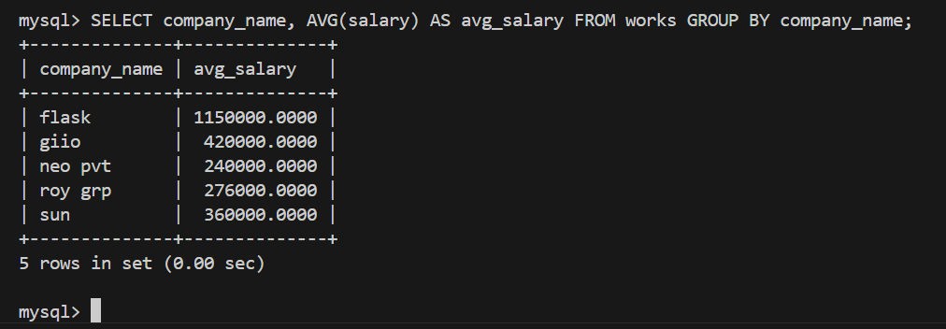

Q21.

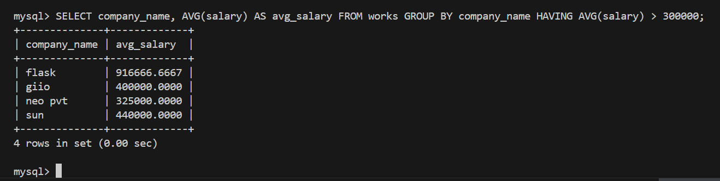

Q22. Use of subquery in FROM clause with AS alias

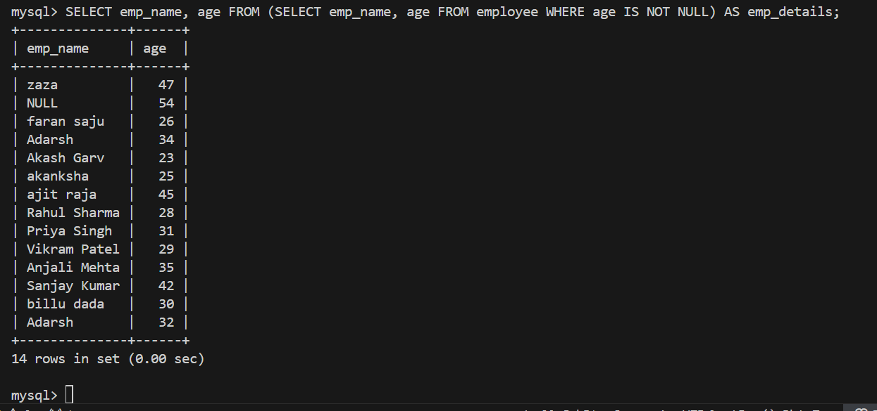

Q23. Use of subquery with MIN in WHERE clause

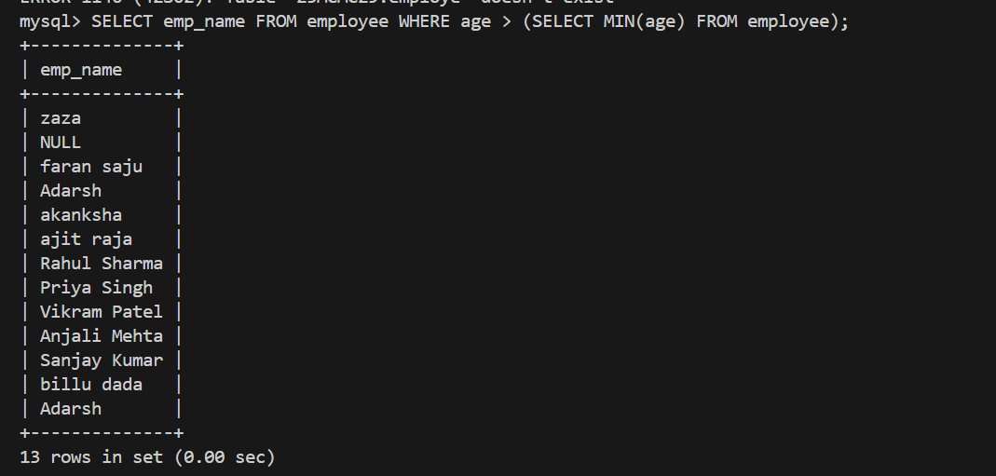

Q24. Use of subquery with AVG in WHERE clause

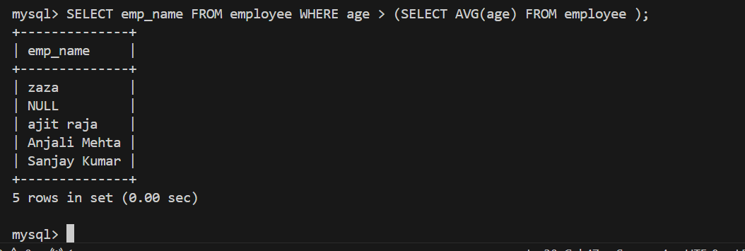

Q25. Use of scalar subquery in SELECT clause

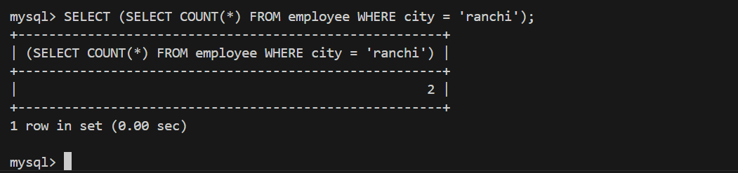

Q26. use of not in with nested subqueries

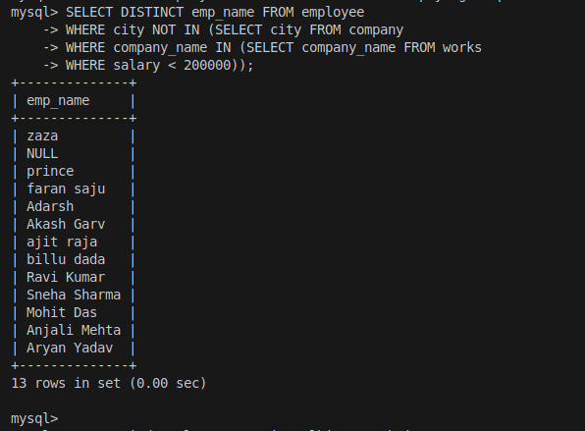

Q27. use of not in with literal values

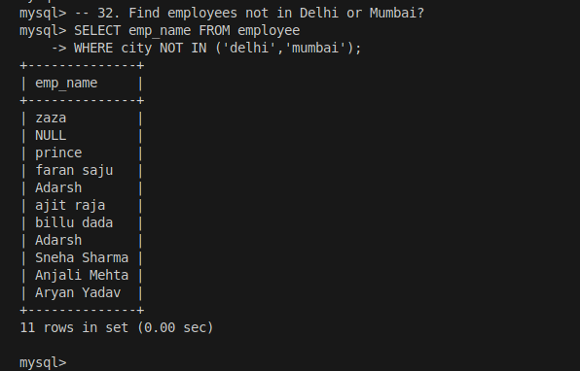

Q28. Use of row constructor with IN subquery

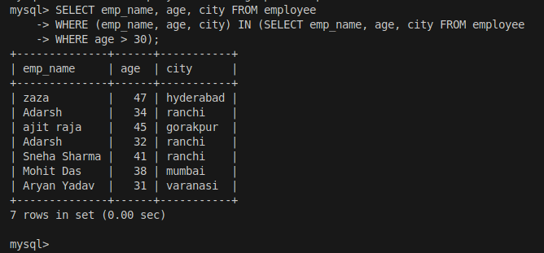

Q29. Use of self-join with table aliases

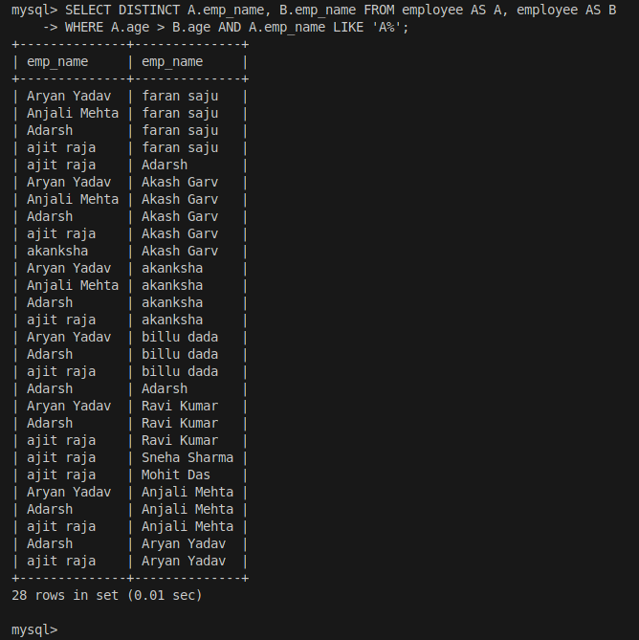

Q30. Use of self-join returning single column

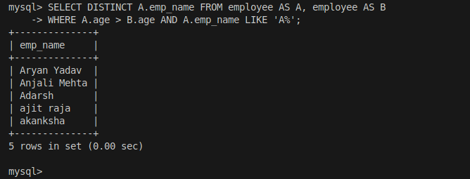

Q31. Use of SOME comparison operator

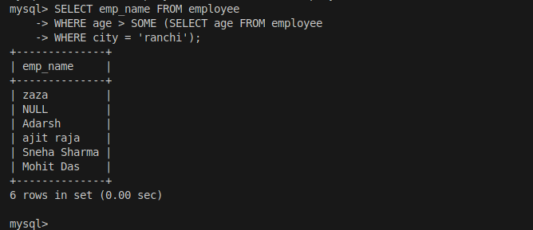

Q32. Use of self-join with specific condition

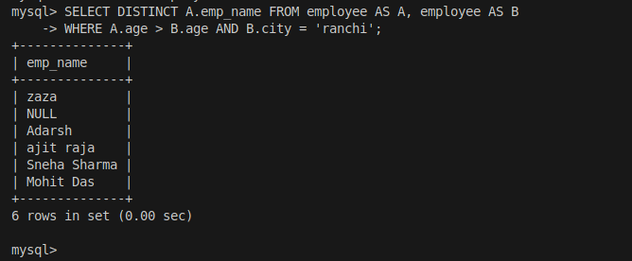

Q33. Use of ALL comparison operator

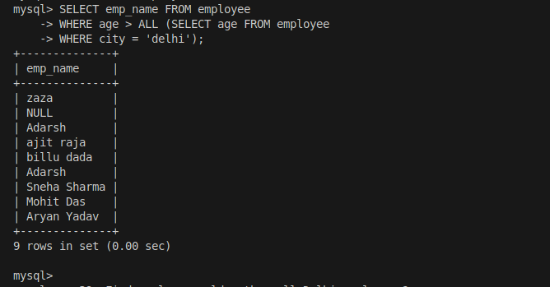

Q34. Use of ALL with subquery

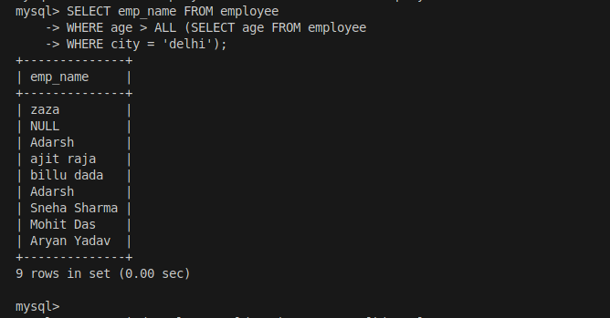

Q35. Use of ALL with subquery with where clause

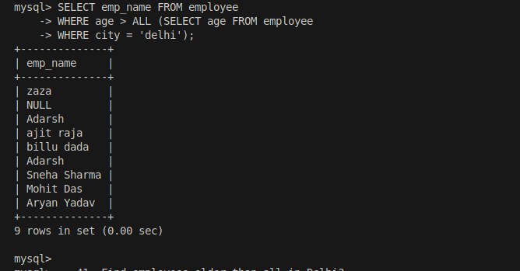

Q36. Use of EXISTS with correlated subquery

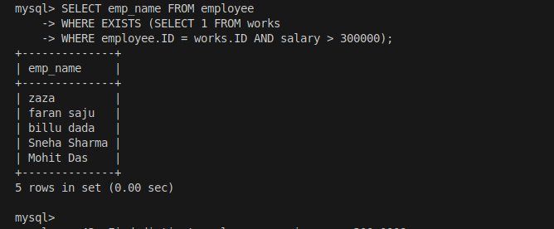

Q37. Use of EXISTS with temp table

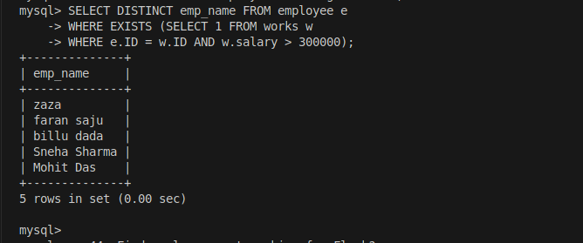

Q38. Use of NOT EXISTS with condition

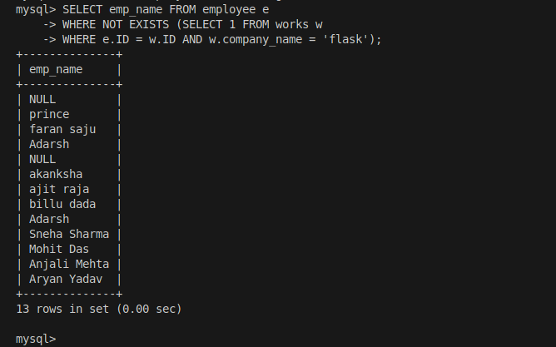

Q39. Use of NOT EXISTS with comparison

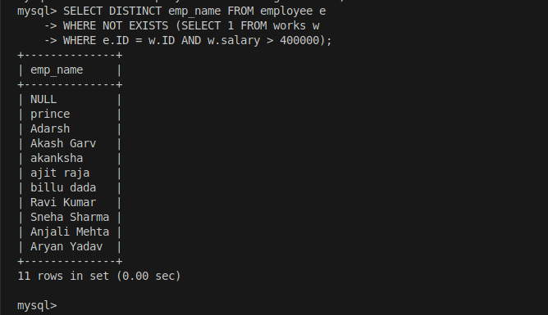

Q40. Use of subquery with COUNT(*) in WHERE

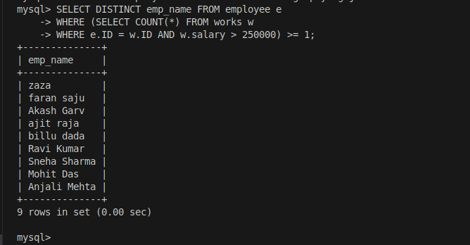

Q41. Use of subquery with COUNT(company name ) in WHERE

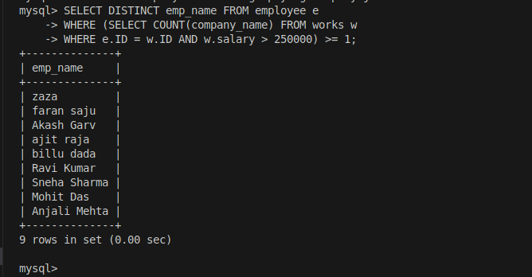

Q42. use of with to get who pay above average total salary

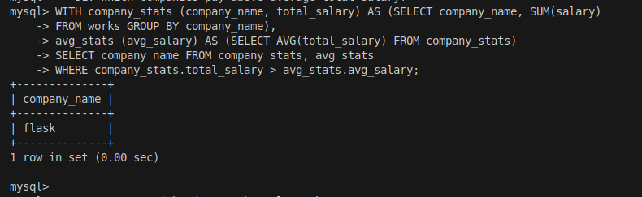

Q43. Use of correlated subquery in SELECT

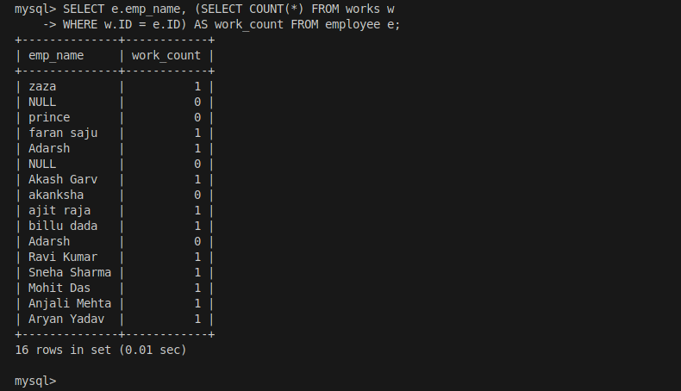

Q44. Use of multiple scalar subqueries in expression

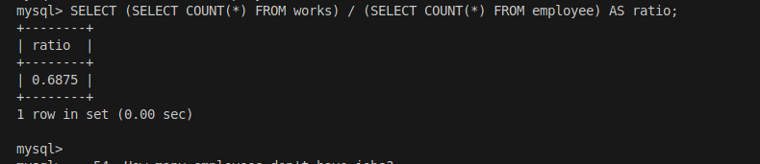

Q45. Use of scalar subqueries in arithmetic operation

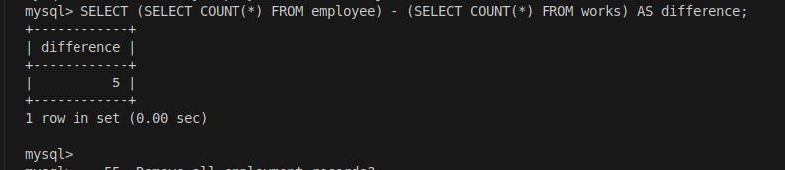

Q46. Use of DELETE with aggregate subquery

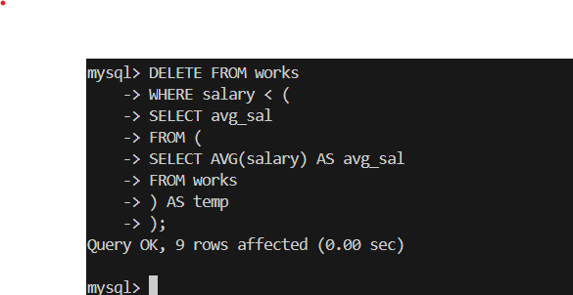

Q47. Use of INSERT with VALUES clause

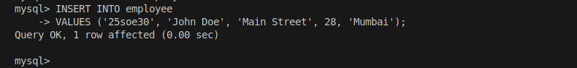

Q48. Use of INSERT with column list

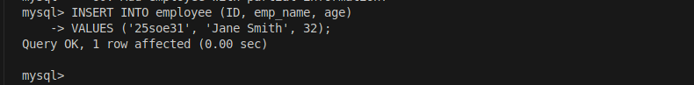

Q49. Use of INSERT with SELECT subquery

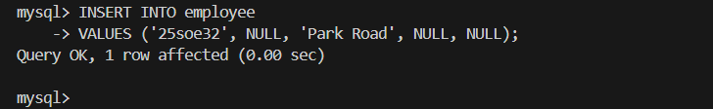

Q50. Use of UPDATE without WHERE clause

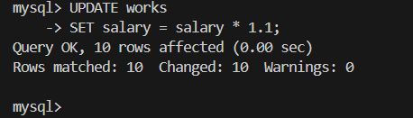

Q51. Use of UPDATE with WHERE condition

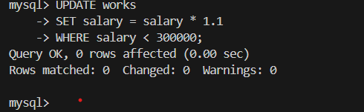

Q52. Use of UPDATE with aggregate subquery

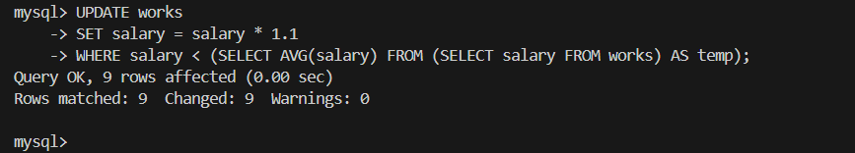

Q53. Use of UPDATE with CASE statement

