## 1. Consider the following employee database.

# employee (ID, emp_name, age, street, city)

# works (ID, company_name, salary)

# company (company_name, city)

## Give an expression each in the relational algebra to express the following queries.

## a. Find the name of each employee whose salary is greater than Rs. 1000000. (1 point)

## b. Find the name of each employee who lives in the city “Hyderabad” and whose salary

## is less than Rs. 1000000. (1 point)

## c. Find the ID and name of each employee who does not work for “University of Hyderabad”. (1 point)

## d. Find the ID and name of each employee who earns at least as much as every

## employee in the database.

# 2 . Create Data base "create database 25MCMCXX”

## Create Database

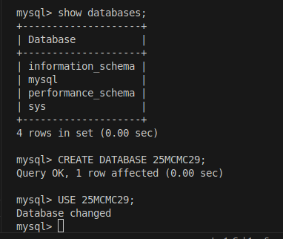

# 3. Now create the employee database tables in your database.

# a. Ensure all the primary key and foreign key relations while creating the tables.

## Creating table employee

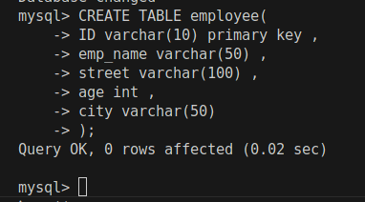

## Creating table company

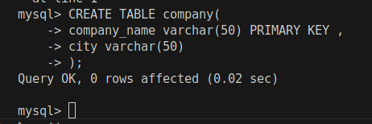

## creating table works

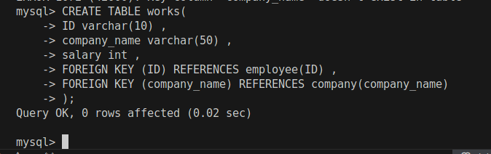

# b . Populate the tables with at least 5 entries per table.

## Inserting data in employee

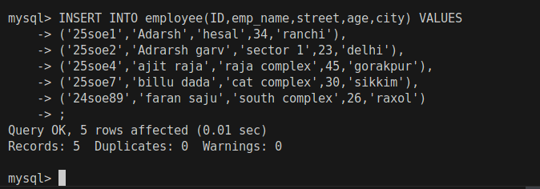

## Inserting data into employee

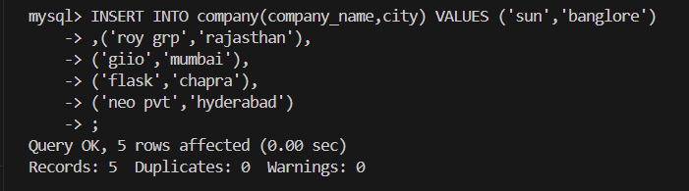

## Inserting data in works

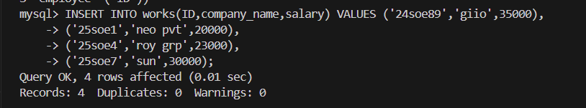

# 4. all the SQL commands discussed/demonstrated in the slides

# Updating works table works

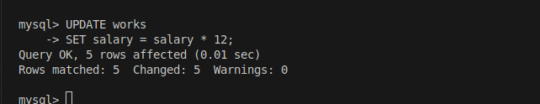

## Updating specific detail of the employee

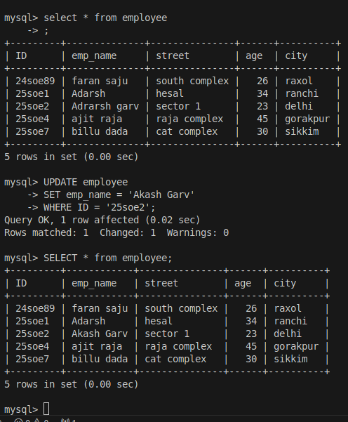

## Projection of NULL

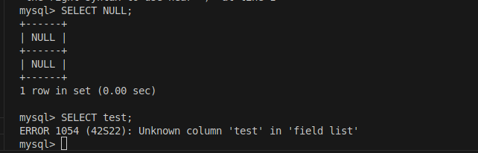

## Projection of empty string

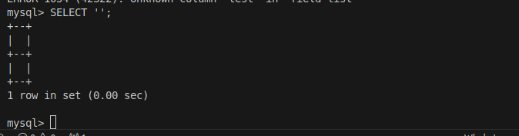

## Projection of string with changed name

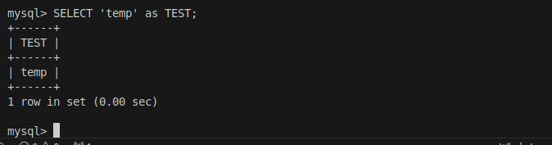

## show all employee in database

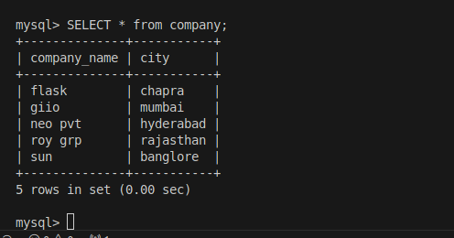

## Display only employee name

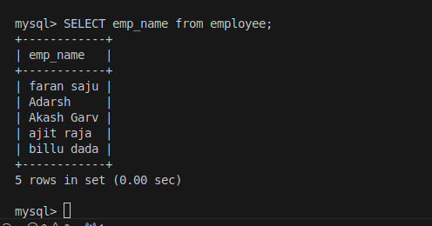

## Show distinct employee name

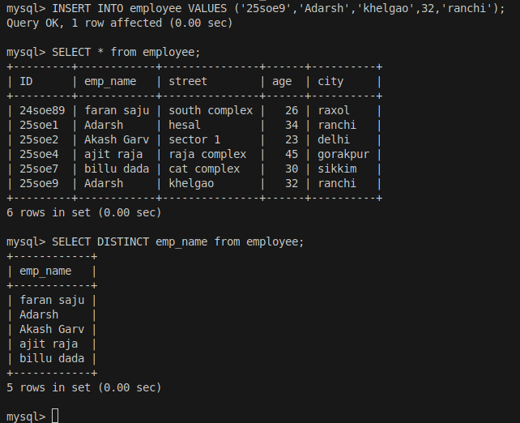

## Show name with min 3 char where 3rd char is A

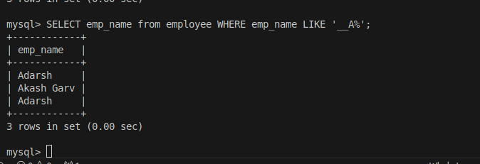

## Show employee name which contains I in it

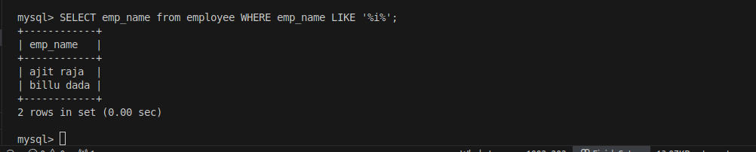

## Use of delete command

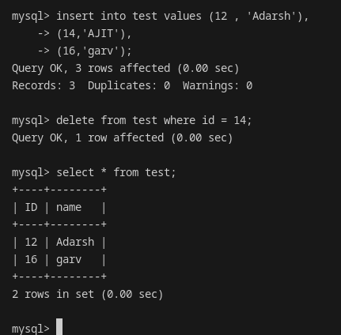

## Use of drop command

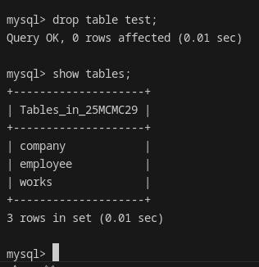

## Use of alter command to add column

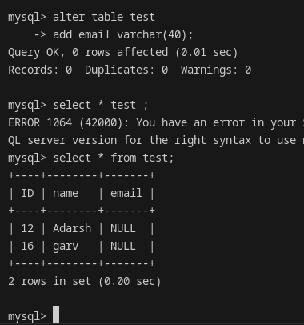

## Use of alter command to drop the column

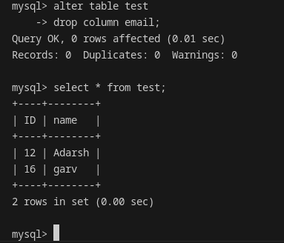

## Use of where clause

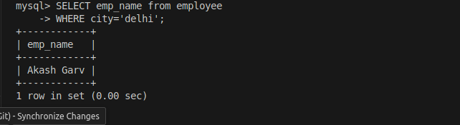

## Projection of string

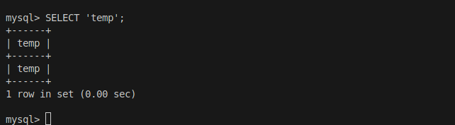

## Projection of string using from on table

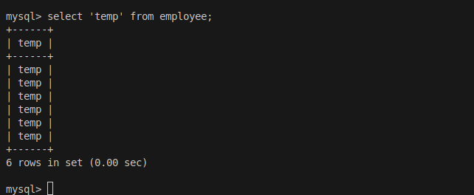

## Projection of attribute name

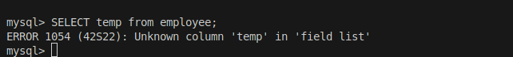

## show all city name

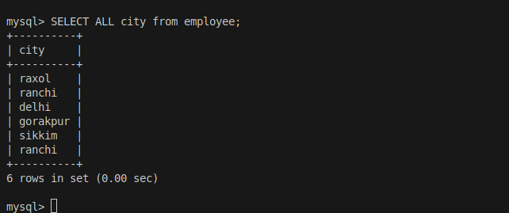

## Show monthly salary of the employee

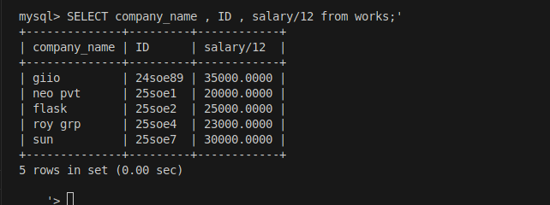

## Use of As command

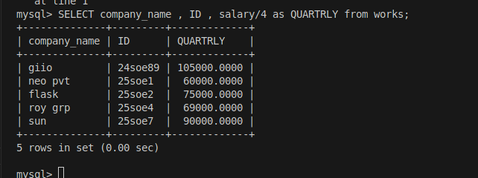

## Pattern matching to get a on 3rd place

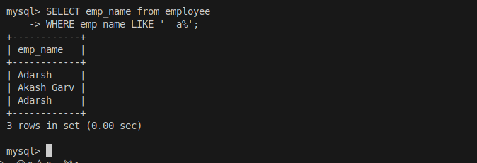

## Pattern matching to get a on 3rd place and salary > 70000

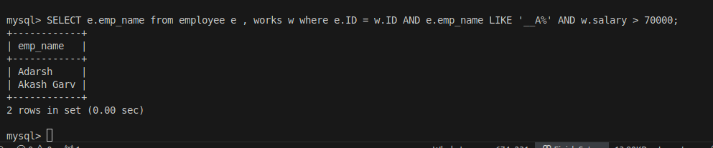

## Cross product of employee and work

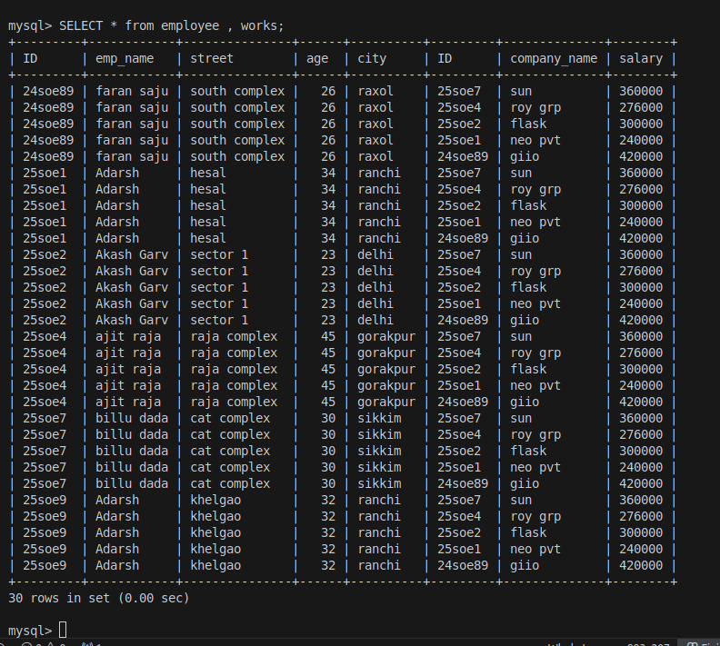

## Cross product of employee and works to get who work in which organization

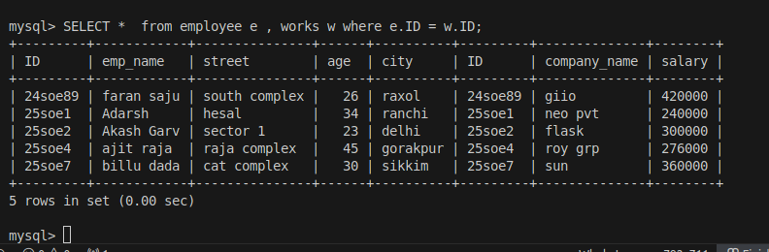

## Show details of those employee who earn more than 25000 per month

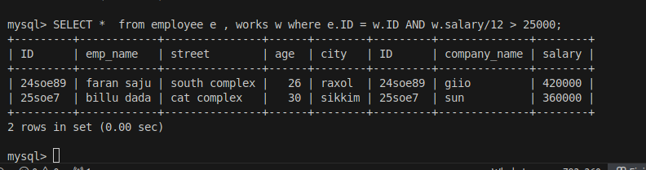

## Get name of employee who is older than some one and lives in ranchi

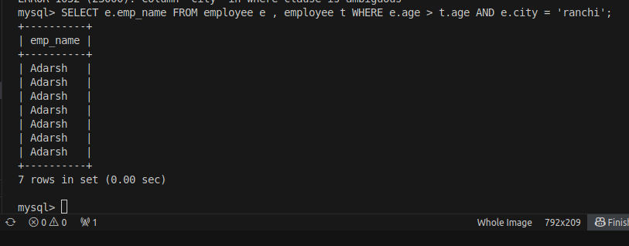

## Joining three table using primary key and foreign key

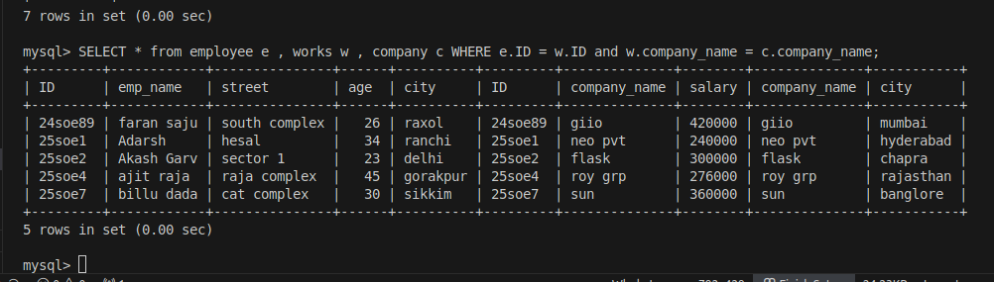

## self join to get name of employee who is at least older than some one

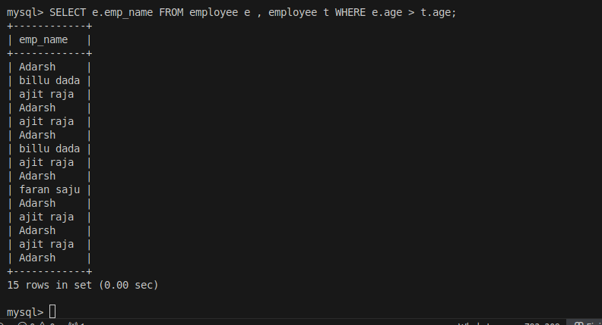

## Use of upper function

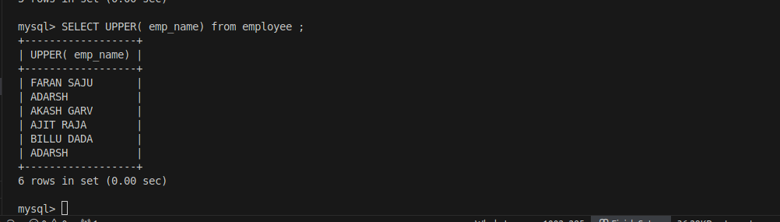

## use of lower function

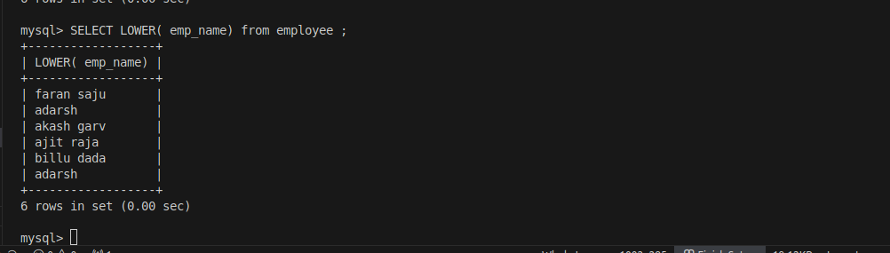

## use of trim function

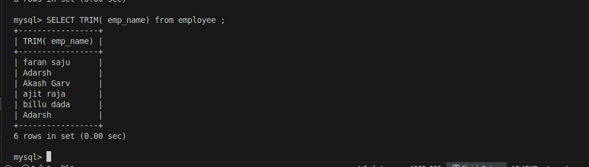

## use of concat function

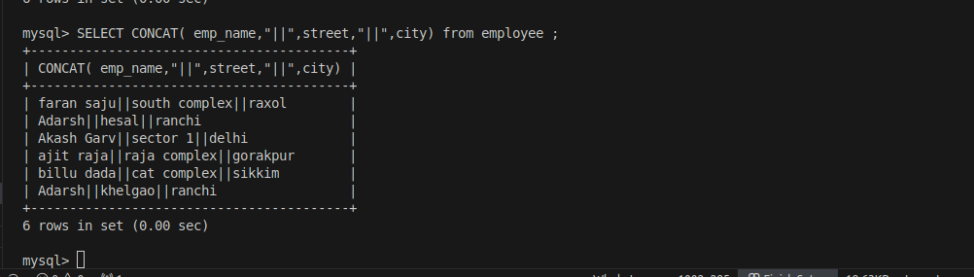

## Pattern matching for min length 3 and ends with a

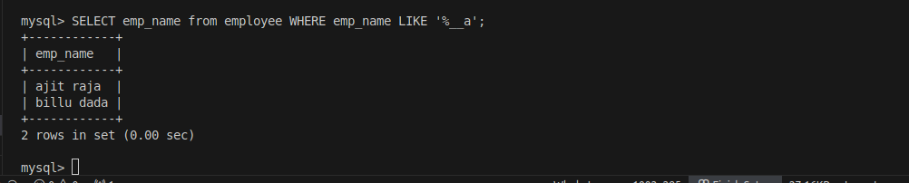

## Pattern matching which has min length of 3 and contains 3rd character as i

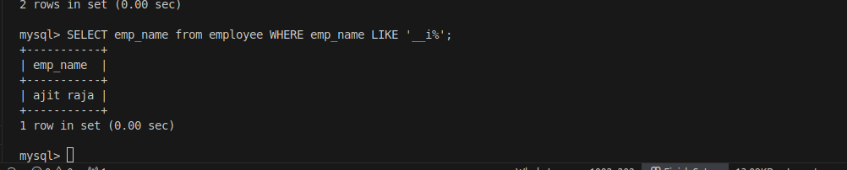

## Pattern matching which contains sh

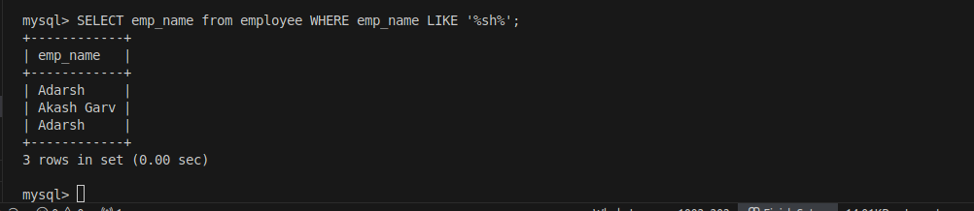

## Give name of employee who’s name contain 6character

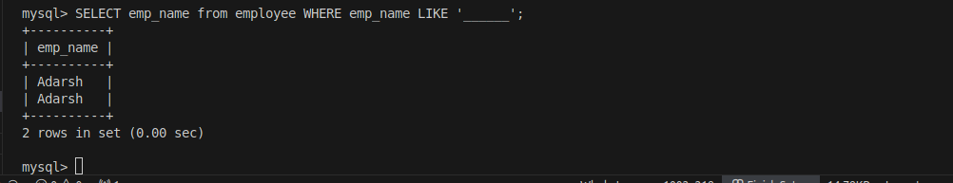

## Give name of employee with minimum of 6 character

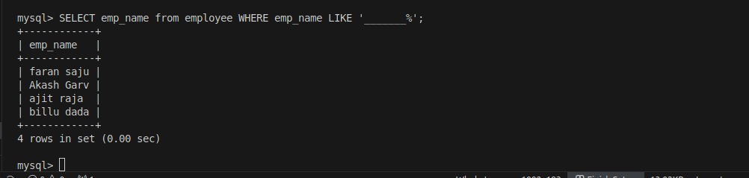

## give name of employee with less than 7 character

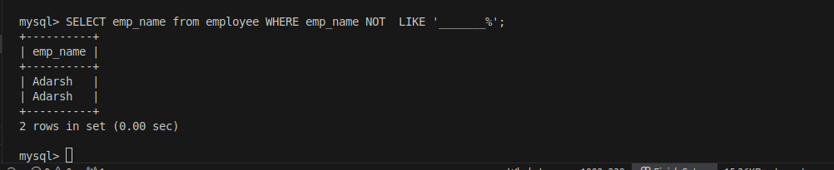

## Use of order by and distinct

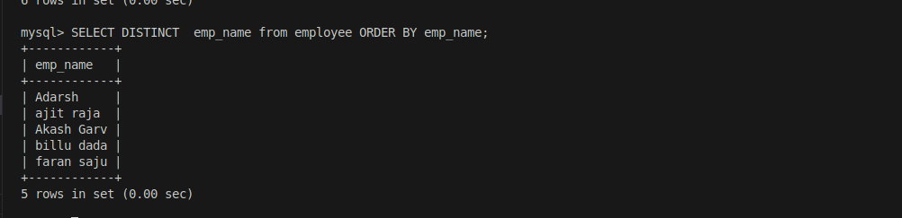

## use of order by

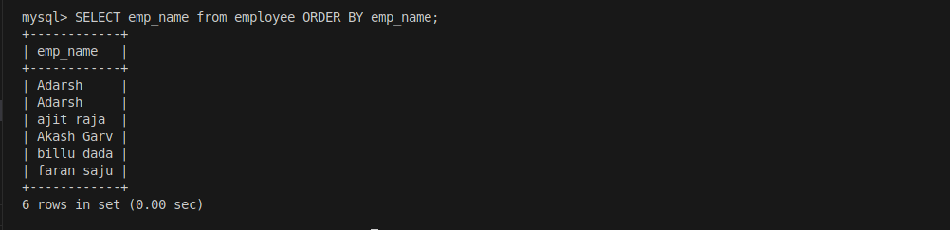

## use of order by and in desc order

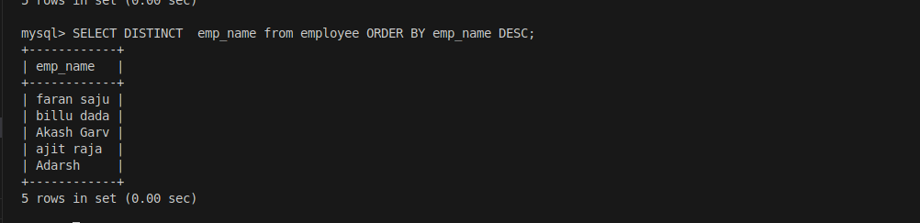

## use order by on two attribute

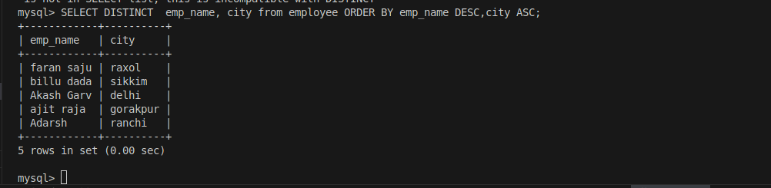

## Show name of those employee who’s salary between 2 lakh to 3.5 lakh

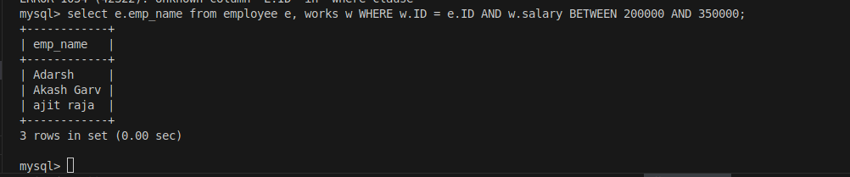

## Show name of those employee who’s salary is not in between 2 lakh to 3.5 lakh

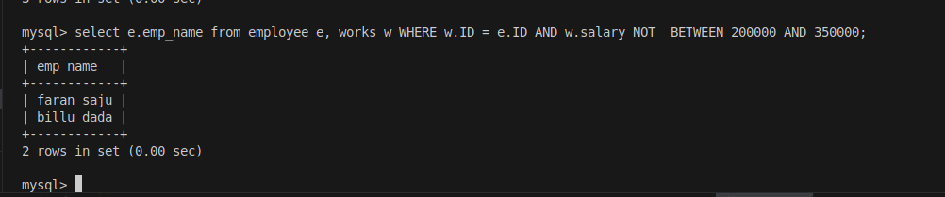

## Show employee name , salary and city of company with company name

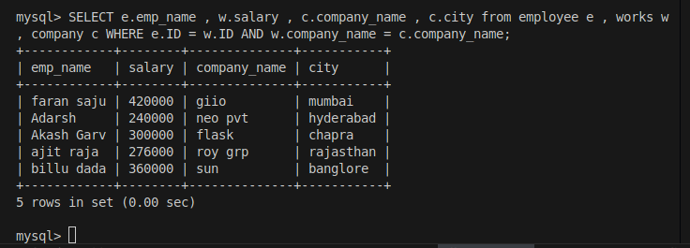

## Use of union get those who live in ranchi or delhi

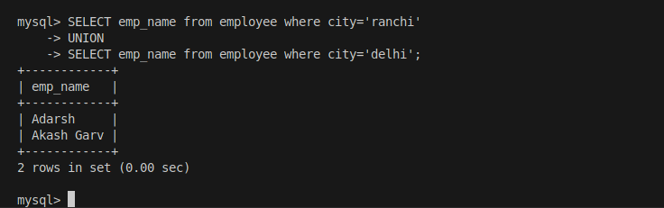

## Get those people who work in same city as they are from

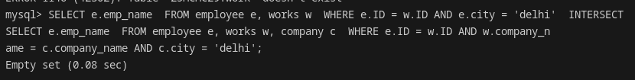

## Get those people who are not employed

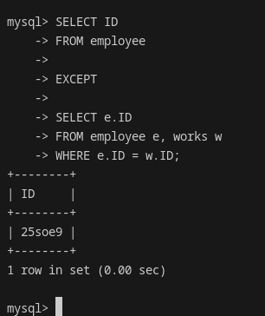

# 5. Now in the created employee database, provide the SQL queries for the following.

# a. Find the name of each employee who lives in the city “Hyderabad”.

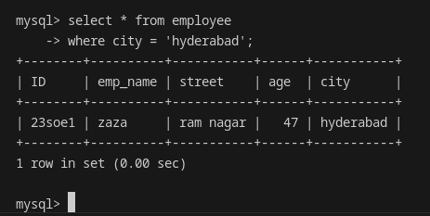

# b. Find the name of each employee who lives in the city “Hyderabad” and whose salary is greater than Rs. 1000000.